Adams Tutorial
Familiarizing with Adams/Car

In this tutorial we will go over the basics of Adams/Car and how to navigate around its interface. For most people Adams will be like no program that you’ve ever dealt with before and so it takes an adjustment period in order to be able to work with it.

Opening Adams/Car -
First of all to open Adams/Car you must click on the Adams/Car shortcut on the desktop. This is the only way to open the program, and you cannot actually open the program as is by going through the start menu. The reason for this is that we use a special program written up to get into Adams/Car and that is what is on the desktop. The icon looks like this-
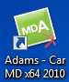
There are a few different versions of Adams on the desktop so make sure you click on the correct one for the task that you want.
Once Adams/Car loads up the window will come up and you click OK on the dialogue box to continue on.

Once Adams/Car opens it takes you to the standard screen, which looks very plain but right away you can see a number of tools.
- This is the tool bar, the main work area of Adams, under it there are many subsections that you will learn to use as you continue to work with Adams.
- The 3-D compass- similar to the one in SolidWorks and Catia, it is your reference for 3-D space.
- MSC Software Button- Clicking on it will bring up the version, installation, and legal information of your version of Adams/Car.
- Select Button-
- Command Navigator- Brings up a list of the available commands along with information on how to use then.
- Database Navigator- brings up a window showing the database that you are working in and how the folders and files are set up inside of it.
- Stop button – Stops an action if possible, useful if a simulation is starting to freeze or if it’s taking too long.
Some of these might not be available when you don’t have a subsystem open, but once you do they’ll turn black again and will become usable again. (e.g. the Edit and Adjust in the above image)

What can also be helpful is right clicking in the background. This will pull up a list of handy shortcuts like views, rotating, zooming and fitting assemblies.

Interface-
Once you start trying to open a file or even start a new file you’ll notice something strange.
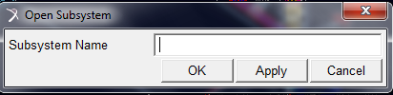
Instead of a normal folders view like we’re used to seeing we get this DOS-style open window, but don’t fret just yet if you right click in the type space menus will come up to help you find what you’re looking for in a more friendly manner, rather than having to know exactly where everything is. This applies to most of these boxes, in many different contexts, so if there’s ever doubt on what you want to select or what not right click and check the drop down for your options.

Creating a database-
Now when you want to work with your files you’ll want to be able to do so in a place where you won’t be disturbing other peoples files and vice versa. However creating a database is not as easy as you are used to and figuring out how to set it up isn’t the most intuitive process.

With Adams/Car open click on the Tools tab, and under that click Database Management, and then under that Create Database.

In the window that pops up now first you’ll type in the name of the folder you want to save in under the Database Alias. Then click on the folder icon and you can navigate to the proper directory to where you want to store your files.
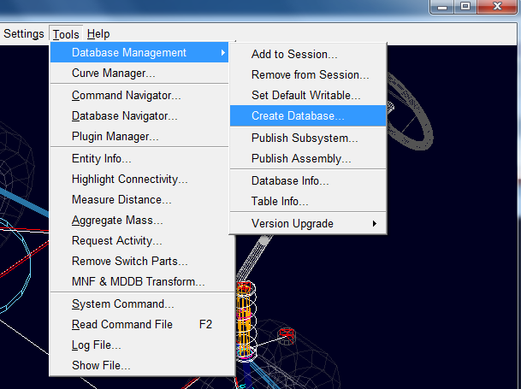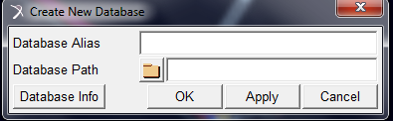

Add/Remove Database to Session

The purpose to adding a Database to session is that when you select open you have the option to search, and this searches directly from the databases that you have, this makes it much easier rather than browse every time.

First select tools then Database Management then select Add to Session
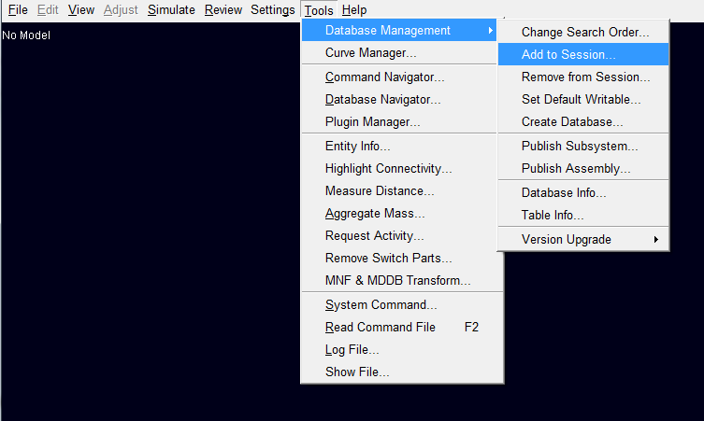

The Database Alias is whatever name you wish to name your database, this can be whatever you want. The Database Path is the database you wish to add, just select the folder and browse till you find your database and select OK or Apply.
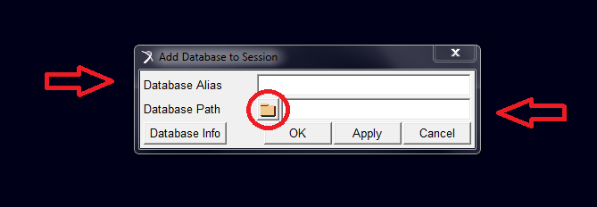

To remove from session select Tools then Database Management then select remove from session. A box pops up and you can simply select which database to remove and select OK or Apply.

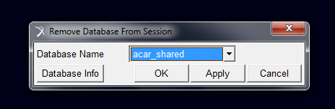

Results of a Simulation –
Adams/Car has a built in postprocessor, but it is not in the main view. So after have set up an event or simulation you can press F8 or Review and then Postprocessing Window. This takes you to a view like this where there are all sorts of post-simulation things you can do with the data as far as displaying it and manipulating it.
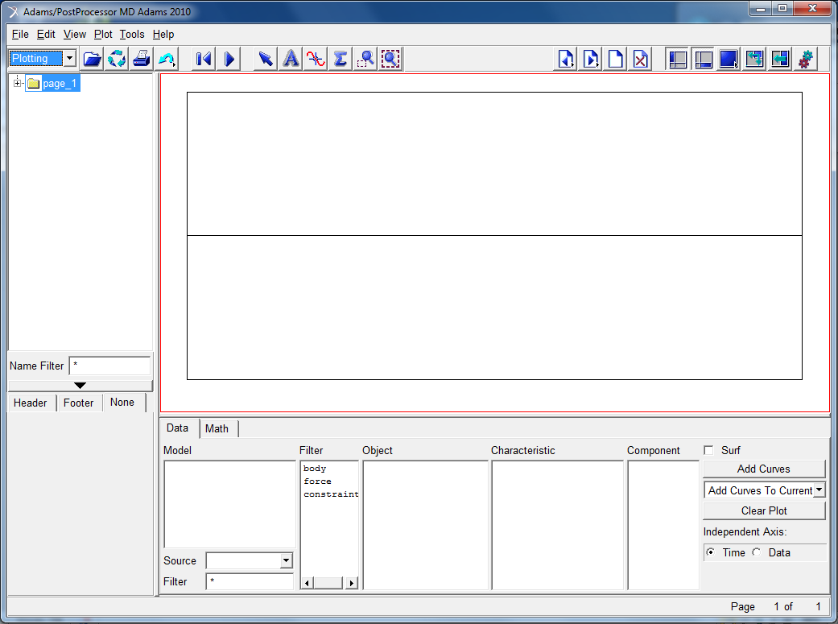
To return to the main window again press F8 again or under File click Close Plot Window

