Adding Colors so that they will transfer to the Cave
CATIA:
- Open the desired Catia part or assembly.
- Change the viewing mode to ‘Shading (SHD)’ or ‘Shading with Edges’ to see how the file will look after being converted
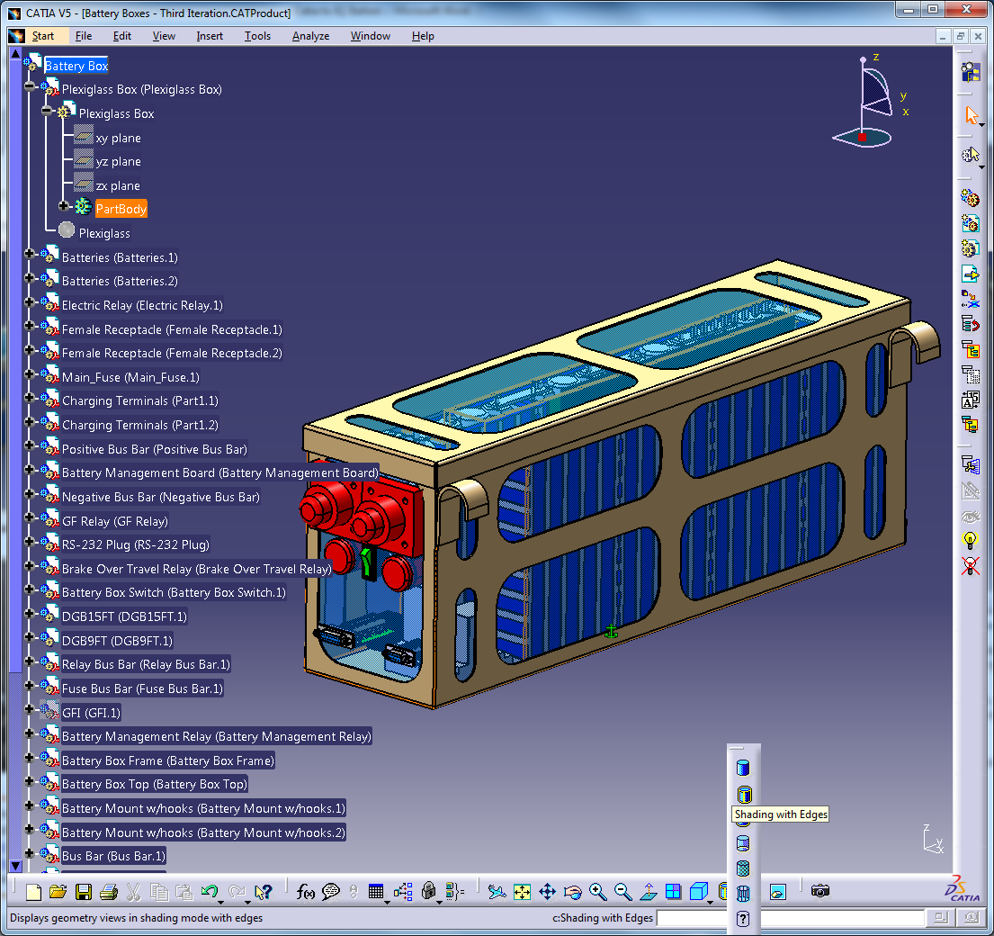

- Apply material
- Right click on each PartBody and select Properties, go to the ‘Graphic’ tab and define the desired Color under ‘Fill’. This must be done for each part within the entire assembly.
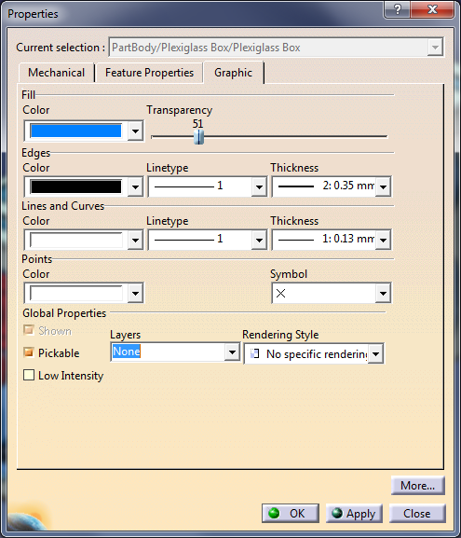

SolidWorks:
Appearance must be applied to each part individually:
- Apply Material
- Right click on part in design tree

- Select solid color
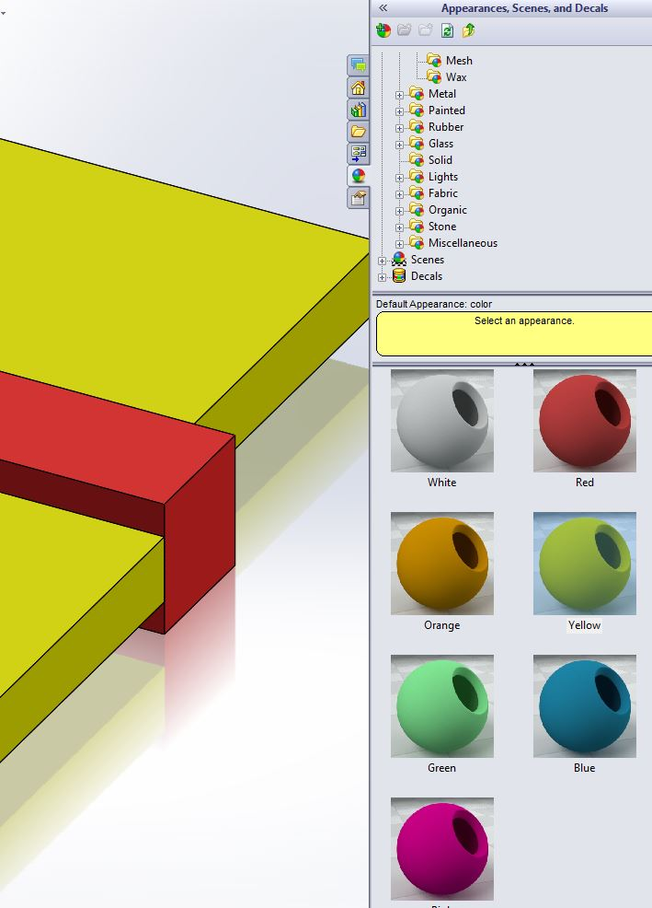
Notes:
- You can fine tune colors with the color bar on the left side of the screen
- Applying color overrides the color of the material but both material and color are essential

