University of Idaho, Department of Mechanical Engineering

Schweitzer Engineering Laboratories (SEL)

Thermally Conductive Card Guide

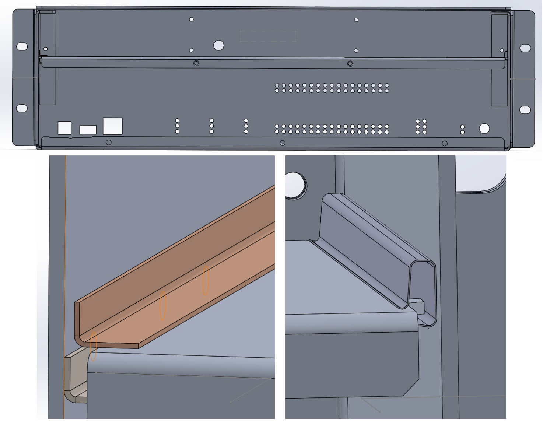

*New Guide Design Current Guide Design*

SEL Thermally Conductive Card Guide

*1Team Members: Marc Dobson, Collin Mabe, Nicholas Tobe, Michael Wendell*

*1University of Idaho Mentors: Dr. Steve Beyerlein and Alex Olson*

*2SEL Sponsors: Jonathan Richards and Dan Schneider*

*1Department of Mechanical Engineering, University of Idaho, Moscow, ID 83844*

*2Schweitzer Engineering Laboratories, Pullman, WA 99163*

**Abstract**

With increasing heat dissipation inside of SEL products, it is critical that new thermal management strategies are implemented in order to remove the heat. SEL components are designed without moving parts leading to many thermal solutions relying on material choice and contact between surfaces. Printed circuit boards (PCBs) are often mounted to aluminum trays and then installed in a computer chassis using a thermal card guide. The card guide acts as a heat sink for the PCB/tray assembly and needs to be improved to reduce the temperature difference between the tray and external chassis temperature. Outlined in this document are the testing, design, and evaluation methods used to create a thermally conductive card guide.

**Contents**

1 Introduction 4

2 Experimental Methods 4

2.1 Thermal Analysis 4

2.2 Experimental Setup 4

2.3 Experimental Calculations 5

3 SolidWorks 6

3.1 Flow-Sim Analysis and Parametric Studies 6

3.2 Guide Design 7

3.3 Prototype Selection 7

4 Prototype 7

5 Future Work 9

6 Appendix 9

I: Experiment 1 9

Goal: 9

Bill of Materials: 9

Setup: 9

Method: 11

Experiment: 13

Results: 13

Error Propagation: 14

Conclusions: 15

ESS: 16

II: Experiment 2 20

Goal: 20

Bill of Materials: 20

Setup: 20

Method: 22

Experiment: 23

Results: 23

Error Propagation: 25

Conclusions: 26

ESS: 27

III: Experiment 3 30

Goal: 30

Setup: 30

Method: 32

Experiment: 32

Results: 34

Error Propagation: 35

Conclusions: 36

ESS: 37

IV: SEL Current Guide Design 41

# Introduction

To improve reliability, SEL products are not designed with moving components. In efforts to remain a market leader, SEL continually increases processor speeds and attempts to pack more input/output capabilities into their products. For each innovation, a cost of greater heat dissipation ensues. Which creates many new and intensive design challenges for mechanical engineers. SEL thermal solutions must be optimized for performance, reliability, manufacturability, and cost. With ever increasing heat dissipation in SEL products, it is critical that they continue to invent new thermal management strategies which keep the product costs low.

Many Printed Circuit Boards (PCBs) are mounted to aluminum trays and installed in their products using card guides. In addition to being highly repeatable and easily re-workable for the manufacturing floor, this tray provides a convenient heat sink for PCB components. Unfortunately, the current card guides are not effective thermal conduits. Tray temperatures typically hover between 10 – 15 °C above external chassis temperatures. A thermally conductive card guide is needed to close this temperature gap and reduce component temperatures throughout the product. SEL has presented the team with a goal of creating a guide with a net thermal resistance of 1 °C /W. This report outlines our experimental and simulation processes as well as outlines a perspective guide design created from these processes.

# Experimental Methods

Physical experiments were performed in order to guide our input variables in SolidWorks (SW) simulations. These experiments were performed in conditions that could be replicated in SW, and allowed for a factor of safety to be defined when comparing a simulation to reality. This factor of safety could be worked in to the process of moving from a SW model to a physical model.

## Thermal Analysis

Uncertainty analysis was a large portion of our experimental process, because of the lack accuracy that our thermocouples were capable of, we used the SolidWorks add in Flow Simulation. This allowed us to use known variables to isolate unknowns and solve for them. When a model was created that accurately showed the results that were seen from the physical experiment, we could use the model to measure other variables that would otherwise be impossible to measure in the lab.

Before we could make large forward strides in our computer simulations, there was a process of project learning that had to be completed. When a model was created that the team deemed accurate, it would be checked by the team sponsors at SEL and they would help redirect the team to make the model more accurate. Since the Flow Simulation software is complicated and quite sensitive to initial set up, this turned into a longer process than was planned for. By the end of this process the team was confident that the results calculated were accurate.

## Experimental Setup

The experimental setup used for the thermal analysis consisted of sheet metal test specimens that were heated by dale resistors with thermocouples placed at various points on the test specimens. The fixture is placed inside of a bell jar (vacuum chamber) to reduce the effects of convection. Thermocouple readers were used to take the measurements from K-type thermocouples and temperatures were recorded manually and periodically until the fixture reached steady state.

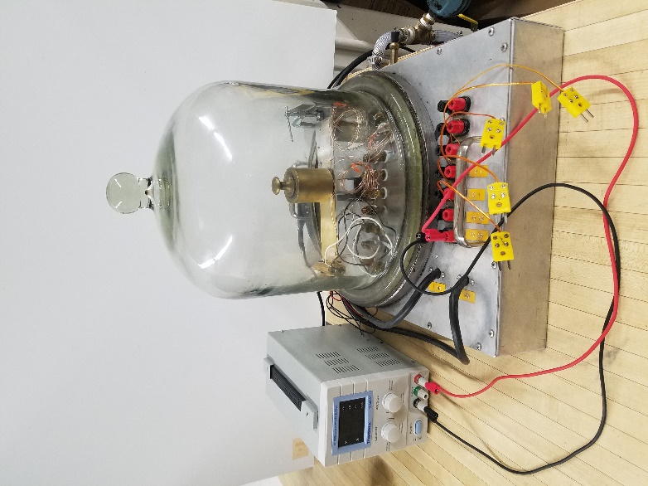

Figure 1: Experimental setup with bell jar

The test specimens used in this experiment were 2 in wide and 6 in long. The material and thickness varied based on the specimen. For specific experiment setups, see the appendix.

## Experimental Calculations

Using the equation for the rate of conductive heat transfer and the equation for thermal resistance through a material the net resistance of the guide can be found, their respective equations can be found below:

$$\dot{Q}=\frac{∆T}{R} R=\frac{L}{kA}$$

Where $\dot{Q}$ is the conductive power at a specific reference point, $∆T$ is the temperature difference between two thermocouples, and $R$ is the thermal resistance between the same thermocouples. $L$ is the length between the two thermocouples, $k$ is the thermal conductivity of the material, and $A$ is the cross-sectional area of the material. Once the conductive power was found at a point the equation can be arranged to:

$$R=\frac{∆T}{\dot{Q}}$$

This allows one to find the thermal resistance between any point and the reference point, then to find the resistance of a certain area one must simply subtract the resistances of the undesired areas from the total resistance. To see specific calculations for each experiment, see appendix.

# SolidWorks

SolidWorks modeling was performed to create thermal simulations and creating potential guide designs. Flow-Sim was used in SW to perform thermal analysis that was guided by results acquired through physical experiments (see Section 2). Once we were sure that the computer simulations were producing accurate results, prototype designs could then be tested in a similar simulation design to give an estimate to how the part would perform in reality.

## Flow-Sim Analysis and Parametric Studies

Parametric studies were essential to accurately determining the value of certain variables. By using the results from these studies to design different guide solutions, the prototypes would be more likely to have thermal properties that were desirable.

Surface area was one of the variables that the team deemed was important enough to study because the information we found could be used in guide designs. This study showed that there was somewhat of a diminishing return on how much contact area is used in a guide. From this information the team decided that guide designs would need to have at least 1.5 ${in}^{2}$ of surface area to be in the ball park of our thermal goals.

Figure 2: Thermal Resistance vs. Surface Area

To find the contact resistance of the material that we were using another parametric study was used. Knowing what the real contact resistance of the material that we use is essential because when we are analyzing just the card guide, the surface resistance can dominate what the overall resistance is of that part of the system because of the small size. To complete this task we made a model in SolidWorks that represented our physical experiment. We created points that could be monitored that were in the same locations as the thermocouples and used the outside steady state temperatures as boundary conditions for the system. This forces SolidWorks to solve between the two points and we were able to vary the contact resistance on the surfaces until the two steady state temperatures on the inside were able to match. This lead us to believe that the true contact resistance was somewhere between 1E-3 (K-m^2/W) and 3E-3 (K-m^2/W). These are the values that were used in subsequent testing in Flow-Sim.

## Guide Design

Looking at SEL’s current guide design and thermal card guides available on the market, guide designs were created with the intention of providing a competitively priced option that performed to SEL’s specifications. Moving forward it was determined that the current SEL design did not provide enough material to act as a heat sink between the tray, guide, and chassis wall. However, the SEL guide design is an inexpensive part (see appendix item IV) making cost an important specification to consider.

## Prototype Selection

Guide designs were modeled in SolidWorks. The guide designs were made with the goal of being under the thermal resistance maximum and accepting SEL’s tray sizes in use. These models that met these two specifications through calculations were then ran through Flow-Sim to determine the expected thermal resistance of the guide. The guides that meet the specification of a thermal resistance of >1⁰C/W are then further analyzed based on the specifications given in the table below.

|  |  |  |  |
| --- | --- | --- | --- |
| **Specification** | **Comment** | **Weights** | **Rank** |
| **Thermal Performance** | Heat transfer abilities beyond the stated minimum (<1⁰C/W) | 19.4% | 1 |
| **Reliability** | Low DPU/Replaceable in case of failure. | 16.7% | 2 |
| **Production Cost** | Cost of production parts | 14.3% | 3 |
| **Insertion Force** | Actual force of insertion | 8.9% | 4 |
| **Corrosion Resistance** | Beyond the stated minimum (Must not promote galvanic corrosion) | 7.8% | 5 |
| **Operational Simplicity** | How easy it is to use; Tool free > Cam > Lead screw | 7.7% | 6 |
| **Tooling Cost** | Cost of tooling | 7.6% | 7 |
| **Tray Thickness** | Support for variable tray thicknesses. (60-100 thousandths of an in.) | 7.2% | 8 |
| **Variable Length** | Value of having the length of the card guide be variable | 5.6% | 9 |
| **Footprint/Mass** | How big is it? Compatible with existing products? | 4.8% | 10 |

Table 1: Design metrics matrix

# Prototype

Prototype designs were modeled in SolidWorks with geometries based on the previous parametric studies performed. Various guide designs were modeled varying from complex latching designs to tool free, spring finger, models.

The selected prototype to create was the spring finger guide. This guide consisted of two main parts, a heat sink and spring finger brackets. The spring fingers would apply a force on the tray creating a solid contact between the tray and the heat sink bracket. For this design the heat sink was made of C26000 cartridge brass and the spring finger bracket was to be spring steel.

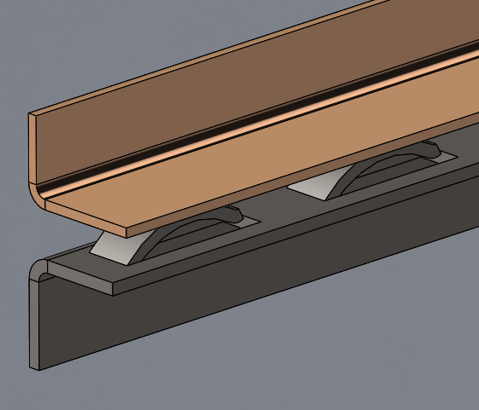

Figure 3: Spring finger guide design with cartridge brass heat sink and spring steel pressure application bracket

Due to time constraints within the project, the bottom bracket was replaced by a 3D printed part using PLA material. This 3D printed part was designed with simple spring fingers to be able to make calculations assuming them as a cantilevered beam. The force applied by the spring fingers could then be solved for by using the deflection equation:

$$δ=\frac{FL}{AE}$$

Where δ is the deflection of the beam, F is the force being applied to achieve the deflection, L is the length of the beam, A is the cross sectional area of the beam, and E is the elastic modulus of the material. Inputting the deflection based on the range of thicknesses of trays from 0.050-0.100 in. gave a full range of forces that would be applied. From these forces the contact pressure can then be determined suitable for the given application.

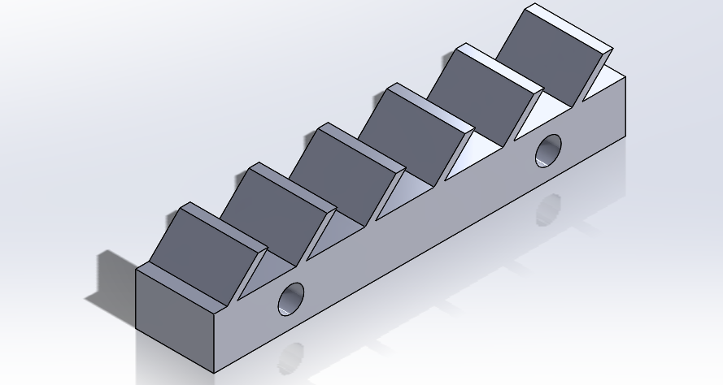

Figure 4: 3D printed spring finger bracket

# Future Work

For future thermal studies several goals should be considered upon moving forward. Currently the experimental setup controls overlap area, contact pressure, and material with regards to contact resistance. More studies could be conducted with a wider range of materials as the current test setup provides results that follow what is calculated by SolidWorks Flow-Sim modeling. With each given material a comparison to the resistance value of the stand-alone material would give a baseline comparison to how an interface between two samples compares to one stand-alone sample.

These thermal studies could be applied to future guide designs to ensure greater accuracy when running Flow-Sim models in SolidWorks. Applying these design concepts that were used the prototype design into a single piece part design.

# 6 Appendix

## I: Experiment 1

### Goal:

Gain a working knowledge of heat transfer through a simple geometrical configuration of the thermal card guide that can be applied to prototypes with more difficult geometries.

### Bill of Materials:

* Bell Chamber
* Pump
* ½” T-fitting
* Teflon tape
* ½” Valve
* ~3’ of ½” reinforced plastic tube
* 6x ½” screw type hose clamps
* Vacuum Gauge
* 6x 4-40 Screws
* 6x 4-40 Washer
* 6x 4-40 Nut
* 2x 50 Ω Resistors
* 0.06”x2”x4” Aluminum 5052
* 0.06”x2”x6” Aluminum 5052
* 0.03”x2”x0.88” Aluminum 502
* 8x 8 Gauge Electrical Wire
* 5x Type K Thermocouple
* 2x Type K Thermocouple Reader
* Power supply
* Plastic support block

### Setup:

**Figure 1:**  Shows our current test setup. The tray will be heated up from each side using 50 Ω resistors. (Right)

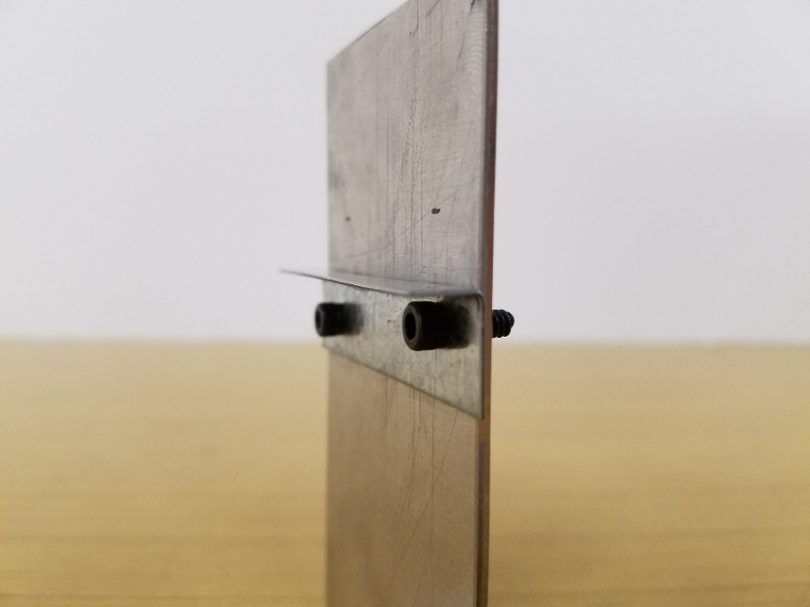

**Figure 2:** A close up of the wall and guide configuration. The guide is connected with two 4-40 screws. (Left)

**Figure 3:**  Bell chamber and pump setup. (Right)

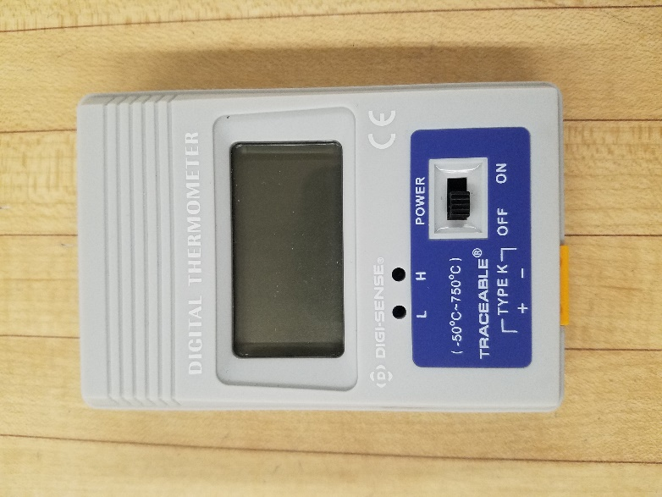

**Figure 4:** Type K Thermocouple Reader(Left)

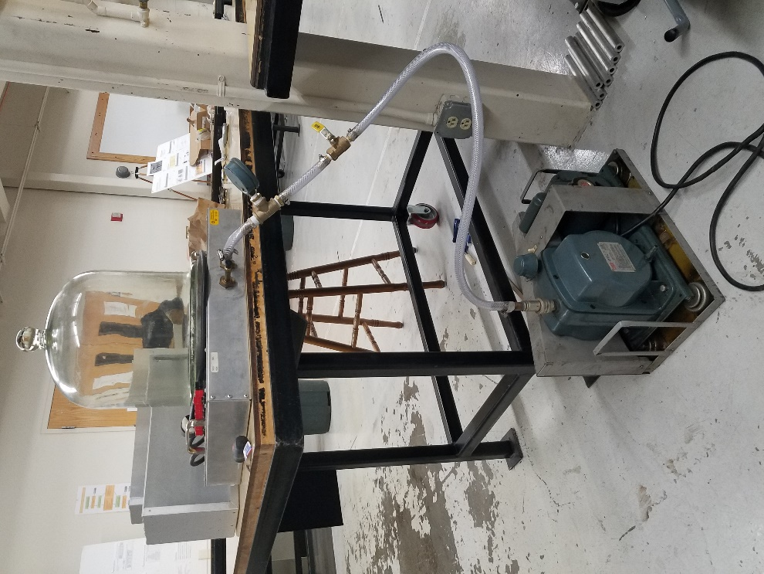

### Method:

Using the equation for the rate of conductive heat transfer and the equation for thermal resistance through a material the net resistance of the guide can be found. Five K-type thermocouples were placed in the system there designations and locations are shown below.

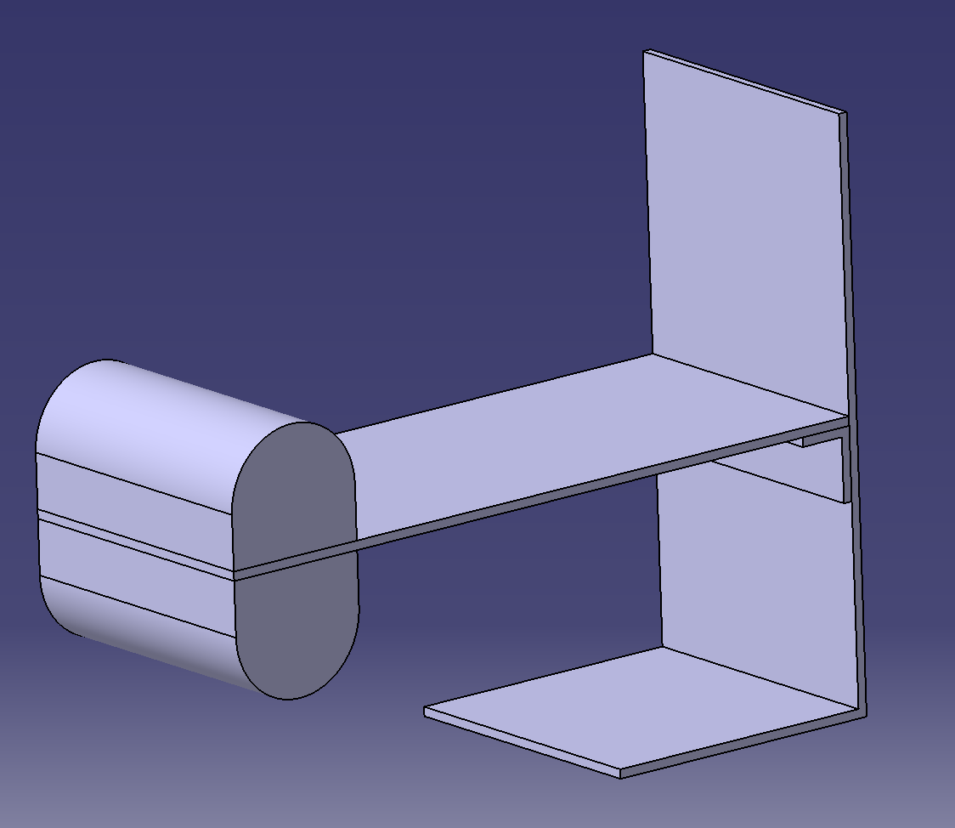

T_4

T_5

T_3

T_2

T_1

**Figure 5:** The locations of the thermocouples. Note that T_2 is located at the center of the beginning of the guide on top of the tray, T_3 is centered on the downward facing side of the guide, and T_5 is centered on the guide.

Using the temperature difference between locations 1 and 2, as well as the known material properties of the material conducting heat the net resistance of the guide can be found using location 1 as a reference. First the thermal resistance be1.085tween points 1 and 2 must be found using the equation:

$$R_{12}=\frac{L}{kA}$$

Where *R12­* is the thermal resistance of the tray in C/W. *L* is the distance between 1 and 2. *k* is the thermal conductivity of the material. In this case the material is H-32 5052 Aluminum with a thermal conductivity of 138 W/K-m. *A* is the cross-sectional area of the tray.

Once the thermal resistance between 1 and 2 is found the conductive power at point 1 can be found using the equations for conductive heat transfer.

$$\dot{Q_{1}}=\frac{T_{1}-T_{2}}{R_{12}}$$

With the conductive power known at point 1, the resistance between 1 and 5 can be calculated.

$$R_{15}=\frac{T_{1}-T_{5}}{{\dot{Q}}_{1}}$$

Then the net resistance of the guide can be calculated by finding the difference between *R15* and *R12.*

### Experiment:

With an input voltage of 11 V and a current of 1.085 A the input power was calculated to be 11.54 W, using the equation:

$$P=IV$$

This power was delivered to two 50 ohm resistors that were used to heat the tray to steady state, this process took 75 minutes. The graph shown below is displaying the temperature readings at each location of the K-type thermocouples until steady state was reached.

**Figure 6:** Shown above is the temperature readings throughout the experiment at each thermocouple locations. A reading was taken every five minutes. Steady state was determined after no significant change was seen in 20 minutes.

### Results:

*\*Note: A copy of all calculations performed in Engineering Equation Solver (EES) can be found at the end of the report.*

#### Experimental Analysis:

The conductive power at point 1 was found to be:

$$\dot{Q_{1}}=1.788 W$$

This an 85% power loss from the input. Most likely this is due to the fact that only about a third of the resistors are actually touching the tray, the rest of the power is being radiated into the atmosphere of the vacuum from the exposed surfaces of the resistors.

The net thermal resistance of the guide was found to be:

$$R_{net}=3.941 C/W$$

#### SolidWorks Simulation Analysis:

The figure below shows the results of the heat transfer simulation created to represent the experiment in SolidWorks. All calculations were performed using temperature readings from the same locations as the thermocouples in the experiment. These initial SolidWorks studies were no necessarily as accurate as the later studies. The learning process for how to use these tools was just getting started. In later experiments there is a trend of simplification of the systems which led to far more accuracy. This simulation was also conducted with the simple SolidWorks thermal study option instead of using the Flow-Sim add in. Though these initial studies may have not yielded accurate numbers, they did give the team insight into what the temperature gradient through the material would look like which was good information to have.

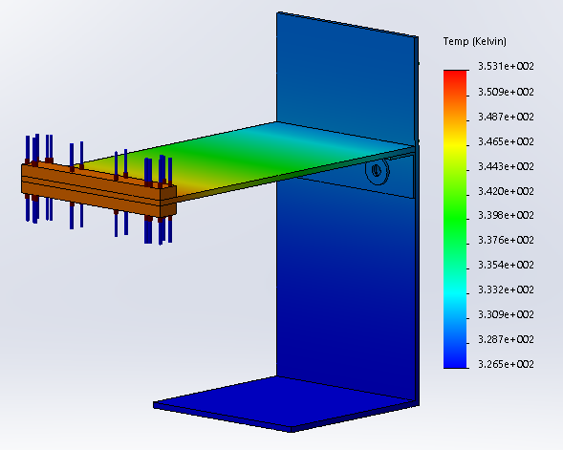

**Figure 5:** A heat transfer simulation in SolidWorks showing the temperature gradient, throughout the tray, guide and wall.

The conductive power at point 1 in the simulation is:

$$\dot{Q_{1SW}}=4.057 W$$

The net thermal resistance of the simulated guide is:

$$R_{25SW}=3.135 W$$

### Error Propagation:

The error propagation was performed using the roots squared method and is shown on the tables below.



**Table 1:** A table of the independent variables of the system.



**Table 2:** The dependent variables calculated at steady state.



**Table 3:** The measurement uncertainties of the system.



**Table 4:** The calculated uncertainty of each variable.

### Conclusions:

With this experiment we were able see where we could make improvements in our systems to produce models with higher accuracy. Some of the variables that we solved for were similar; for example there was only a 20% difference in the resistance from the real world and CAD models. We knew we were on the right track and that future iterations of this experiment were likely to be far more accurate. This gave us confidence moving forward.

### ESS:

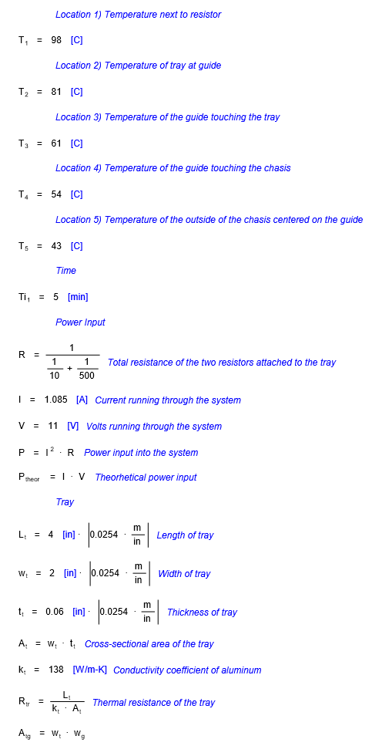

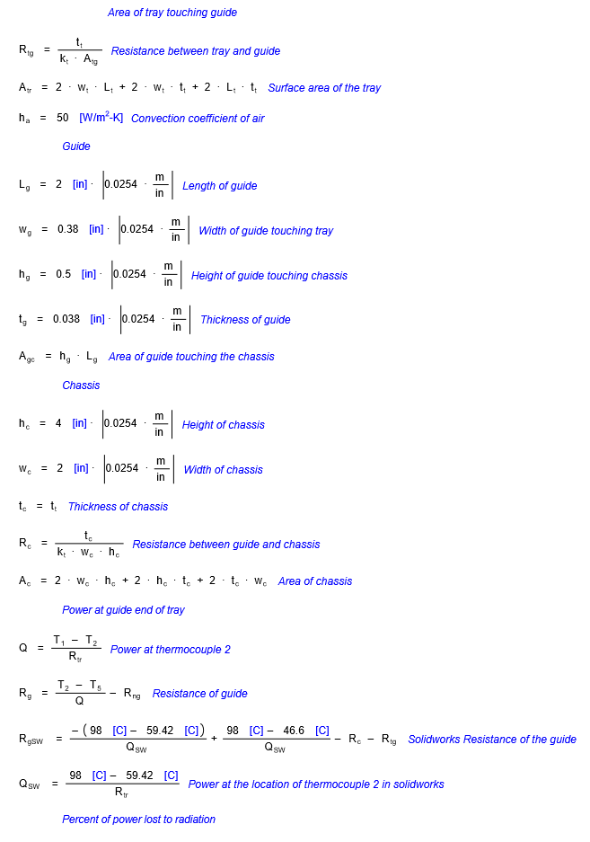

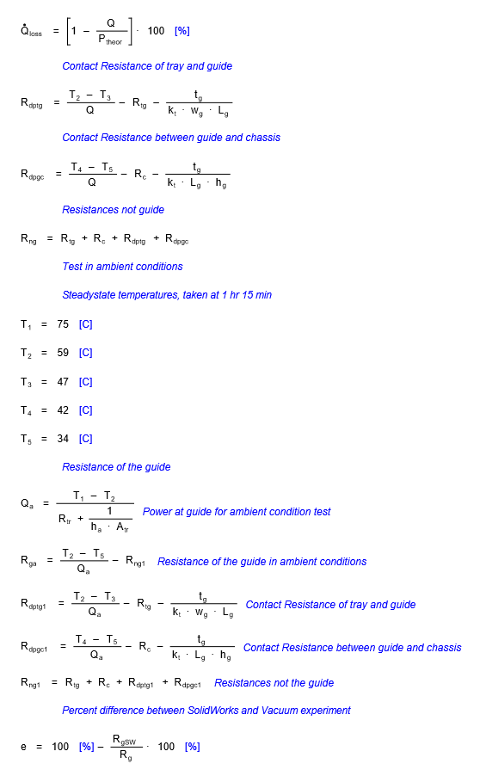

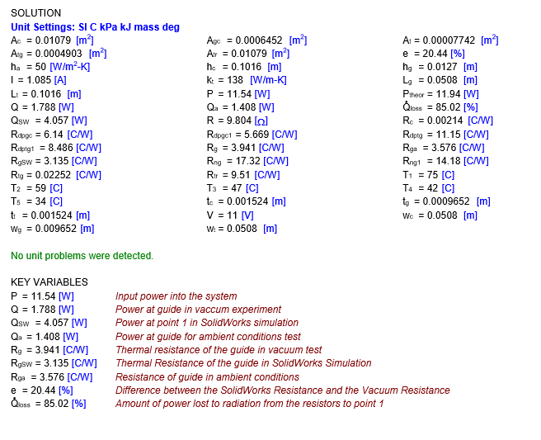

## II: Experiment 2

### Goal:

Understand resistances between interfacing points and through the metal itself. Then use our results to find unknown values through parametric studies with SolidWorks Flow-Sim. With these parameters known, they can be implemented into tests of prototype guide designs within SolidWorks and be verified by the experiment.

### Bill of Materials:

* Bell Chamber
* Power Supply
* Pump
* ½” T-fitting
* Teflon tape
* ½” Valve
* ~3’ of ½” reinforced plastic tube
* 6x ½” screw type hose clamps
* Vacuum Gauge
* 6x 4-40 Screws
* 6x 4-40 Washer
* 6x 4-40 Nut
* 2x 50 Ω Resistors
* 0.060” 5052 Aluminum
* 8x 8 Gauge Electrical Wire
* 5x Adhesive Type K Thermocouple
* 2x Type K Thermocouple Reader
* Plastic support block

### Setup:

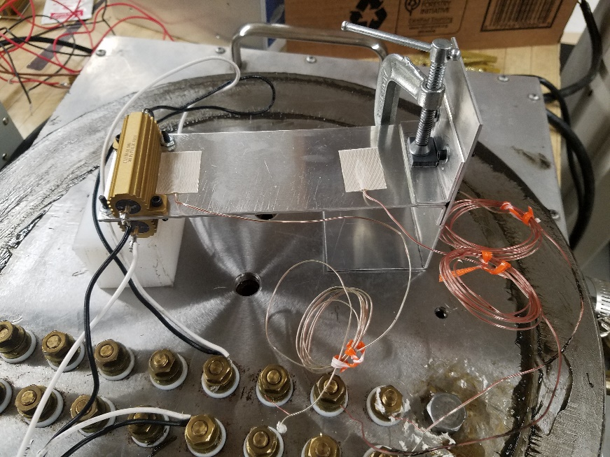**Figure 1:**  Shows our current test setup. The tray will be heated up from each side using 50 Ω resistors.

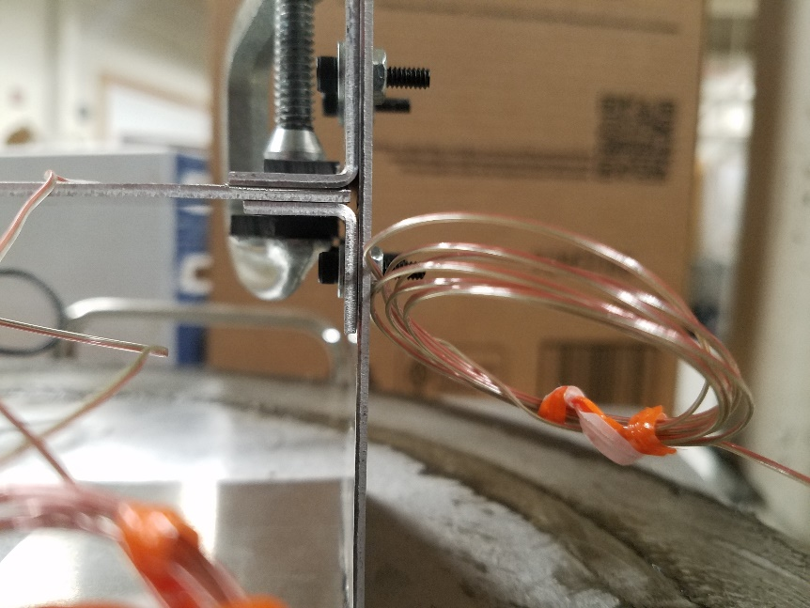

**Figure 2:** A close up of the wall and guide configuration. The guide is connected with two 4-40 screws. A C-clamp insulated with plastic is used to apply contact pressure to reduce contact resistance

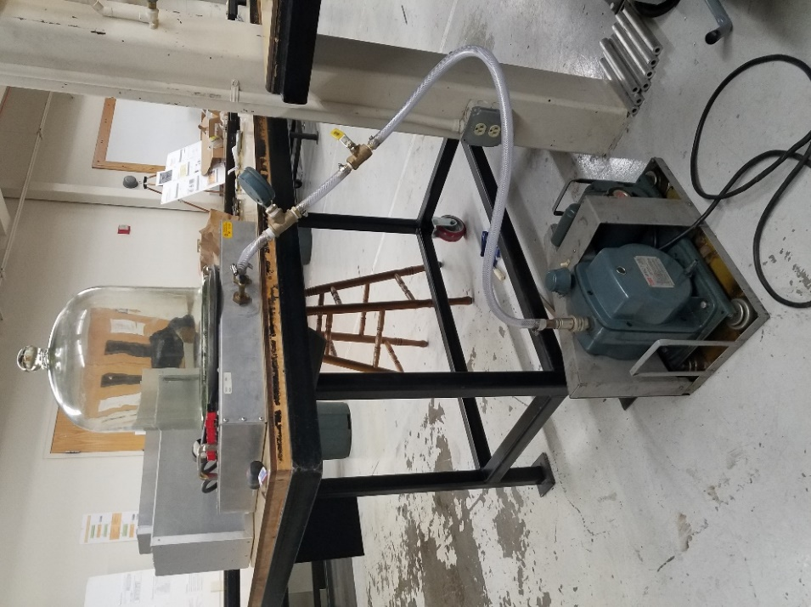**Figure 3:**  Bell chamber and pump setup. (Left)

**Figure 4:** K-type thermocouple reader. (Right)

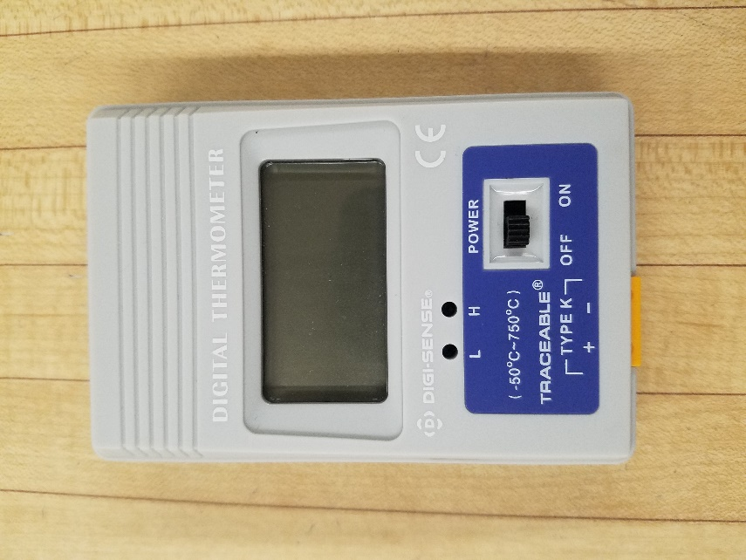

### Method:

Using the equation for the rate of conductive heat transfer and the equation for thermal resistance through a material the net resistance of the guide can be found. Three K-type thermocouples were placed in the system there designations and locations are shown below.

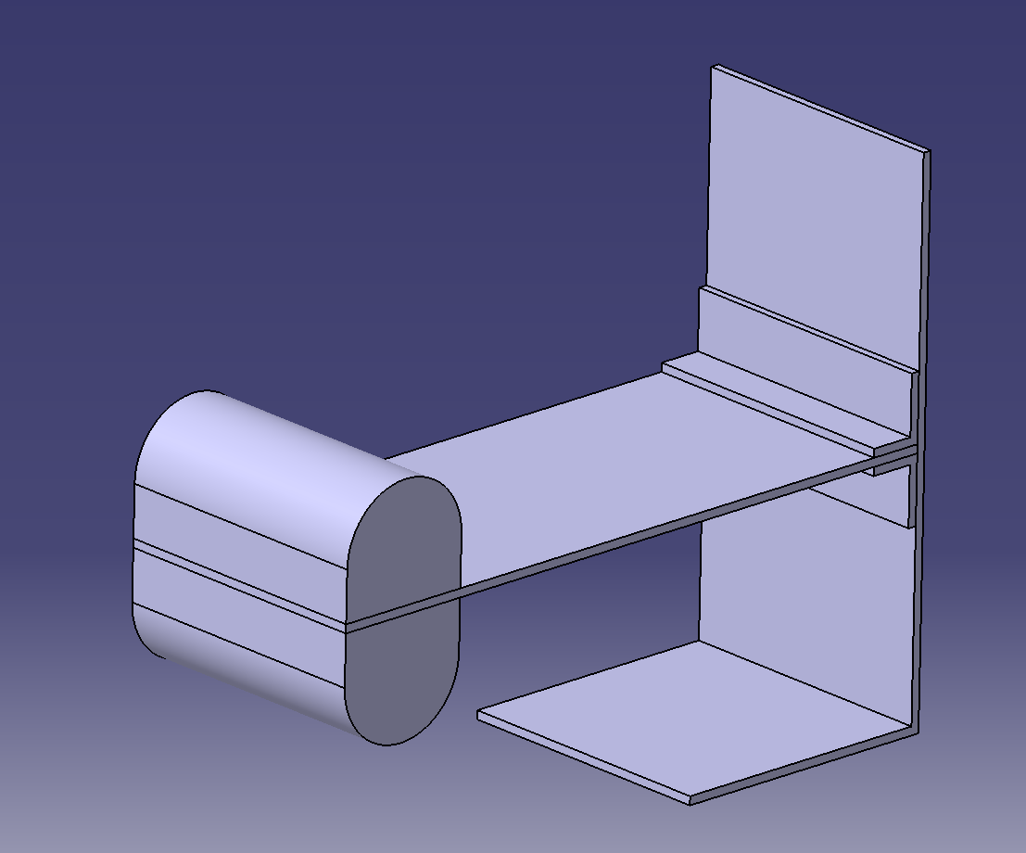

T_3

T_2

T_1

**Figure 4:** This picture displays the designations and locations of the K-type thermocouples. Not that T_3 is located at the center of the guide on the back side of the chassis.

Using the temperature difference between locations 1 and 2, as well as the known material properties of the material conducting heat the net resistance of the guide can be found using location 1 as a reference. First the thermal resistance between points 1 and 2 must be found using the equation:

Where *R12­* is the thermal resistance of the tray in C/W. *L* is the distance between 1 and 2. *k* is the thermal conductivity of the material and *A* is the cross-sectional area of the tray. In this case the material is H-32 5052 Aluminum with a thermal conductivity of 138 W/K-m. *A* is the cross-sectional area of the tray.

Once the thermal resistance between 1 and 2 is found the conductive power at point 1 can be found using the equations for conductive heat transfer.

With the conductive power known at point 1, the resistance between 1 and 3 can be calculated.

$$R_{13}=\frac{T_{1}-T_{3}}{{\dot{Q}}_{1}}$$

Then the net resistance of the guide can be calculated by finding the difference between *R13* and *R12.*

### Experiment:

With an input voltage of 6 V and a current of 1.122 A the input power was calculated to be 6.732 W, using the equation:

$$P=IV$$

This power was delivered to two 50 ohm resistors that were used to heat the tray to steady state, this process took approximately 70 minutes. The C-clamp placed at the guide is used to ensure a good contact between the guide and the aluminum tray. The thermal losses through the guide are assumed negligible, due to the small plastic spacers placed in between the clamp and the guide, which have an extremely low conductivity. The graph shown below is displaying the temperature readings at each location of the K-type thermocouples until steady state was reached.

**Figure 5:** Shown above is the temperature readings throughout the experiment at each thermocouple locations. A reading was taken every five minutes. Steady state was determined after no significant change was seen in 20 minutes.

### Results:

*\*Note: A copy of all calculations performed in Engineering Equation Solver (EES) can be found at the end of the report.*

#### Experimental Analysis:

The conductive power at point 1 was found to be:

$$\dot{Q_{1}}=3.754 W$$

This is about a 44% power loss from the input. This is extremely different from the 85% power loss in Experiment 1. Most likely this is due to the fact that we changed the attachment of the thermocouples from duct tape to an adhesive type thermocouple. This power loss seems much more realistic than that of Experiment 1.

The net thermal resistance of the guide was found to be:

$$R_{net}=4.528 C/W$$

#### SolidWorks Simulation Analysis:

The figure below shows the results of the heat transfer simulation created to represent the experiment in SolidWorks. All calculations were performed using temperature readings from the same locations as the thermocouples in the experiment. At this point, the bottom of the bell jar was being modeled with the rest of the system to simulate a large heat sink. In theory this would be a good way to simulate the environment, and maybe an individual who was well trained in SolidWorks Thermal FEA analysis would find some decent results, however we had far too many unknowns to accurately model the system. Again we found ourselves in a position where we solved for a fairly accurate representation of the temperature gradient but not one we were confident was producing accurate numbers. This shifted our goals slightly moving forward as we discovered how little we really know about contact resistance at the interfaces of metals.

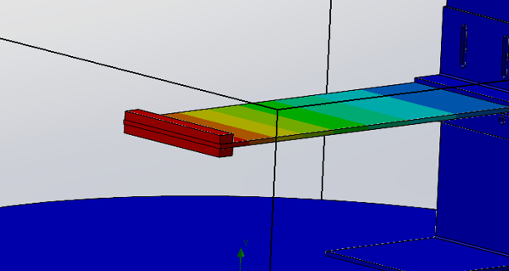

T3=27 ⁰C

T2 = 36⁰C

T1 = 54⁰C

**Figure 6:** Locations of thermocouples on the physical test setup (image from Flow-sim, color gradient can be neglected).

The conductive power at point 1 was found to be:

$$\dot{Q_{1SW}}=1.521 W$$

The net simulated resistance of the guide was found to be:

$$R_{net}=5.831 C/W$$

### Error Propagation:

The error propagation was performed using the roots squared method and is shown on the tables below.

|  |  |  |  |
| --- | --- | --- | --- |
| **Independent Variables** |  |  |  |
| **current** | **I** | **1.122** | **amps** |
| **voltage** | **V** | **6.732** | **volts** |
| **temp diff** | **DeltaT** | **17** | **DELTAC** |
| **Thermal Conductivity** | **k** | **138** | **W/m^2-K** |
| **Length** | **L_12** | **0.0960** | **m** |
| **Tray width** | **w_t** | **0.0517** | **m** |
| **Tray thickness** | **t_t** | **0.0016** | **m** |

**Table 1:** A table of the independent variables of the system.

|  |  |  |  |  |
| --- | --- | --- | --- | --- |
| **Dependent Variables** |  |  |  |  |
| Heat flux at 1 | Q_dot_1 | 2.0204 | W | **Q_dot_1=(T_1-T_2)/R_12** |
| Thermal Resistance Between 1 and 2 | R_12 | 8.4143 | C/W | **R_12=L_12/(k*A)** |
| Cross-sectional area of tray | A_t | 8.27E-05 | m^2 | **A_t=w_t*t_t** |
| Thermal Resistance Between 1 and 3 | R_13 | 16.8286 | C/W | **R_13=(T_1-T_3)/Q_dot_1** |
| Thermal Resistance Between 2 and 3 | R_23 | 8.4143 | C/W | **R_23=R_13-R_12** |

**Table 2:** The dependent variables calculated at steady state.

|  |  |  |  |
| --- | --- | --- | --- |
| **Measurement uncertainties** |  |  |  |
| Current | u_I_o | 0.0005 | amps |
| Volts | u_V_o | 0.005 | V |
| Temperature | u_T_o | 0.5 | C |
| Length | u_L_o | 0.0000127 | m |
| Thermal conductivity | u_k_o | 0.5 | W/k-m^2 |

**Table 3:** The measurement uncertainties of the system.

|  |  |  |  |  |
| --- | --- | --- | --- | --- |
| **Calculated Uncertainties with Root Sum Squared** |  |  |  |  |
| Cross-sectional Area of tray | u_A_t | 6E-7 | m^2 | **u_A_t=sqrt((u_L_o*w_t)^2+(u_L_o*t_t)^2)** |
| Thermal resistance between 1 and 2 | u_R_12 | 0.073 | C/W | **u_R_12=sqrt((u_L_o/(k*A_t))^2+(L_12*u_k_o/(k^2*A_t))^2+(L_12*u_A_t/(k*A_t^2))^2)** |
| Heat flux at 1 | u_Q_dot_1 | 0.061 | W | **u_Q_dot_1=sqrt((u_T_o/R_12)^2+((T_1-T_2)*u_R_12/R_12^2)^2)** |
| Thermal resistance between 1 and 3 | u_R_13 | 0.572 | C/W | **u_R_13=sqrt((u_T_o/Q_dot_1)^2+((T_1-T_3)*u_Q_dot_1/Q_dot_1^2)^2)** |
| Thermal Resistance between 2 and 3 | u_R_23 | 0.499 | C/W | **u_R_23=u_R_13-u_R_12** |

**Table 4:** The calculated uncertainty of each variable.

### Conclusions:

Test was completed in a vacuum scenario. We are still analyzing the effects of radiative heat losses from the assembly. This experiment still has some distance to cover as matching it to the SolidWorks Flow-Sim model has not been fully achieved. There is still 22% difference between the simulation and the actual experiment but this time the simulation was conservative. Whereas in Experiment 1 the simulation underestimated the thermal resistance of the guide.

Moving forward we need to focus on solving for the contact resistances of the interfaces of the materials we are testing. It is essential that we solve for this value so that we can use that number when testing our prototypes in SolidWorks.

### ESS:

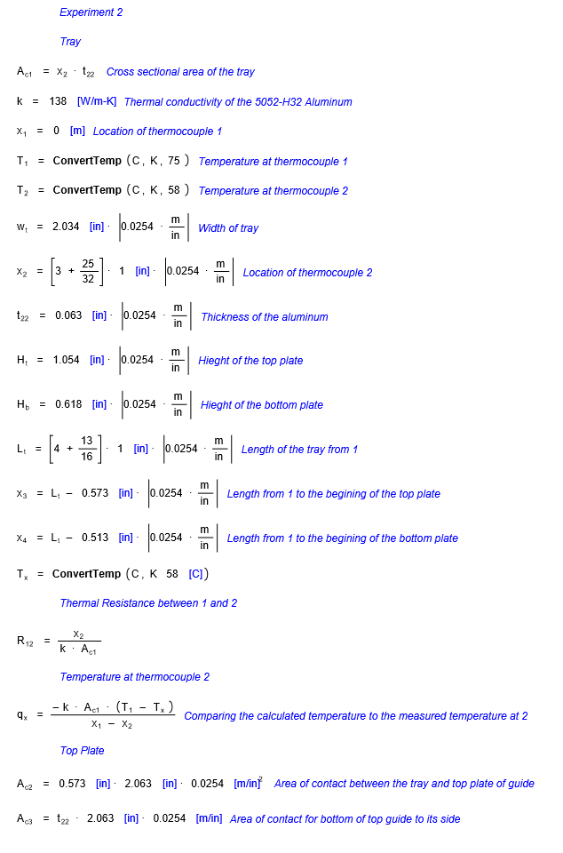

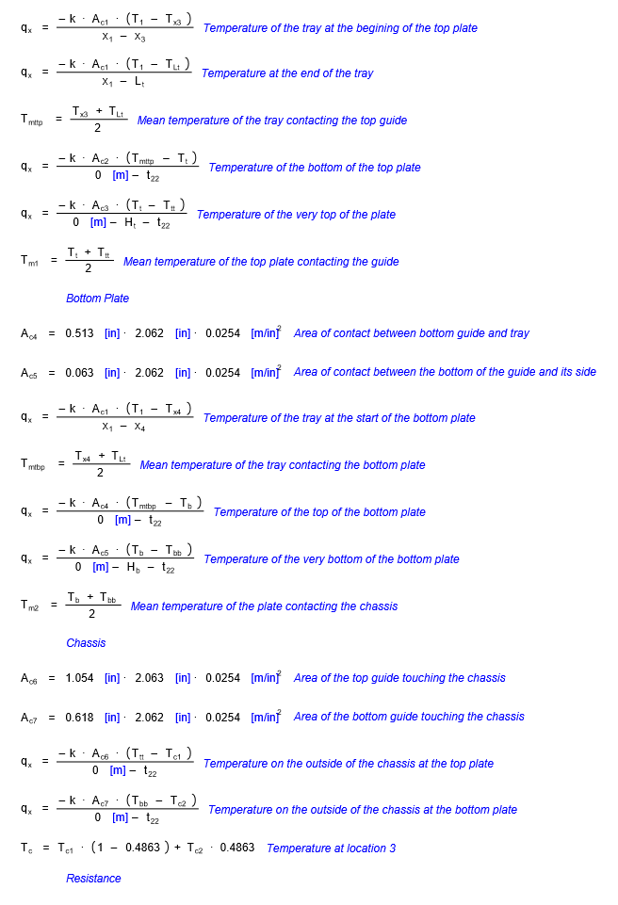

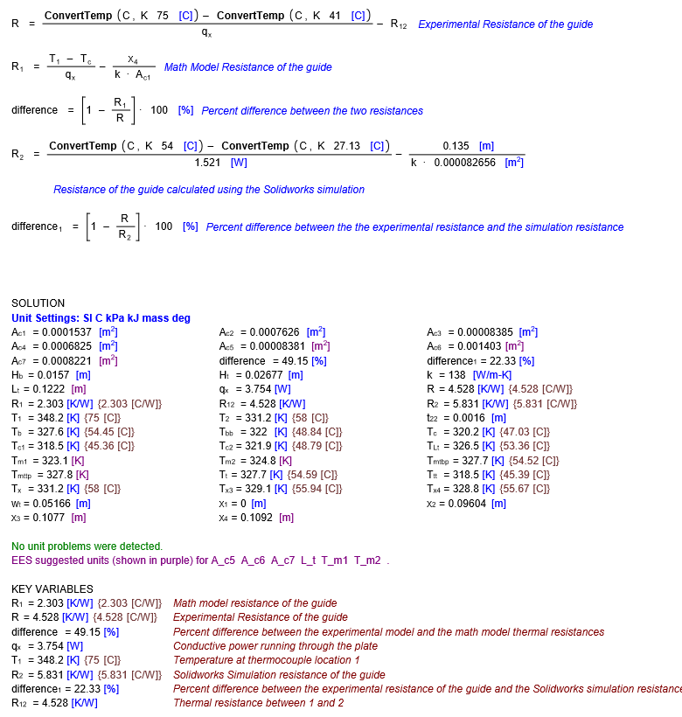

## III: Experiment 3

### Goal:

Determining contact resistances at different pressures in order to find a reasonable input for contact resistance into the SolidWorks simulation. Simultaneously, we will be comparing C26000 Cartridge Brass to H32-5052 Aluminum. The brass has similar conductive properties as the aluminum but avoids the high frictional resistance that aluminum on aluminum contact causes.

### Setup:

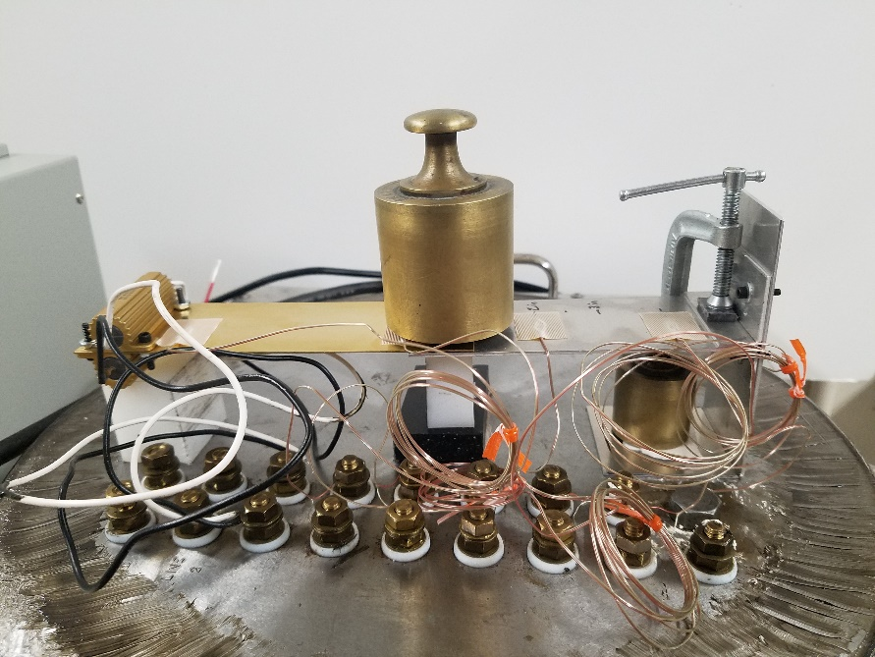**Figure 1:** The system setup with two thermocouples on the brass and aluminum trays and will be designated as 1-4 from left to right. A 1 kg and 2 kg were used to provide pressures of 7.8 kPa and 15.7 kPa respectively. The tray will be heated up by the two 50 ohm resistors. Note thermocouple 5 is center on the guide on the outside of the chassis.

T_5

T_4

T_3

T_2

T_1

**Figure 2:** Direct current power supply, used to supply the resistors with power in order to heat the tray.

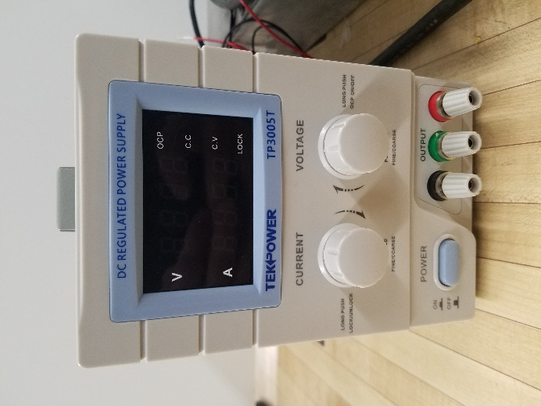

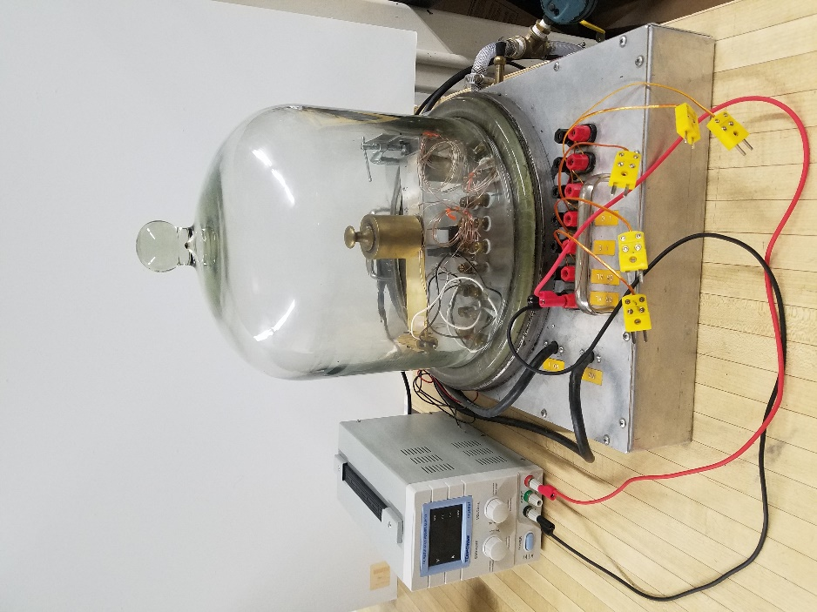

**Figure 3:** Bell chamber and power supply setup.

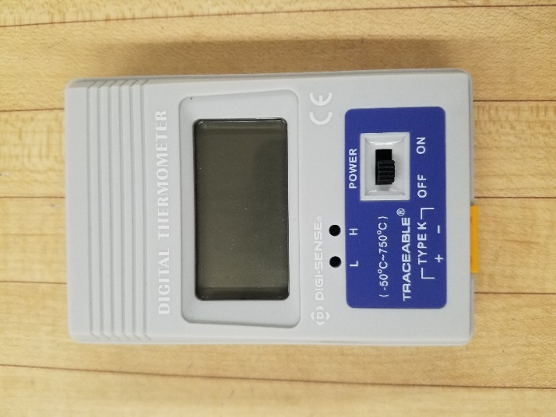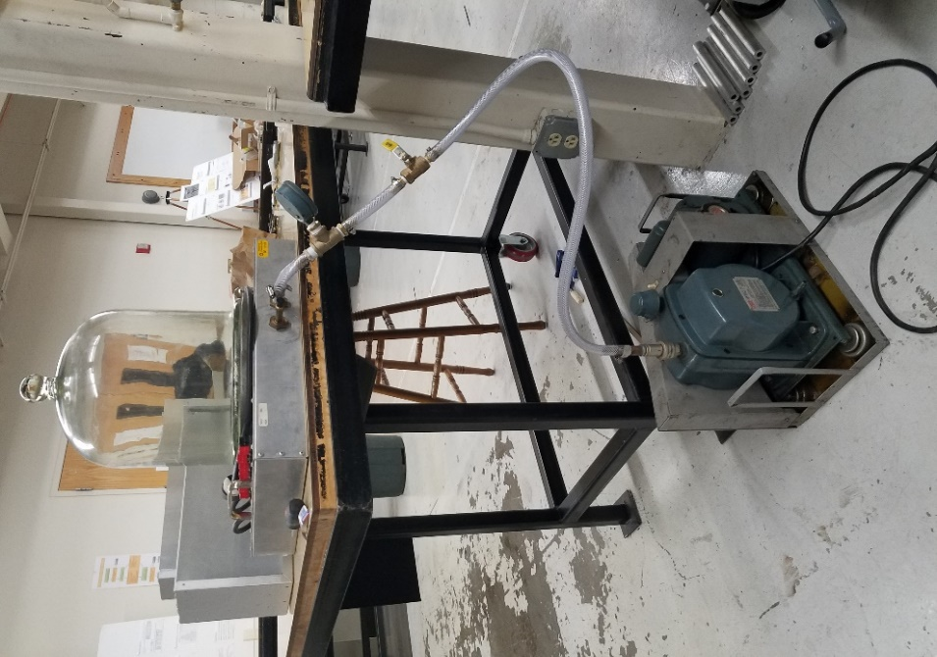  
**Figure 4:** Bell chamber and pump setup. **Figure 5:** K-type thermocouple reader.

### Method:

Using the equation for the rate of conductive heat transfer and the equation for thermal resistance through a material the net resistance of the guide can be found.Using the temperature difference between locations 1 and 2, as well as the known material properties of the material conducting heat the net resistance of the guide can be found using location 1 as a reference. First the thermal resistance between points 1 and 2 must be found using the equation:

Where *R12­* is the thermal resistance of the tray in C/W. *L* is the distance between 1 and 2. *k* is the thermal conductivity of the material and *AB* is the cross-sectional area of the material. In this case the material is C26000 Cartridge Brass with a thermal conductivity of 127 W/K-m. *A* is the cross-sectional area of the tray.

Once the thermal resistance between 1 and 2 is found the conductive power at point 1 can be found using the equations for conductive heat transfer.

With the conductive power known at point 1, the resistance between 1 and 3 can be calculated.

$$R_{13}=\frac{T_{1}-T_{3}}{{\dot{Q}}_{1}}$$

Then the net resistance of the contact area can be calculated by finding the difference between *R13* and *R12.*

The contact resistance can be found by dividing the net thermal resistance of the contact area by the contact area:

$${R''}_{contact}=\frac{R_{net}}{A_{contact}}$$

The thermal resistances of the brass and the aluminum can be compared on resistance per unit length and thickness, due to the differing material thicknesses and the differing thermocouple locations. The thermal resistance of the guide will be compared to the results from *Experiment 2*.

### Experiment:

With an input voltage of 6 V and a current of 1.106 A the input power was calculated to be 6.636 W, using the equation:

$$P=IV$$

This power was delivered to two 50 ohm resistors that were used to heat the tray to steady state, this process took approximately 60 minutes. The C-clamp placed at the guide is used to ensure a good contact between the guide and the aluminum tray. The thermal losses through the clamp are assumed negligible, due to the small plastic spacers placed in between the clamp and the guide, which have an extremely low conductivity. The graphs shown below display the temperature readings at each location of the K-type thermocouples until steady state was reached for each pressure.

*Contact Pressure of 7.8 kPa using 1 kg weight*

**Figure 6:** Shown above is the temperature readings throughout the experiment at each thermocouple location. Steady state was determined after no significant change was seen in 15 minutes.

*Contact Pressure of 15.7 kPa using 2 kg weight*

**Figure 7:** Shown above is the temperature readings throughout the experiment at each thermocouple location. Steady state was determined after no significant change was seen in 15 minutes.

### Results:

*\*Note: A copy of all calculations performed in Engineering Equation Solver (EES) can be found at the end of the report.*

#### Experimental Analysis:

The conductive power at points 1 and 3 was equal for each pressure and was found to be:

$$\dot{Q_{1}}=1.728 W$$

$$\dot{Q_{3}}=0.8833 W$$

The thermal resistance of the brass is slightly higher than that of the aluminum, which makes sense due to the brasses lower conductivity value.

$$\dot{R_{12}}=0.164 Km/W$$

$$\dot{R_{34}}=0.143 Km/W$$

The net thermal resistances of the guide varied unexpectedly at each pressure.

At 7.8 kPa: $R=2.264 C/W$

At 15.7 kPa: $R=1.132 C/W$

Ideally the thermal resistance of the guide should be the same since the pressure was only varied at the overlap of the plates. These test were ran on two separate days and the C-clamp could have been adjusted causing this change. The value at 7.8 kPa is also about half of the resistance found in *Experiment 2*, 4.528 C/W. Once again this can be attributed to the inaccurate use of the C-clamp. For future experiments it would behoove the group to find a different solution that is easily measured.

The contact resistance at each pressure is as follows:

At 7.8 kPa: $\ddot{R_{con}}=0.004481 Km^{2}/W$

At 15.7 kPa: $\ddot{R_{con}}=0.002987 Km^{2}/W$

These values are consistent with what was expected of the experiment, contact resistance should decrease as pressure increases.

#### Flow-Sim Parametric Study:

The experiment in the lab provided information needed to create an accurate model of the thermal system using temperature boundary conditions. Models of the two plates were created with the ends being the locations of T1 and T4 everything else in the system was neglected. We would then attempt to guess the contact resistance and check the results of T2 and T3 to the experimental results. Using the parametric study feature in Flow-Sim several contact resistances were listed and ran, helping to narrow down a range of values to study at higher resolution. This led us to use the range of numbers 1E-3 (K-m^2/W) to 9E-3 (K-m^2/W) because initial testing on a larger scale showed that 1E-3 (K-m^2/W) was fairly close. We are confident with this result, this is compounded by the fact that the model was monitoring the heat transfer rate at the interface and it was close to what we would have expected it to be due to radiation losses.

|  |  |  |  |  |  |
| --- | --- | --- | --- | --- | --- |
| Contact Resistance [°C-m^2/W] | T1 [°C] | T2 [°C] | T3 [°C] | T4 [°C] | Heat Transfer At Interface [W] |
| 1.00E-03 | 71 | 40.128 | 32.45 | 28 | 1.053625146 |
| 2.00E-03 | 71 | 40.58 | 32.29 | 28 | 1.018139552 |
| 3.00E-03 | 71 | 40.985 | 32.14 | 28 | 0.986358399 |
| 4.00E-03 | 71 | 41.357 | 32 | 28 | 0.956996562 |
| 5.00E-03 | 71 | 41.704 | 31.87 | 28 | 0.929523995 |
| 6.00E-03 | 71 | 42.03 | 31.75 | 28 | 0.903613797 |
| 7.00E-03 | 71 | 42.339 | 31.63 | 28 | 0.879278524 |
| 8.00E-03 | 71 | 42.629 | 31.52 | 28 | 0.856078303 |
| 9.00E-03 | 71 | 42.905 | 31.42 | 28 | 0.83419384 |

### Error Propagation:

|  |  |  |  |
| --- | --- | --- | --- |
| Independent Variables |  |  |  |
| current | I | 1.106 | amps |
| voltage | V | 6 | volts |
| temp diff | DeltaT | 31 | DELTAC |
| Thermal Conductivity | k | 127 | W/m^2-K |
| Length | L_12 | 0.0889 | m |
| Tray width | w_t | 0.0508 | m |
| Tray thickness | t_t | 0.0008 | m |

**Table 1:** A table of the independent variables of the system.

|  |  |  |  |  |
| --- | --- | --- | --- | --- |
| **Dependent Variables** |  |  |  |  |
| Heat flux at 1 | Q_dot_1 | 1.0028 | W | **Q_dot_1=(T_1-T_2)/R_12** |
| Thermal Resistance Between 1 and 2 | R_12 | 16.9532 | C/W | **R_12=L_12/(k*A)** |
| Cross-sectional area of tray | A_t | 4.13E-05 | m^2 | **A_t=w_t*t_t** |
| Thermal Resistance Between 1 and 3 | R_13 | 33.9063 | C/W | **R_13=(T_1-T_3)/Q_dot_1** |
| Thermal Resistance Between 2 and 3 | R_23 | 16.9532 | C/W | **R_23=R_13-R_12** |

**Table 2:** The dependent variables calculated at steady state.

|  |  |  |  |
| --- | --- | --- | --- |
| **Measurement uncertainties** |  |  |  |
| Current | u_I_o | 0.0005 | amps |
| Volts | u_V_o | 0.005 | V |
| Temperature | u_T_o | 0.5 | C |
| Length | u_L_o | 0.0000127 | m |
| Thermal conductivity | u_k_o | 0.5 | W/k-m^2 |

**Table 3:** The measurement uncertainties of the system.

|  |  |  |  |  |
| --- | --- | --- | --- | --- |
| **Calculated Uncertainties with Root Sum Squared** |  |  |  |  |
| Cross-sectional Area of tray | u_A_t | 6.45E-07 | m^2 | **u_A_t=sqrt((u_L_o*w_t)^2+(u_L_o*t_t)^2)** |
| Thermal resistance between 1 and 2 | u_R_12 | 0.27322 | C/W | **u_R_12=sqrt((u_L_o/(k*A_t))^2+(L_12*u_k_o/(k^2*A_t))^2+(L_12*u_A_t/(k*A_t^2))^2)** |
| Heat flux at 1 | u_Q_dot_1 | 0.04169 | W | **u_Q_dot_1=sqrt((u_T_o/R_12)^2+((T_1-T_2)*u_R_12/R_12^2)^2)** |
| Thermal resistance between 1 and 3 | u_R_13 | 1.49533 | C/W | **u_R_13=sqrt((u_T_o/Q_dot_1)^2+((T_1-T_3)*u_Q_dot_1/Q_dot_1^2)^2)** |
| Thermal Resistance between 2 and 3 | u_R_23 | 1.22211 | C/W | **u_R_23=u_R_13-u_R_12** |

**Table 4:** The calculated uncertainty of each variable.

### Conclusions:

From this experiment, two things can be concluded. With only a 13% difference between the conductive resistances of the aluminum and brass, functionally the brass could replace the aluminum as material for the guide. That being said the brass would be much more expensive. Secondly, if the desire is to reduce thermal contact resistance, pressure is one method of remedying this.

### ESS:

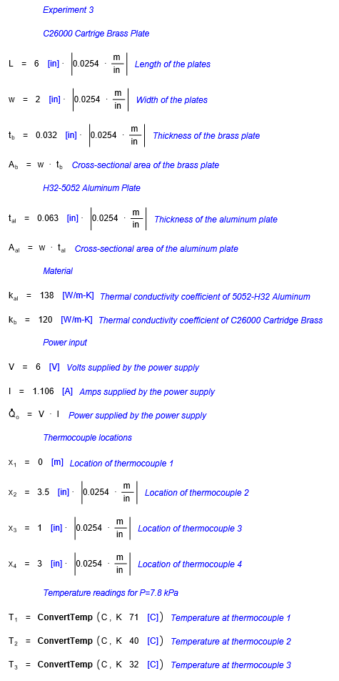

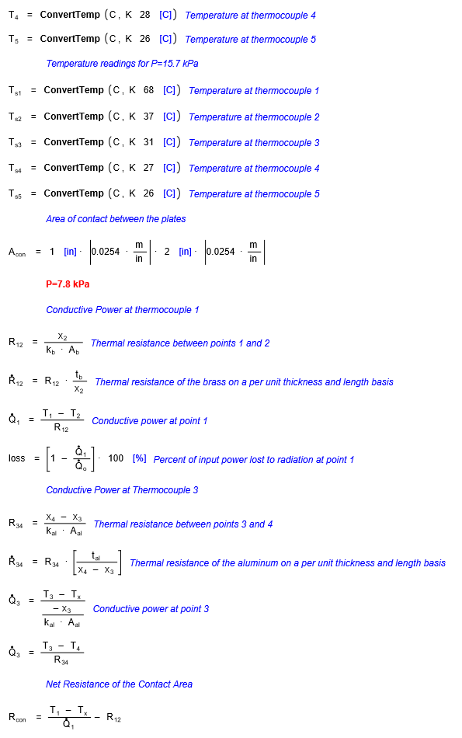

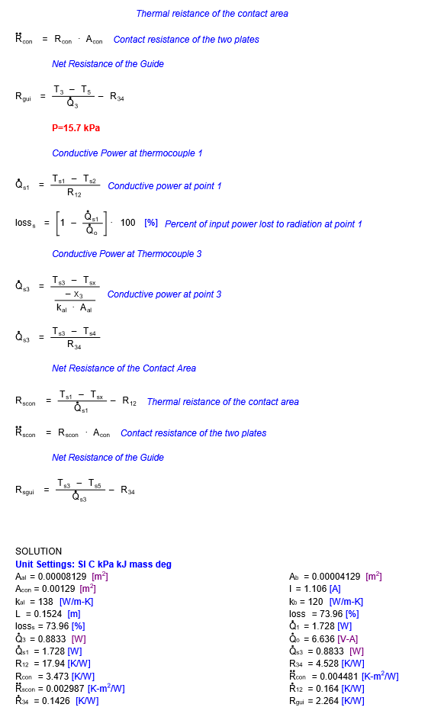

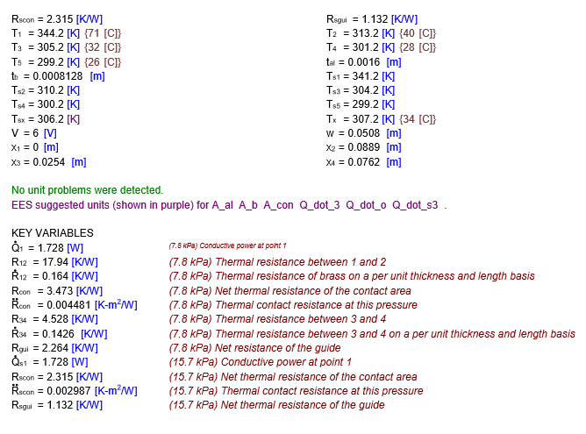

## IV: SEL Current Guide Design

