Dimensioning and Tolerancing with Model Based Definitions in CATIA V5

Tysen Buster
ME 421
April 26, 2018

Tolerancing the ME 410 Block Project

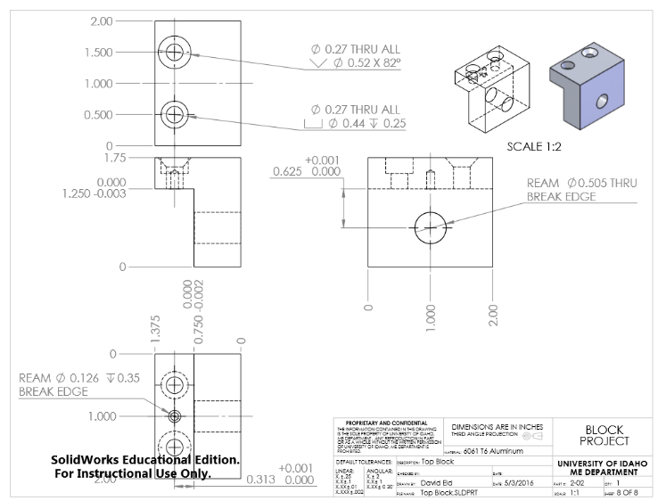
Top Block
Figure 1: Top block 2D drawing.
Creating the Top Block from the 2D drawing was a very straightforward process. There were no assumptions about size that had to be made.
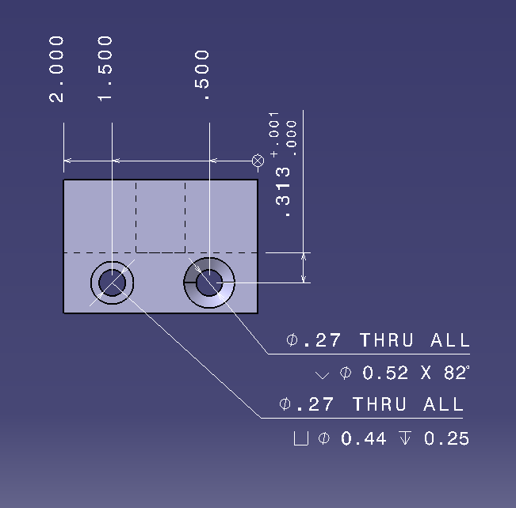
The basic block size dimensions and hole locations were added first using the dimension tool. Once that was completed, the tolerances were added. Tolerances were added using the “Dimension properties” toolbar at the top of the Functional Tolerancing and Annotation workbench (TOL_NUM2 was the selection used throughout this project). The upper and lower limits were added by right clicking on the dimension and moving to the tolerance tab of Properties. Significant figures were adjusted with the “Numerical Properties” toolbar. Finally, hole callouts were added using the “Text with Leader” tool. The “Insert Symbols” tool is found next to the dimension properties toolbar and was used to signify the different callout symbols.
Figure 2: Top view of Top Block.
The top view features the most information and includes the hole callouts and locations as well as the block depth. The side view features the block dimensions. The front view shows the center hole callout and locations.

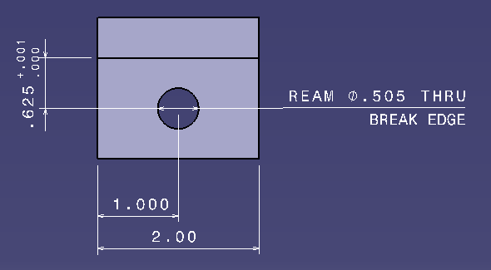
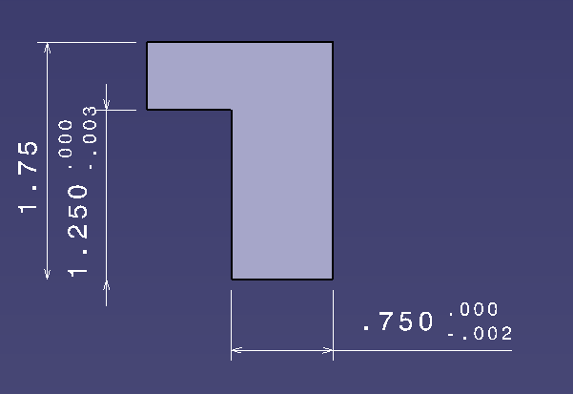
Figure 3: Side view of Top Block.
Figure 4: Front view of Top Block.
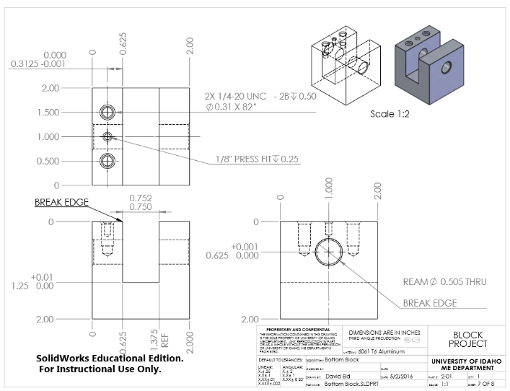
Bottom Block
Figure 5: Bottom Block 2D drawing.
The Bottom Block was created by making a simple square pad and pocketing a slot down the middle, and then adding the holes at the designated locations.
The block dimensions were added first for the top, side, and front view. The significant figures were adjusted with the “Numerical Properties” toolbar to align with the 2D drawing. Tolerances were added to the dimensions using the “Dimension Properties” toolbar. Hole callouts were then added with the “Text with Leader” tool and the various symbols were added with the “Insert Symbol” tool.
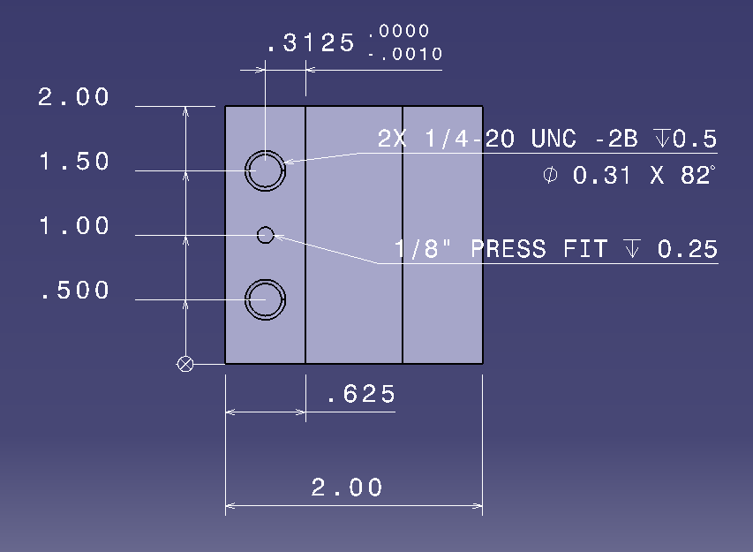
The views are very similar to the views found in the 2D drawing. Hole location dimensions use the same edge as the zero mark. The “REF” modifier indicates that the dimension is a reference and is not necessarily used in the machining process. CAD software also may place a reference dimension in parentheses isntead of adding the REF modifier.
The top bock will fit into the bottom block with maximum clearance of .004” and a minimum clearance of 0”. Machining for this part may want to lean into the tolerances to ensure a proper fit.
Figure 6: Top view of Bottom Block.
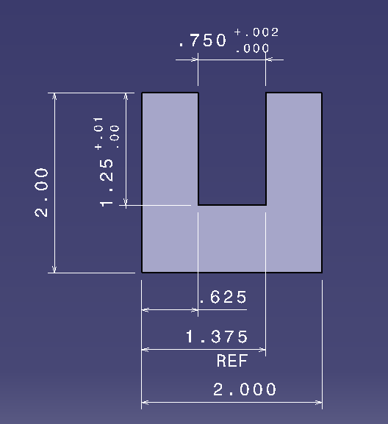
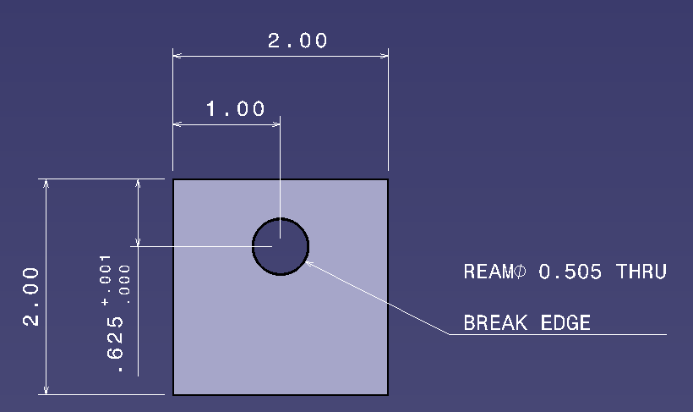
Figure 7: Front view of Bottom Block.
Figure 8: Side view of Bottom Block.

Female Lathe Part
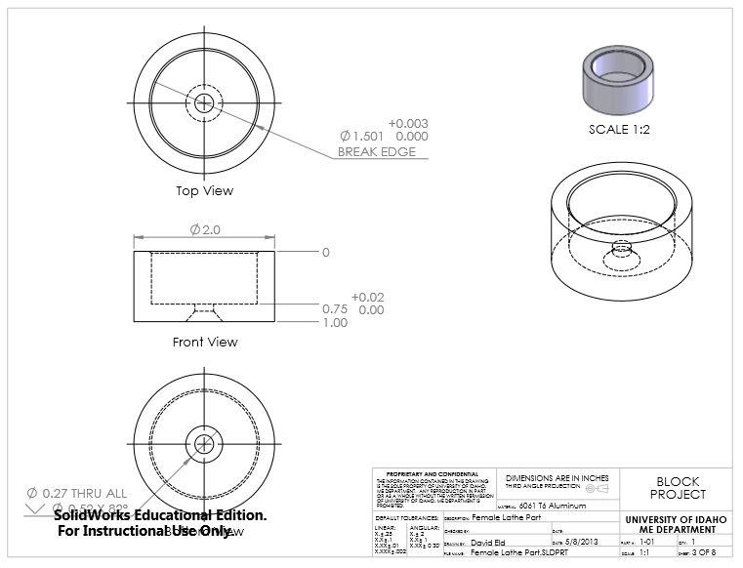
The Female Lathe Part was made with one circular pad and two concentric circular pockets.
After creating the part, the main size dimensions were added and adjusted to have the correct significant figures. These main dimensions include the outer diameter of the part and the total length of the part. Then the inner pocket was dimensioned and the hole callout was added. The “Break Edge” callout indicates that the edge should not be left sharp. This can be dulled by adding a chamfer to be made during the maching process.
Insead of showing a side view with the hidden lines and dimensions for the holes, the hole depths were added to the top view and include proper tolerances.
Figure 9: Female Lathe Part 2D drawing.
The slot that the Male Lathe Part will fit in will be up to .005” larger than the Male part when max toleranecs are used. The smallest amount of space between the two parts fiting together is .001”.
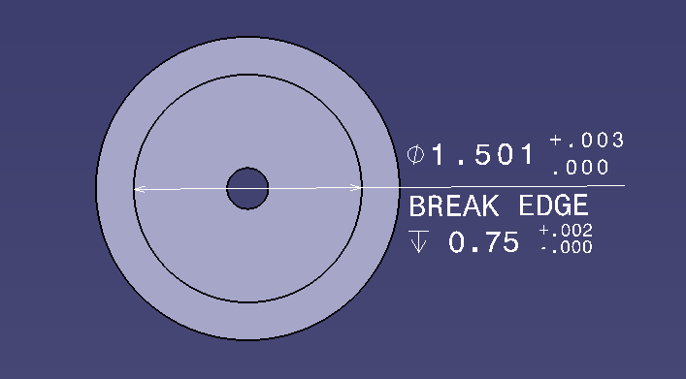
Figure 10: Top View of Female Lathe Part.

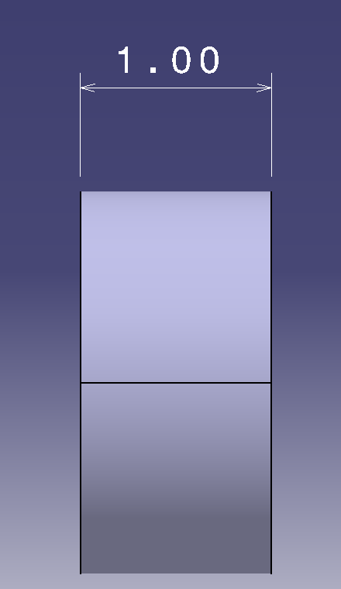
Figure 11: Side view of Female Lathe Part.

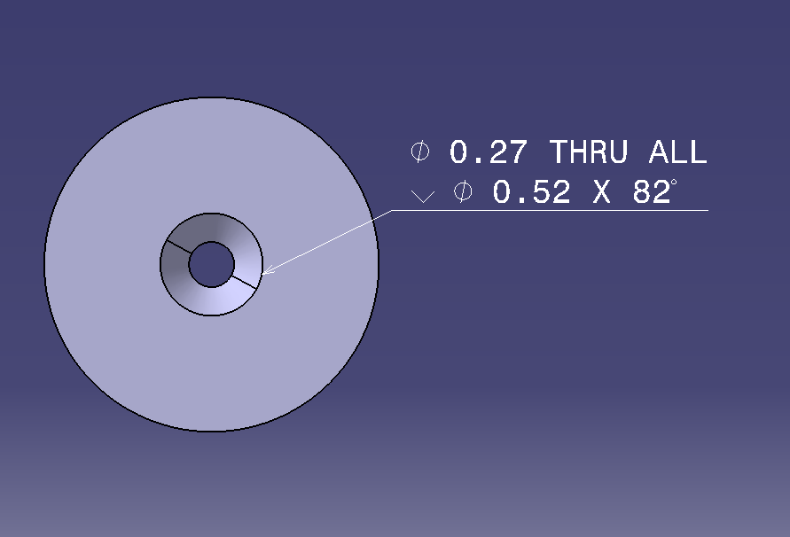
Figure 12: Bottom view of Female Lathe Part.

Male Lathe Part
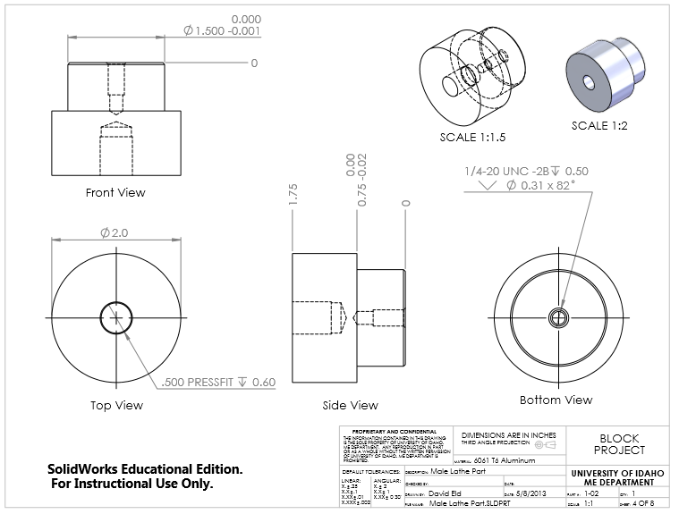
The Male Lathe Part was made with two pads and two pockets.
Figure 13: Male Lathe Part 2D drawing.
After adding the pad diameter dimensions and lengths using the “Dimension” tool, the hole callouts were added using the “Text with Leader” tool and the “Insert Symbol” tool. Proper significant figures were added using the “Numerical Properties” toolbar.
As stated before, the Male Lathe Part fits into the Female Lathe part with a clearance varying between .005-.001”. The Lathe fits into the Male Lathe Part with no clearance at all, meaning it will be a very tight fit.

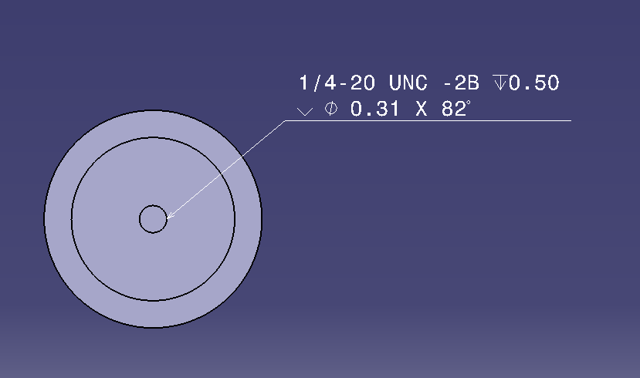
Figure 14: Back view of Male Lathe Part.

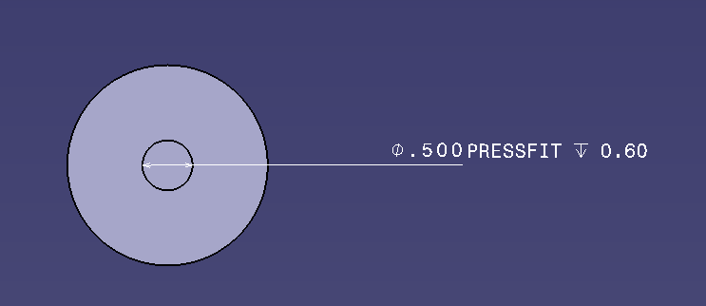
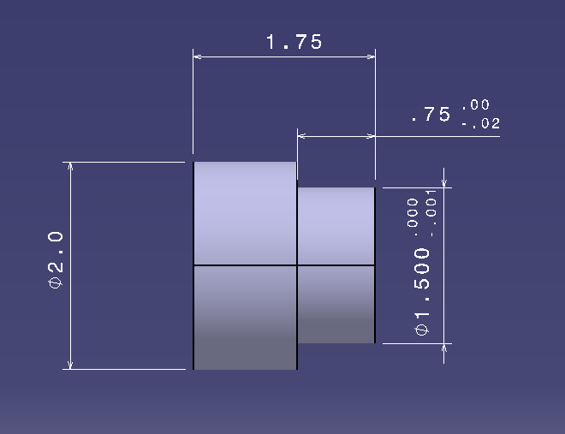
Figure 15: Front view of Male Lathe Part.
Figure 16: Side view of Male Lathe Part.
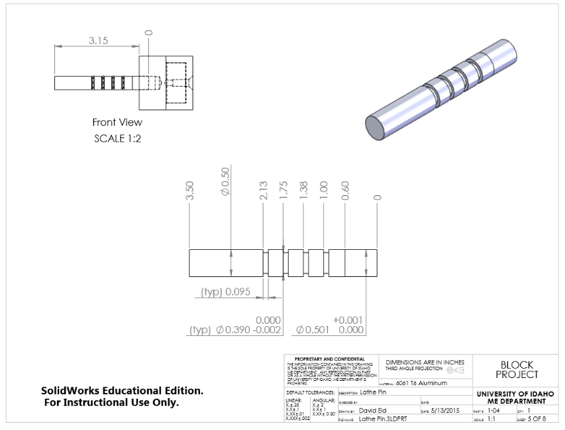
Lathe Pin
Figure 17: Lathe Pin 2D drawing.
The lathe pin was a simple part to create using different circular pads.
Length locations for the various diameters were added first and the proper significant figures were applied using the “Numerical Properties” Toolbar. Then the different diameter dimensions were added. Tolerances were added using the “Dimension Properties” toolbar and through the “Properties” menu for each dimenison. Finally, the “(typ)” modifier was added to the two dimensions shown using the “text” tool. (typ. Signifies that any other features on a part that are left undimensioned, but look like the typ. feature, are to be dimensioned as the typ. feature)
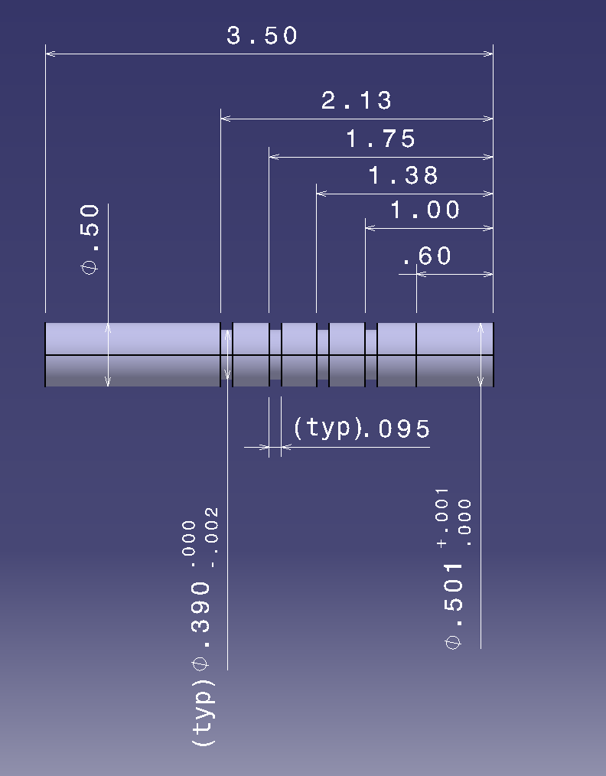
Figure 18: Side View of Lathe Pin.

2-D Drawing Package vs. Model Based Definitions

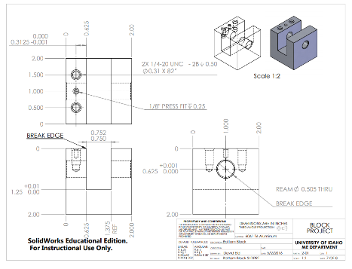
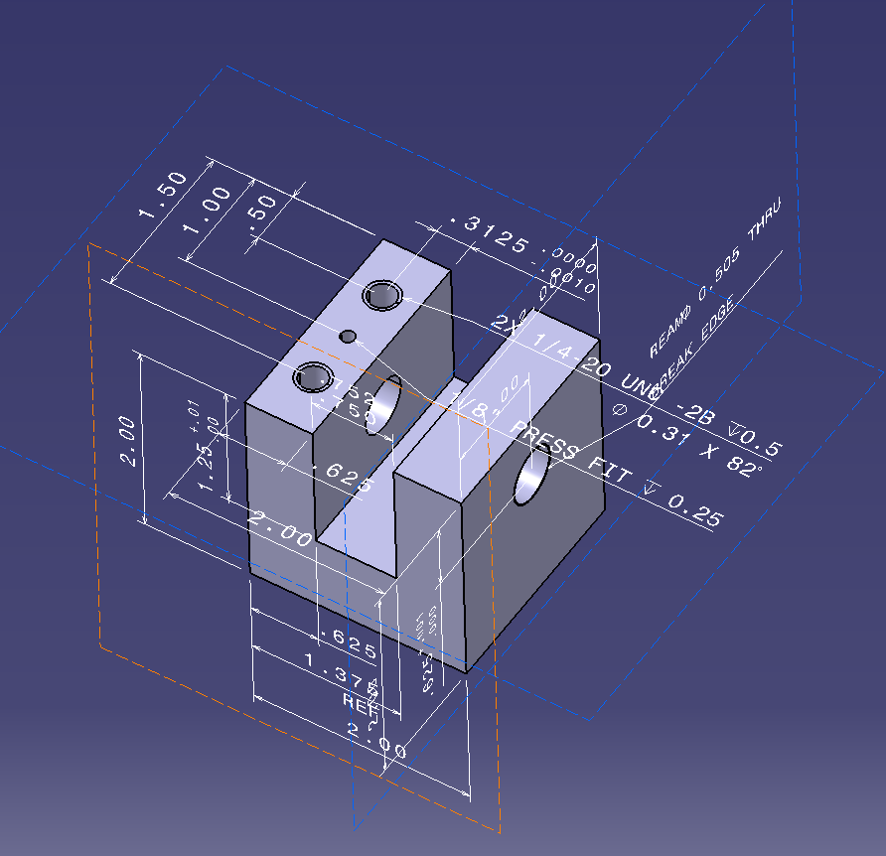
At first glance, a model based definition might seem like a cluttered mess and the 2-D drawings may become more appealing. However, after spending some time learning the in’s and out’s of model based definitions, they can provide additional uses and features. While the model based definition can be broken down into 2-D views that are essentially pieces of a drawing package, they have many advantages over a traditional drawing package.
Figure 19: A traditional drawing of a part from University of Idaho's ME 410 Block Project.
Figure 20: A cluttered view of a model based definition part from the University of Idaho's ME 410 Block Project.

Figure 21: Alternative isometric view of the same part found with the MBD.
______________________________________
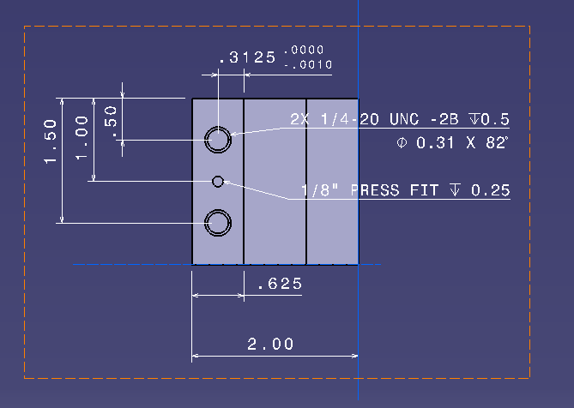
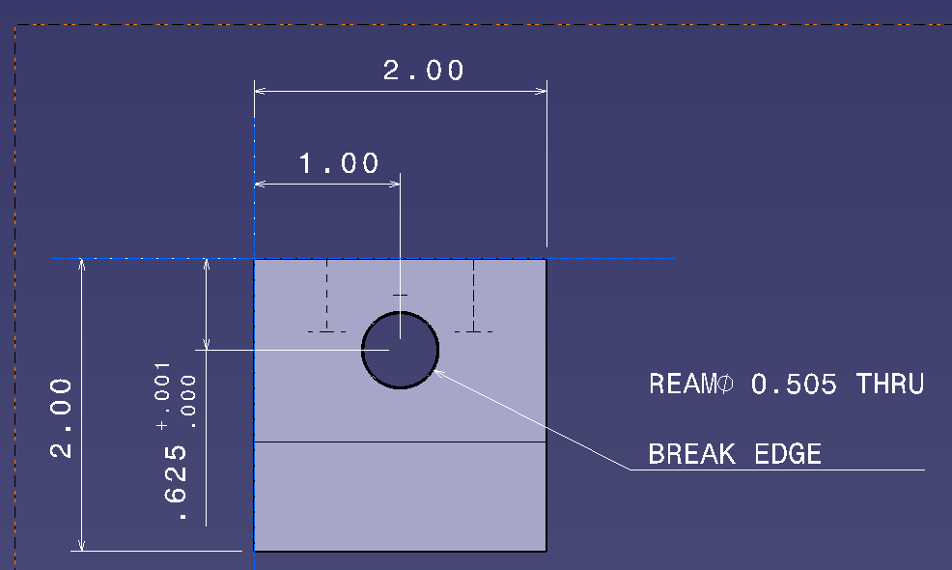
Firstly, the part/product can be manipulated to any view that the user desires. The primary views featuring dimensions and GD&T data can be found in a 2-D drawing, but other views can be utilized with ease. The user can also reveal hidden lines at the touch of a button. The user can also explore the relationships between the parts in a product and see how they work real time. This can be a huge time saver for understanding larger assemblies with complex part relationships.
Figure 22: Primary views found in a 2-D drawing, shown in an MBD.
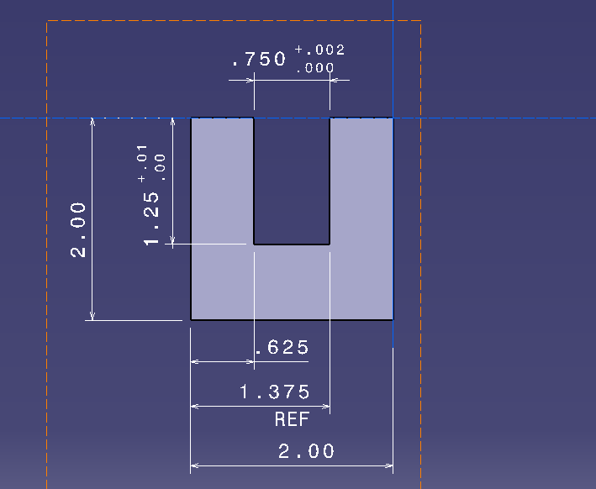
____________________________________________________________________________________
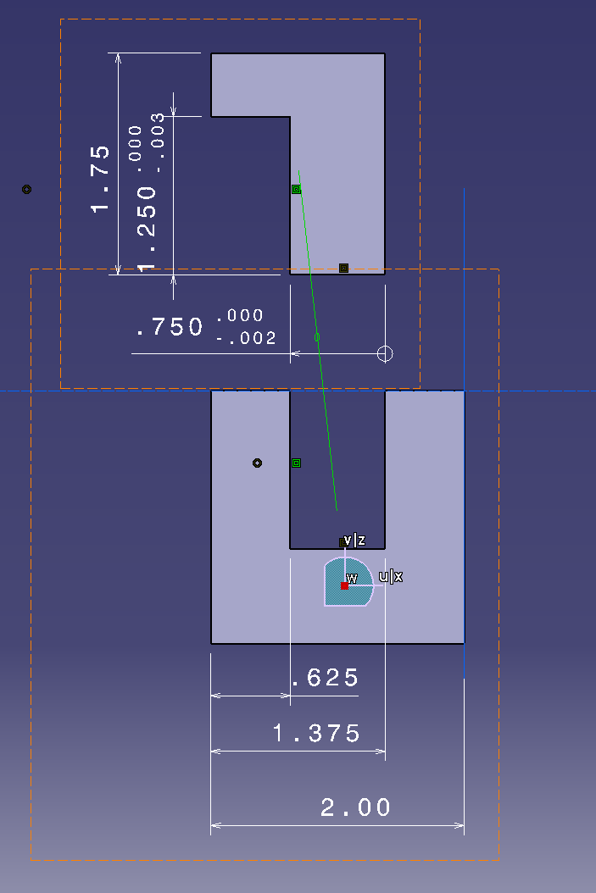
Secondly, the tolerances can also be directly compared in the digital assembly to verify proper part design. Also, a tolerancing wizard can keep track of tolerances on other parts and make sure an improper tolerance isn’t made that conflicts with another. Tolerances and geometric features can also be adjusted on the fly as needed and the tolerance advisor will still check for any conflicts. This is crucial and allows the designer to worry less about keeping track of tolerance relationships/part fit and focus more on part function.
Figure 23: Dimensions and tolerances are compared between two parts to verify the fit between them.
_____________________________________________________________________________________
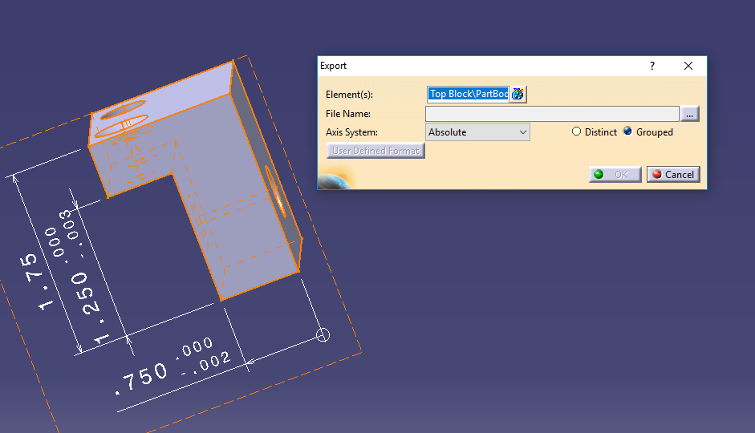
Thirdly, digital models allow for rapid prototyping of products. Where applicable, the model can be uploaded to a 3-D printer. This can cut down on valuable machining time and allow for faster analysis of form and function of parts in physical world, and therefore allow more time for alterations. Alternatively, the digital model can be machined via a computer numerical controlled machine (CNC machine) and a materially accurate model can be created. As a prototype is refined and is approaching the final product, having a model based definition can also make the machining process much easier by mapping it out digitally and giving estimated time to complete the part. CATIA even features a STL Rapid Prototyping workbench.
Figure 24: A part being exported as an STL file in the STL Rapid Prototyping Workbench. STL files are a common file extension for 3-D printers.
_____________________________________________________________________________________
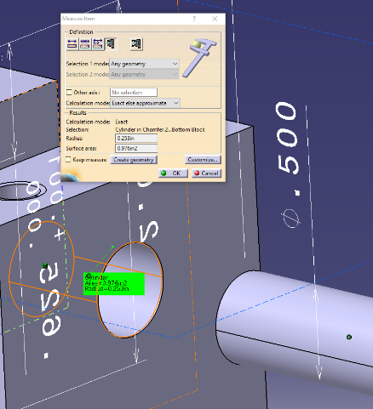

Finally, a model based design fills any gaps that may have been included in a 2-D drawing package. If a manufacturer noticed a missing dimension in a drawing package, they would have to go through the potentially time consuming process of contacting the designer and tracking down the necessary information. With a model based definition, the manufacturer can simply refer to the digital model and gather the required dimensions for themself. Not to mention that paper costs will become nearly nonexistent.

Figure 25: A pin hole is missing a dimension. However it is easy to determine the hole radius for machining and to verify that the pin will fit by using the tools available with an MBD.

_____________________________________________________________________________________
While model based definitions have many advantages over a traditional drawing package, they do have potential drawbacks. With a variety of 3-D modeling programs available, compatibility between manufacturer and designer could potentially be an issue. A universal file type may be developed in the future to become solve these issues. Similarly, manufacturers may rely on traditional drawing packages and won’t be able to accept MBD designs. And finally, a switch to a MBD designs can be costly, especially upfront. Equipment costs can be quite high upfront, and licenses need to be renewed each year. Companies are cautious about switching over to a new system when the current system is functional. They are instead using MBD’s in addition to 2-D drawings. The drawings are slimming down and any additional information desired is found in the 3-D MBD.
_____________________________________________________________________________________
In conclusion, model based definitions have many valuable features that can provide additional information over a 2-D drawing package. It allows the user to access different views not shown in a 2-D drawing, allows tolerance comparison in individual parts and in product assemblies, eases the rapid prototyping process, and gives the manufacturer more direct access to part and product dimensions. However, while MBD’s are becoming a key supplement to 2-D drawings, the former won’t be outright replacing the latter in the near future.

http://www.business-advantage.com/blog/cad-trends-2016-results-of-worldwide-survey/

