Michael Johnson
Paul Sowinski
Kyle Pflueger

CATIA Kinematics Tutorial

Overview:
This tutorial will explain how to create a simple piston engine, animate it and run kinematic analysis. From constraining the parts, creating joints and commands to analyzing the data in both CATIA and Excel, this tutorial will show the basics steps as well as a few trouble shooting solutions to this process.

Constraining the Part

- It’s really important that the product is fully assembled and can work how it was design in the assembly workbench.
- While this doesn’t seem all that important it not only saves time when entering the DMU kinematics portion, but also allows for any unseen problems to be fixed earlier on
- The product should be able to work properly when the manipulate button is selected, also with respect to constraints checked, and maneuvered

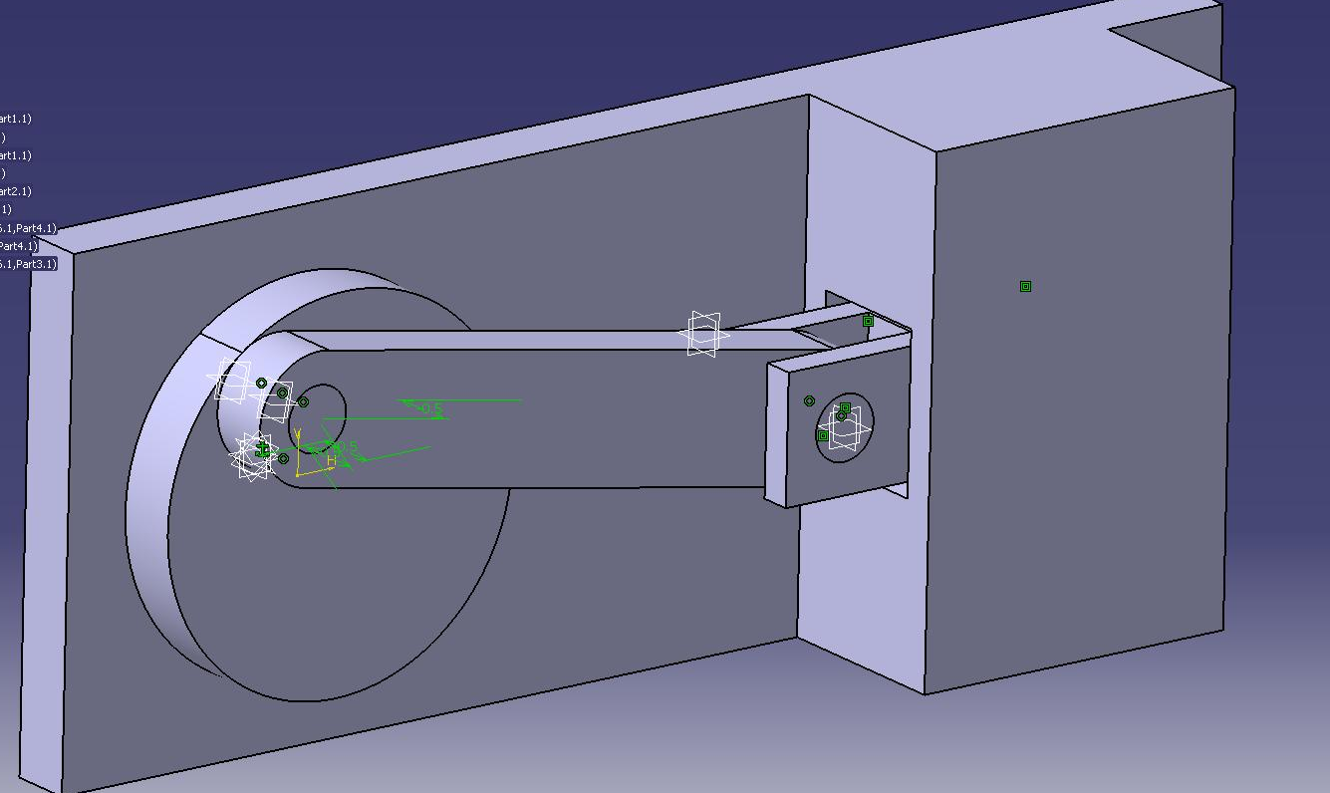

Importing into the DMU workspace/ converting constraints

- Select the kinematic workbench under, the Digital Mock Up tab, in the start menu
- Once inside the Kinematics workbench select the assembly constraints conversions and the wait for the constraints to become joints.

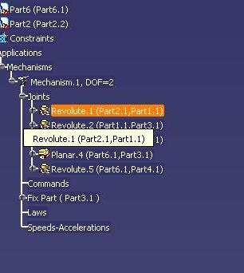
- Once the mechanism has been created, go through the joints in the tree and double click on the
- joints that need to be defined to limit the DOF’s (degrees of freedom).
- One you have double clicked on the particular joints, it will then create a command.
- If you are defining a revolute joint, select angle driven in the menu and set the boundaries.
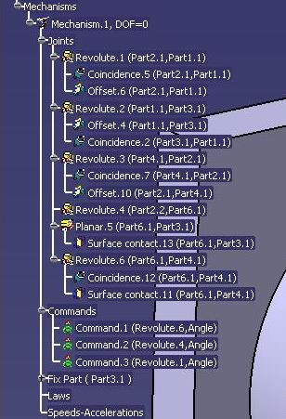
- Here you can see the Commands that have been generated.
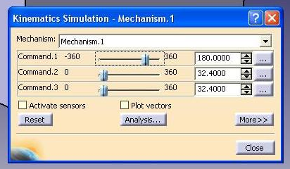
- Now you can select the Simulation button and slide the Commands previously created through their range of movement.
- By simply sliding the bars you can determine which Command will drive the simulation.
- Also, remember which Command it is, so later it will be easy to define a time based formula.

- Here is the Mechanism Analysis menu. It will tell you the status of the mechanism and whether enough Commands have been added to fully define it.
- Select the Command which you want to be the focus of the Simulation by either clicking or dragging the slide that corresponds with the Command.
- Then in the window on the right select insert.
- The button below the “skip to start” button can be toggled to three different settings. The current setting plays through once and stops at the end.
- The drop down box on the right allows you to set how quickly the animation plays.
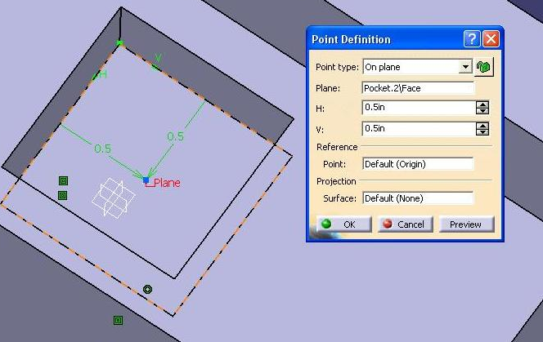
- To output the data for a point we must first have a point to track. To create one just double click on a component and define a point.
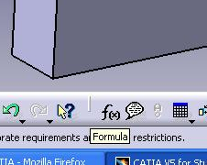
- Click on the formula button, or select it within the menu.
- Select the Command you wish to constrain with time, click add formula. Edit the field.
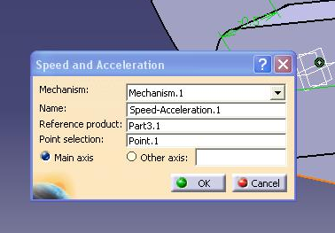
- Click on the “Speed and Acceleration” button to access this menu.
- Select a stationary part as a “reference product”, in this case the engine block.
- Then select the point you wish to track, the point that was just created.
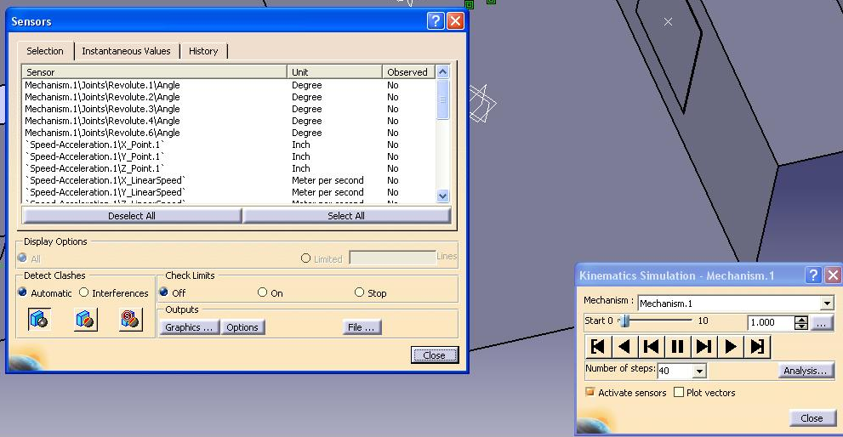
- Now click “Simulation with Laws”, the window on the right will appear.
- You can set the overall run time (and thus cycles) by clicking the ellipsis.
- You can adjust the quality of the animation and data by changing the number of steps. This can be a manually input number or one selected in the drop down menu.
- Once you check “Activate sensors the window on the left will appear; now you can select which pieces of data you want to output data for. “Graphics” will show you a graph within CATIA, “File” will allow you to export the data to Excel.
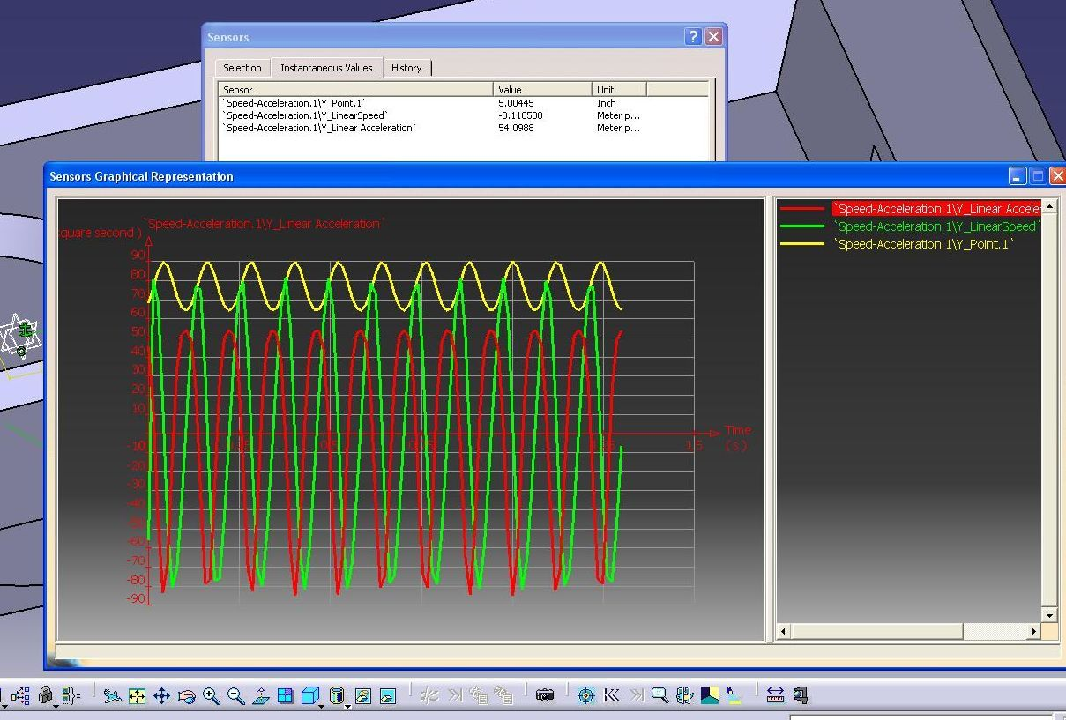
- In the sensors box you must select what you wish CATIA to analyze. In the selection tab toggle values you wish to have analyzed by clicking on them, this will change the ‘No’ in the observed column to ‘Yes’. To ensure you have the appropriate values being observed, enter the instantaneous values tab, this will list all of the values selected.
- Prior to simulating it is important to go into the history tab in the sensor box. Be sure to clear the history. If this step is ignored output of data may be misleading.
- With the sensors activated, run the kinematic simulation. This will collect the desired data. Clicking “Graphics” allows for a review of the data. Export the data to Excel by clicking “File”. The document output will have columns titled the same as the titles in the selection tab.

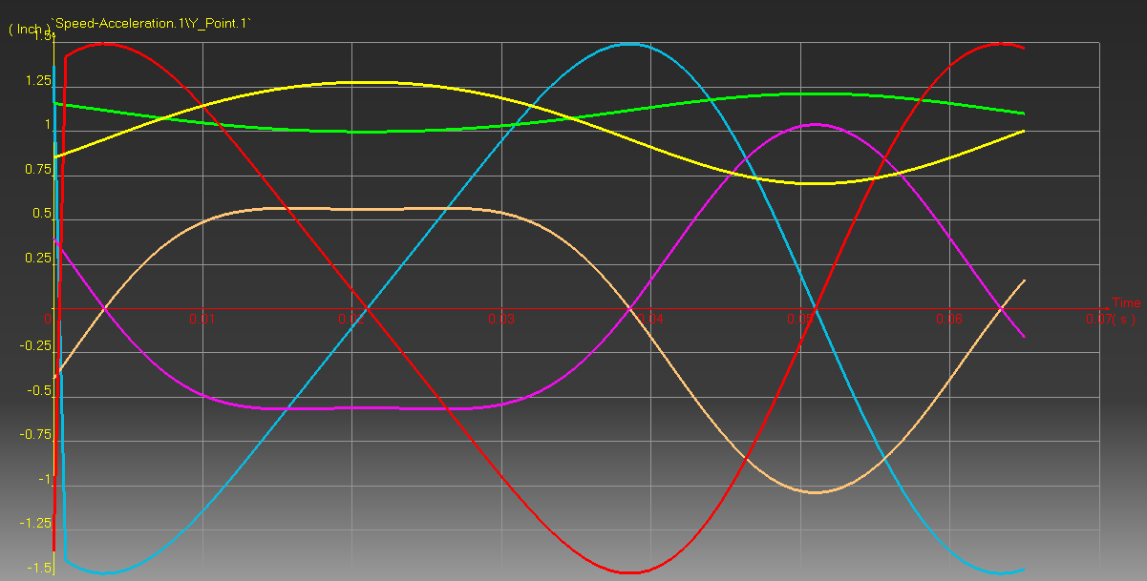

- These are the types of charts CATIA can save. The drawback to these is you can only view one scale/one unit at a time, which can be confusing when you have 3,4,5… different things graphed requiring different scales and or units.

- Here is some data charted in Excel from the spreadsheets exported into Excel. The advantage to these is that you can chart everything separately so it is very clear.
- Also you can easily calculate mean piston speed, add in a column for angular displacement, or many other customizations.
- One thing to be wary of is that CATIA will report data (speeds, accelerations, et cetera) with respect to major axes- not in relation to your parts or any, necessarily, easily conceived conventions. While the engine in this simple tutorial happened to be aligned with a simple axis, had the piston traveled at skewed angle, it would have been necessary to resolve the data to reflect that. Easily done in Excel, albeit.

