TITLE BLOCK TEMPLATE TUTORIAL

This tutorial will walk you through the process of creating a CATIA drawing with a University of Idaho specific title block. First, we will go over how to load the part/product drawing views. Second, we will explain how to add the title block, and third, how to populate the title block via part/product properties and sheet properties.

- Load Part/Product
  - Open Catia V5
View Creation Wizard Button
  - Open the part/product document that you wish to draw
  - Enter the Drafting Workbench by going to: Start Mechanical Design Drafting
    - To load a part onto the drawing sheet, click on the “View Creation Wizard” button, and complete the prompts for sheet layout as desired:

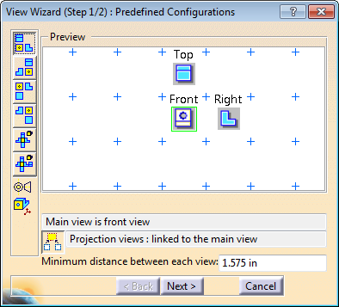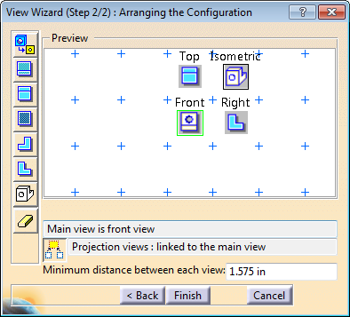

    - You should now be prompted at the bottom left of the CATIA screen to: “Select a reference plane on a 3D geometry.” To do this, click on “Window” at the top of the screen and select your part/product file from the dropdown tab.
    - The part/product file will automatically appear and you will be prompted to select a face to be the front view of the drawing. When an appropriate face is hovered over the “Oriented Preview” box will appear as shown in the figure to the right.
    - When a face has been selected, you will automatically return to the drafting workbench, where your part/product will be displayed in the previously selected views. The boxes surrounding each individual view will remain green until you click elsewhere on the screen at which point they will turn blue – the selected view will display a red box. While the boxes are green the orientation of the front view can be manipulated using the large blue arrows in the top righthand corner of the screen. Examples are shown below.

- Adding the Title Block
To add the title block, go to “Edit” and select “Sheet Background” from the dropdown menu. This allows one to add a title block to the sheet background.
*A part/product does not have to be added to the sheet to implement the title block, but because it pulls data from the part/product file to populate select fields it is advised. Also note that if a part/product is not loaded in CATIA at all when the drawing is initiated you will not be able to add views to the drawing.

  - Click on the “Frame and Title Block” button to access the available title blocks.
Frame and Title Block Button
  - If you are working in IPS units select: “UI_TitleBlock_Standard_Fall2013” from the dropdown menu. If you are working in SI units select: “UI_TitleBlock_Metric_Fall2013” from the dropdown menu.
†Both of the UI title block templates should be located in the CATIA default directory. If the above selections are not available please see the instructions at the end of this tutorial on how to access the backup macro directory.
  - From the “Frame and Title Block” button there are six selections to choose from:
    - CreateLayout:
This field creates the frame, page border, and auto-fills the cells of the title block.
    - DeleteAll:
This field deletes all sheet background material.
    - Update:
When changes have been made to the part/product file (i.e. part properties have changed), apply “Update” to update the changes made to the title block.
    - AddRevision:
This field adds a revision block to the top right hand corner of the sheet. The revision block auto-populates the revision number and date. User is prompted by an input box for the revision engineer’s name and comments.
    - DrawnBy:
This field prompts for the drafter to enter their name via an input message box and auto-populates the date field. It should be used when the “DrawnBy” field is empty or should be updated.
    - ReviewedBy:
This field prompts for the reviewer to enter their name via an input message box and auto-populates the date field
  - Upon creation of the title block (using the “CreateLayout” selection) an input box will prompt for the drafter’s name. Once this field is populated it will not prompt for the drafter’s name again (unless the title block is deleted and recreated). The title block will automatically populate select fields from the part/product file, and should look similar to the following:
*Note: see section #3 for more information on auto-population

  - When the title block is finalized go to “Edit” and select “Working Views” to exit the sheet background.
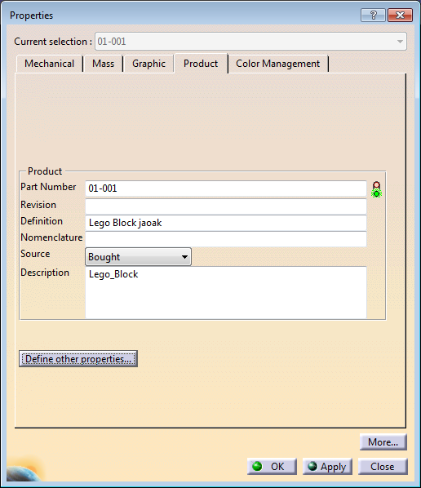
- Populating the Title Block
  - Part/Product Properties: Switch to the part/product document. To edit an auto-populated field enter part properties by right clicking on the product in the design tree (top-most entry), and select “Properties.” Go to the “Product” tab and fill in the following text fields appropriately:
    - Part Number
    - Description
*Note: Project name and quantity must be defined by the user in order for the title block to be fully populated. The procedure for both is as follows:
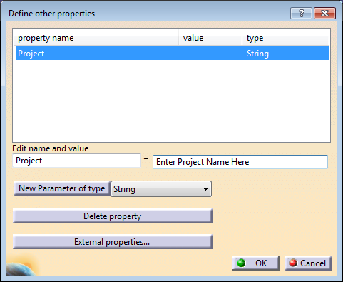
    - Project Name: In product “Properties” under the “Product” tab click the “Define other properties…” button. Next select “string” from the dropdown menu and click on the “New Parameter of type” button. This creates a new property. Next enter “Project” into the name field as shown, and set the name of your project equal to this entry. Select “OK” to create the property for the project name field.
    - Quantity: The same process used to create the project name property will be used to create the quantity property. Again select the “Define other properties…” button, except this time select “integer” from the dropdown menu. Click on the “New Parameter of type” button and enter “Quantity” into the name field. Set this new field equal to the quantity of parts you wish to be displayed in the title block.
** Once these fields have been created, they may be revised in the product properties window on the “Product” tab without having to redefine them.

When finished select “OK” and exit out of the “Properties” dialogue box. Before saving the part/product make sure a material has been assigned:
    - Material: Material should be assigned to the part/product and should be visible in the design tree. It is preferred to have the material assigned to the PartBody as opposed to the product; however, the title block will search for a material assignment in both locations.
Save the part/product

  - Sheet Properties: Return to the drafting workbench to adjust any relevant sheet properties. Make sure the drawing is in “Working View” and right click on the active sheet in the design tree and select “Properties.” From sheet properties the units and angle projection, scale, and sheet number may be adjusted. All of these changes will be reflected once the title block has been updated.

  - Updating:
    - If changes relevant to the title block have been made to the part/product or sheet properties, re-enter the “Sheet Background” mode, select the “Frame and Title Block” button and apply “Update.” The title block should now be updated to reflect any changes made to the part/product file and/or the sheet.
*Note: If it is desired to alter the sheet layout (portrait vs. landscape) it is necessary to re-create the drawing and add in a new title block – title blocks will not update to a new sheet layout.

†Title Block Macro Location:
Both the “Standard” and “Metric” title block macros should be located in the CATIA default settings directory which is automatically accessed when CATIA starts up. If you cannot access either of these macros as described in the above tutorial, follow the directions below to access the backup copies of the macros:
- Go to: Tools Options Mechanical Design Drafting Layout
- Copy the below directory into the field for “Directory for frame and title block”: S:\Engineering\SeniorDesign\Catia Course\Settings\CATIA Drawing Title Block
- Select “OK”
You should now be able to access the macros. Return to step 2 part b above.

******Please see below table for summary of title block cells and they’re functionality******

