ME529 Combustion and Air Pollution
Topic 06a. Flame Propagation - Laminar Premixed Flames

Flames can be classified to organize their study:

- premixed or diffusion
- laminar or turbulent
- homogeneous or heterogeneous
- stationary or traveling
- deflagration or detonation
- luminous or non-luminous

We'll start with pre-mixed or diffusion flames, and look at them as either laminar or turbulent.

6.1 Laminar Pre-mixed Flames

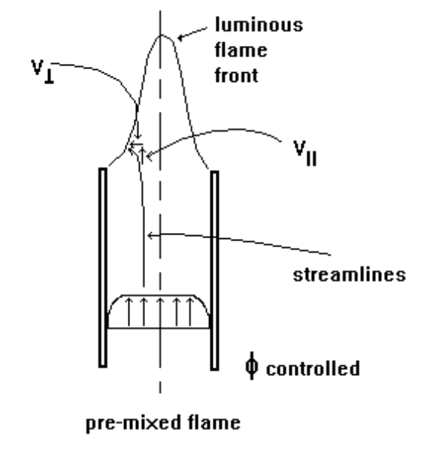

Flame propagation refers to the propagation of the reaction zone or “combustion wave” through a combustible mixture. When the transport of heat and active species (free radicals) have initiated chemical reaction in the adjacent layer of the combustible mixture, the layer itself becomes the source of heat and radicals and is then capable of initiating reaction in the next layer. A quantitative theory of flame propagation must be based on the transfer of heat and mass from the reaction zone to the unburned mixture.

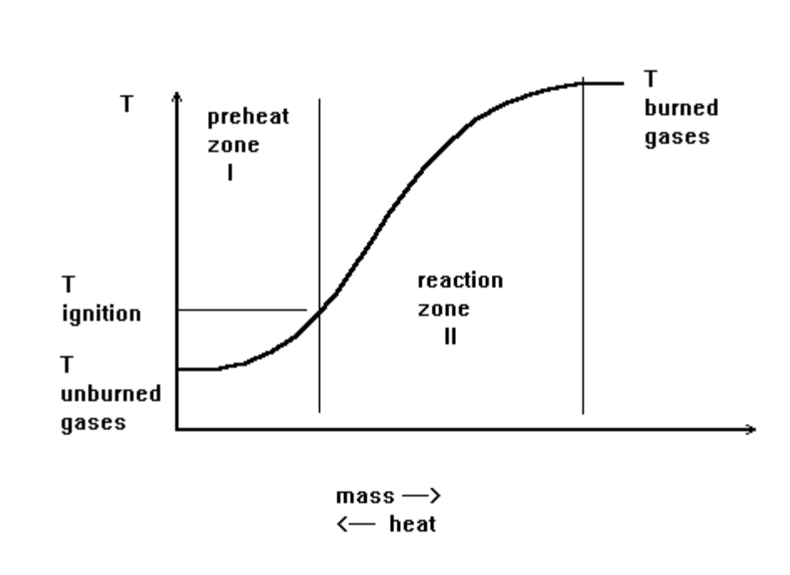

The enthalpy rise across the flame due to combustion is balanced by conduction from the reaction zone.

The flame propagation speed in a pre-mixed fuel/air mixture can be visualized:
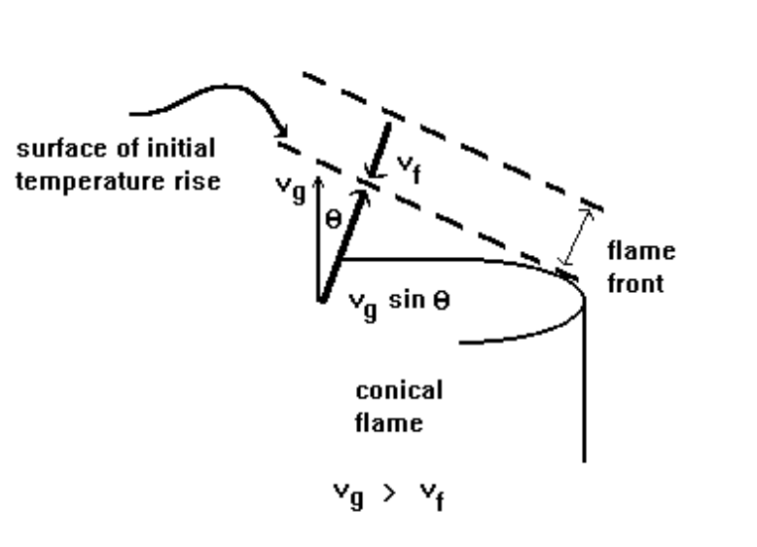

To avoid flame blow-off, v_{f} = v_{g}sin . The flame velocity, v_{f}, may be defined as the velocity component of the cold unburned gas normal to the one dimensional flame front. In flames stabilized on a burner tube (Bunsen burner) the flame front is inclined at an angle against the gas flow and it is possible therefore to stabilize a flame (obtain a stationary flame) at gas flow rates higher than the rate of flame propagation. This is the reason why Bunsen burners can maintain flames over a range of flow rates and fuel oxidant mixture ratios - a flat flame burner is stable only for the flow rate of the gas that exactly matches the flame velocity.

Flame velocity depends on:

- fuel type
- fuel-oxidant mass ratio (equivalence ratio)
- initial temperature of combustible mixture
- pressure
- flow pattern
- geometry of system

There are several theories that attempt to predict pre-mixed laminar flame propagation speed:

- Thermal theories: energy transfer to an unburned mixture is the controlling mechanism in flame propagation
- 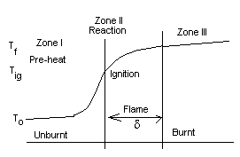Diffusion theories: Mass transfer (particularly of chain carriers) is the controlling mechanism in flame propagation
- Comprehensive theories: combination of the two above models

Thermal theories

Mallard and Le Chatlelier (1885)

Assumption: the energy conducted from zone II equals that necessary to bring unburned gases to ignition temperature

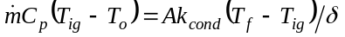

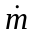 mass flow rate into the combustion zone
k_{cond} thermal conductivity of burning gases
δ flame thickness

For a one-dimensional flame:

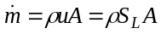

S_{L} laminar burning velocity – flame front velocity (relative to a stationary reference point) through an unburned mixture
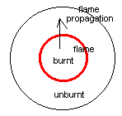

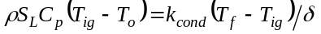

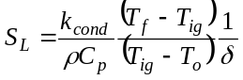
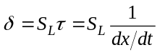
τ characteristic reaction time
d[fuel]/dt reaction rate in terms of fractional conversion (x = [fuel]/[fuel]_{o})

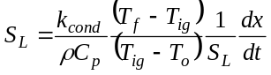

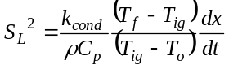

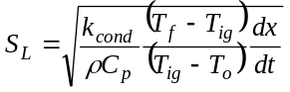
Effect of pressure:
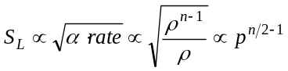
Effect of temperature:
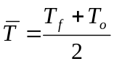
n = order of the reaction

Zeldovich, Frank-Kamentskii & Semenov thermal theory (1938):

Diffusion of molecules (but not free radicals) as well as heat is included.
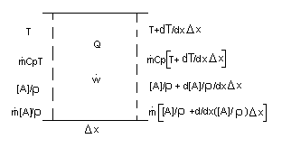
[A] molar concentration of reactant
-Dρ[d[A]/ρ]/dx diffusive molar flux
mass flow rate per unit area (mass flux)
[A]/ρ convected mass
C_{p}T convected heat
Q heat of reaction
T temperature
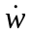 species production or reaction rate

The molar flux (mol/cm² sec) convected into the control volume through a flow cross section of unity:

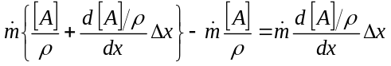

The molar flux (mol/cm² sec) diffused into the control volume through a flow cross section of unity:

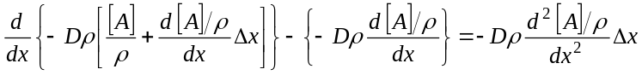

The molar flux (mol/cm² sec) reacting in the control volume:

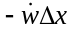

Conservation of mass ==> diffusion + convection + sink = 0

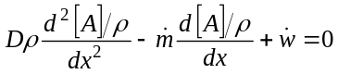

Conservation of energy:

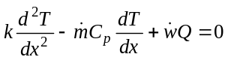

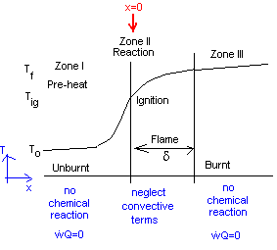

- pre-heat zone

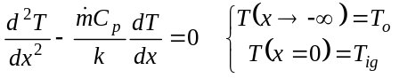

- reaction zone

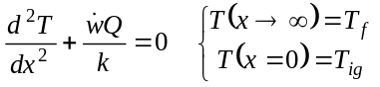

continuity of heat conduction: 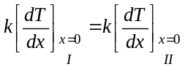

Multiple both sides of the reaction zone II energy equation by 2 dT/dx:

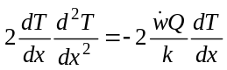

Use the product rule of differentiation to write:
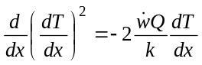

Integrate from T_{ig} to T_{f}:

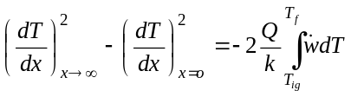
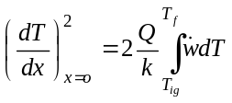

Now, work on the energy equation for the preheat zone I:

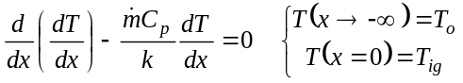
Integrate once:
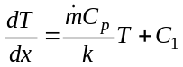

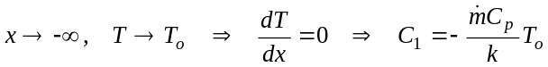

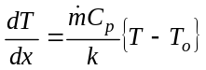

At x=0, the boundary between zones I and II, we know that the heat flux must be the same. Hence,

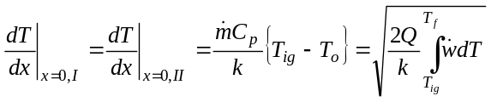

Substitute in the expression for the flame velocity 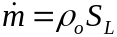 where the area A=1 cm², and solve for S_{L}.

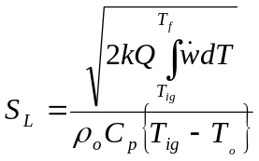

In this model, you also observe the square root dependence of the laminar flame velocity on the rate of fuel consumption. In either model, the global reaction rate models for fuel consumption (from Topic 5 Kinetics) can be used here.

Diffusion Theories

Lewis and Von Elbe, 1934, developed for ozone reaction
Tanford and Pease, 1947, diffusion of radicals is more important than temperature gradients

Comprehensive Theories

These flame spread models combine thermal and diffusion principles and must be solved numerically.

In addition to heat and mass transfer across the flame, momentum must also be conserved. We can use these laws to estimate the pressure drop across a flame.
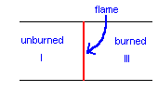
Conservation of mass: 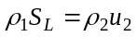

Conservation of momentum:
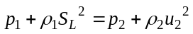

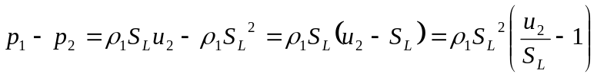

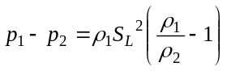

For a gaseous fuel, 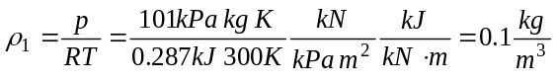

A typical laminar flame speed: 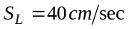

A typical density ratio between burned and unburned gases: 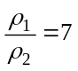

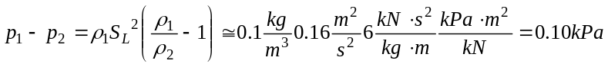

One-tenth of a kPa pressure drop is very small.

The laminar burning velocity S_{L} is a property of a fuel/air mixture. It varies with the fuel and its temperature, pressure and equivalence ratio: 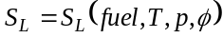

Successfully modeling flame speed is compounded because of the uncertainty of available data. For example, the thermal properties of radicals needed in some models are not known. Also, there is still substantial uncertainty surrounding reaction rate constants. Consequently, if you really need to know flame speed, experiments are required.

Experimental Methods for Measuring Flame Speed

- Bunsen burner - pre-mixed

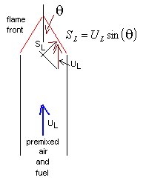Laminar burning velocity is proportional to the laminar gas velocity: 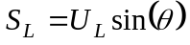

One aspect of flame stability can be studied with the Bunsen burner:

If the gas velocity > burning velocity ==> blow off

If the burning velocity > gas velocity ==> flash back

The burning velocity measured with a Bunsen burner is not the true adiabatic burning velocity because of heat transfer from the flame to the environment.

- 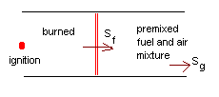cylindrical tube

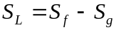

- flat flame burner

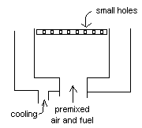
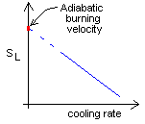

- closed spherical bomb
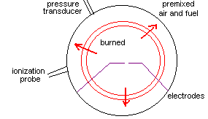
Analyzing data from the bomb requires corrections for unsteady heat conduction and varying temperature at the wall. The ionization probe is an open circuit that flame radicals will close. This senses the flame arrival time. The probe can be moved to different locations to see if any buoyancy effects are present.

Flame velocity of gas-air mixtures at 20 C (Gunther, 1974) (Vol % of fuel)
fuel | v_{f} _{max}  cm/s | [fuel] _{max}  vol % | v_{f} _{st}  cm/s | [fuel]_{st}  vol %
methane | 43.0 | 10.17 | 42.0 | 9.5
ethane | 48.7 | 5.99 | 47.6 | 5.64
propane | 47.2 | 4.27 | 46.0 | 4.07
butane | 45.2 | 3.38 | 43.4 | 3.13
n-pentane | 55.0 | 2.64 | 54.8 | 2.56
ethylene | 78.0 | 7.0 | 77.8 | 6.55
propylene | 54.7 | 4.64 | 54.4 | 4.51
1-butylene | 53.3 | 3.48 | 53.0 | 3.38
acetylene | 168.0 | 9.3 | 155.0 | 7.75
hydrogen | 364.0 | 42.5 | 237.0 | 29.58
CO | 19.5 | 41.5 | 17.4 | 29.58
0.9 CH₄ + 0.1 N₂ | 41.0 | 12.6 | 39.0 | 11.7
0.8 CH₄ + 0.2 N₂ | 40.2 | 14.0 | 39.0 | 13.1
gas 15.6 MJ/m³ | 103.5 | 25.2 | 86.0 | 21.4
gas 17.3 MJ/m³ | 91.0 | 23.1 | 81.0 | 20.1

Note that the flame velocities in the above table are higher when the mixture is richer than stoichiometric. The maximum flame temperature occurs in stoichiometric mixtures. But when the mixture is slightly fuel rich, the concentrations of free radicals - which play a significant role in flame propagation - are at a peak. (There is enough fuel present to consume all the oxygen, which results in peak power if the combustion occurs in a SI engine.)

Two types of flame stability limits exist:

- the ability of the mixture to support flame propagation; this defines the flammability limits of the fuel
- flow conditions that lead to blow off, or to flash back (mentioned above)

The lower flammability limit (also called the weak or lean limit) is the minimum percentage of fuel in the fuel/air mixture that can be flammable, or the minimum Φ.

The upper flammability limit (also called the rich limit) is the maximum percentage of fuel in a fuel/air mixture that can be flammable, or the maximum Φ.

Within the flammability limits between fuel-rich and fuel-lean conditions, flame propagation is possible once ignition occurs. Safe installations to prevent explosion hazards use this data.

As temperature and pressure increase, flammability limits generally widen. The fuel rich limit may increase significantly at higher temperatures due to “cool flames.” Cool flames ignite at low temperatures, 300 - 400 C, and propagate best at high fuel equivalence ratios. Their presence may cause violent explosions within the normal flammability limits.

Effect of pressure on flammability limits (O₂ partial pressure in %)
fuel in air | 10  atm | 50  atm | 125  atm
methane | 6.0 - 17.1 | 5.4 - 29.0 | 5.7 - 51.6
hydrogen | 10.2 - 68.5 | 10.0 - 73.3 | 9.9 - 74.8
CO | 17.8 - 62.8 | 20.6 - 56.8 | 20.7 - 51.6

When inert gas is added to the flammable mixture, the flammability limits narrow. The narrowing happens mainly in the lowering of the rich limit. The lean limit remains mostly unaffected. Near the lean limit, oxygen is a diluent just as nitrogen is. At the rich limit, it is fuel that is largely replaced by the diluent, as the fuel is present in excess in the mixture. Hence, the lowering of the rich flammability limit is due to a different mode of expressing the limits when diluents are added. The effectiveness of the diluent increases according to its molar heat capacity (CO₂ > H₂O > N₂ > He > Ar).

Maximum safe percentage of oxygen in combustible gas-air mixtures with carbon dioxide or nitrogen added
fuel | CO₂ as  diluent | N₂ as  diluent
methane | 14.6 | 12.1
ethane | 13.4 | 11.0
propane | 14.3 | 11.4
ethylene | 11.7 | 10.0
propylene | 14.1 | 11.5
hydrogen | 5.9 | 5.0
CO | 5.9 | 5.6

The quenching thickness or quenching distance is another measurable property of a fuel. The quenching distance is the smallest diameter or minimal channel width in which a flame can propagate. Walls of the channel act as sinks for heat and free radicals and therefore quench the flame at their surface.

The quenching distance is used in the design of flame arrestors between the fuel tank and burner of out door grills, camping stoves, hydrogen tanks, etc. Flame quenching at non-combustible surfaces within IC engines accounts for the unburned HCs spewed out of the tailpipe. We will discuss this form of pollution later.

Physical and combustion properties of selected fuels
fuel | quenching distance  cm | E_{ig} _{min}  MJ | T_{ig}  C
methane | 0.039 | 3.3 | 610
ethane | 0.0354 | 6.5 | -
propane | 0.031 | 3.05 | 470
butane | 0.0312 | - | -
n-pentane | 0.051 | 8.2 | 285
ethylene | 0.019 | 0.96 | -
propylene | 0.031 | 2.82 | -
acetylene | 0.0118 | 0.3 | 425
hydrogen | 0.00984 | 0.2 | -

The flash point of a fuel is the lowest temperature for ignition but not sustained burning.

The fire point of a fuel is the lowest temperature for ignition and sustained burning.

Ignition temperatures depend strongly on the apparatus in which they are measured. Standardized tests are now used to give comparative values. Ignition is kinetically controlled and there is a temperature limit below which the rate of reaction is so low that the heat of reaction is dissipated by heat losses and the mixture temperatures cannot rise.

Ignition temperatures are lower for a slightly fuel-rich mixture.

The minimum ignition energy for a combustible mixture is the minimum amount of energy that will ignite the mixture. It is determined experimentally with spark ignition.

References

Gunther, R., “Verbrennung und Feuerungen,” Springer, Berlin, 1974.

