ME 345 – HTx Fall 2023 Week 2 Homework

Problem 1:
The wall of an industrial furnace is constructed from fireclay brick that is 0.15 [m] thick, with a thermal conductivity of 1.7 [W/m-K]. During steady-state operation the temperatures were found to be T_{inside} = 1400 K, and T_{outside} = 1250 K. If the wall has dimensions of 1.2 [m] wide and 0.5 [m] tall, calculate the following:
- Heat rate of loss through the wall [W]
- Heat flux through the wall [W/m²]
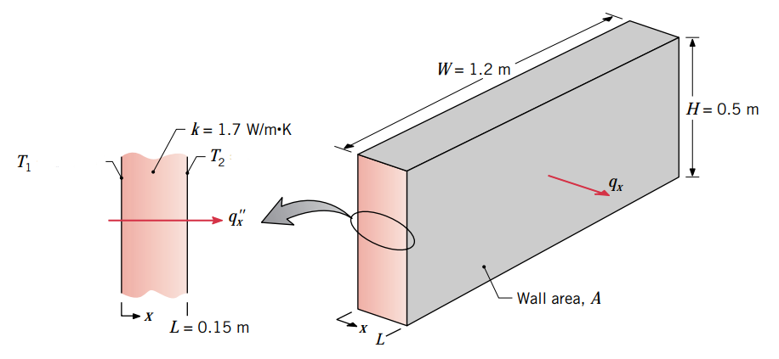

Problem 2:
For the sheet of extruded solid insulation (3 m x 3 m x 25 mm) and conditions shown below calculate the following:
- Heat rate of loss through the insulation [W]
- Heat flux through the insulation [W/m²]
- Comparing this to the problem above, which wall would be a better insulator?
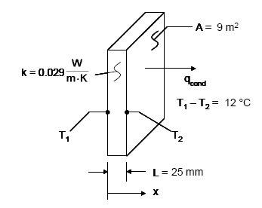

Problem 3:
You’re going to explore heat transfer through the shaft of a power generation gas turbine. Details are shown in the figure below. Find the following:
- Compare the ratio of the heat rate [W] through the shaft over the power output [W].
- Make a plot showing the ratio above as a function of shaft length. Explore lengths between 0.005 to 1 [m]
- Discuss the implications and feasibility of operating this turbine with a shaft length of 0.05 [m]
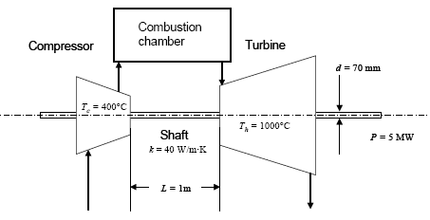

Problem 4:
You’re going to boil water in a pan, and have the option of using either an aluminum pan or copper pan (both of same dimensions). Assuming 1D steady-state conditions through the bottom of the pan calculate the following:
- Temperature at the bottom of the pan (T₁) in [°C] for aluminum pan
- Temperature at the bottom of the pan (T₁) in [°C] for copper pan
- How does T₁ relate to the temperature of the top surface of the burner?
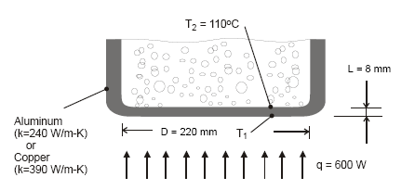

Problem 5:
Let’s do a calculation comparing convection heat transfer between really cold air and your hand, and pretty cold water and your hand. Assume the surface temperature of your hand remains at 30 °C for both cases. The conditions for each case are shown in the table below. Calculate the following:
- Heat flux [W/m²] from your hand to the cold water (low velocity, like in a slow-moving stream)
- Heat flux [W/m²] from your hand to the very cold air (modest velocity, like a winter breeze)
- What implications does this have for things like staying warm in the winter?
- Estimate the surface area of your body and calculate the heat rate [W] for each case. How does this compare to your typical 100 [W] heat rate loss in a comfortable environment?

Convection in mildly cold water  - T_{water} = 10 °C  - Velocity = 0.2 m/s  - h = 900 W/m²-K | Convection in much colder, faster air  - T_{air} = -5 °C  - Velocity = 35 km/hr  - h = 40 W/m²-K

