ME 345 – HTx Fall 2023 Week 4 Homework

Problem 1:
Draw me a picture! But, the picture should have mathematical meaning. Imagine you have 1D Steady-State conduction through a circular solid with a cross-sectional area that looks like the figure below. The walls are insulated. The implications of this are that anywhere throughout the material q is a constant. However, q’’_{x} is *not* a constant (because cross sectional area changes with x). Assume T₁ = 200 °F and T₂ = 50 °F. Draw pictures to represent the following:
- Heat flux as a function of x (from x=0 to x=L)
- Temperature distribution as a function of x (from x=0 to x=L)
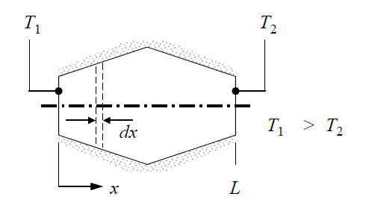

Problem 2:
Temperature distribution across a 0.3 [m] thick wall at a certain instant in time was found to be
$$T\left(x\right)=a+bx+cx^{2}$$
Where a = 200 °C, b = -200 °C/m, and c = 30 °C/m². Thermal conductivity of the wall is 1 W/m-K, and there is no volumetric heat generation. Calculate the following:
- On a per-area basis, calculate the heat rate (in and out) and the energy storage rate for the wall.
- If the cold surface was exposed to a fluid that was at 100 °C, what would the convection coefficient have to be?

Problem 3:
1D steady-state conduction with uniform heat generation occurs in a plane wall that is 50 mm thick. Thermal conductivity of the wall is 5 W/m-K. Under these conditions the temperature distribution is shown to be
$$T\left(x\right)=a+bx+cx^{2}$$
At x = 0 the surface temperature is T(0) = T₀ = 120 °C, and the free-stream fluid is at T∞ = 20 °C. The convection coefficient is h = 500 W/m²-K, and the surface at x = L is perfectly insulated. Find the following:
- Apply an overall energy balance to the wall and calculate the volumetric energy generation rate (q_dot)
- Determine coefficients a, b, and c by applying boundary conditions to the temperature distribution equation above.
- Once these are known, plot the temperature distribution throughout the wall.

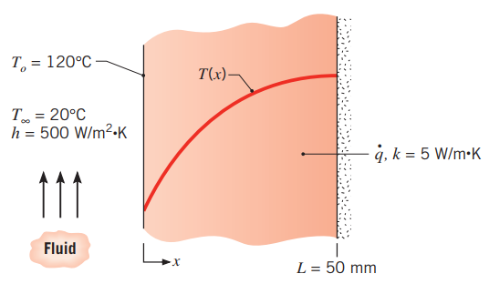

Problem 4:
You’re thinking about building in a cold climate, and your structure requires your basement wall to be 200 mm thick. The inside temperature is 20 °C, and the outside temperature is 0 °C. The designer is considering two materials:
- Aerated concrete block with a k-value of 0.15 [W/m-K].
- Stone mix concrete with a k-value of 1.4 [W/m-K]
You are going to calculate the necessary thickness (t) of polystyrene (rigid foam) insulation you would need to apply to the inside of the stone mix concrete wall such that it would have the same heat flux as the aerated concrete block wall. For polystyrene, use a k-value of 0.027 [W/m-K]

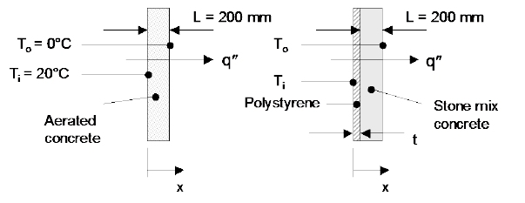
Wall a (aerated concrete) Wall b (stone mix concrete with insulation)

Problem 5:
A building originally constructed long ago has a wall thickness of 30 mm with a thermal conductivity of
k_{s} = 0.1 [W/m-K]. As a way to reduce heating costs the owner is looking to add a layer of insulation *and* a layer of glass to the outside of the original sheathing. The thicknesses and thermal conductivities are shown in the image below. In both the original and retrofitted configurations the inside and outside temperatures and convection coefficients are the values shown in the figure.
Ignoring any contact resistance between layers, use the thermal resistance model to calculate the following:
- Calculate the heat flux [W/m²] through the original wall
- Calculate the heat flux [W/m²] through the retrofitted wall
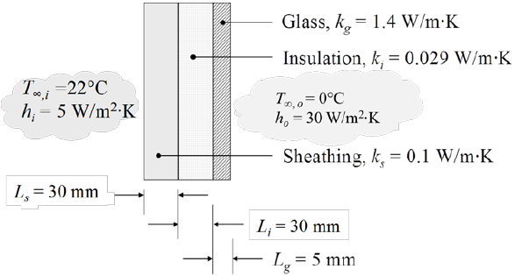

Problem 6:
You’re going to model wind chill experienced by human skin. To do this we are going to assume the following:
- Fatty layer of ‘insulation’ of the human is 3 [mm] thick
- Fatty layer has a thermal conductivity of 0.2 [W/m-K]
- Temperature at the inside surface of the fattly layer is 36 [°C]
- Temperature of the air outside is -15 [°C]
- On a calm day the convection coefficient between the skin and air is h_{calm} = 25 [W/m²-K]
- On a windy day the convection coefficient between the skin and air is h_{wind} = 65 [W/m²-K]
Calculate the following using the thermal resistance model:
- Temperature [°C] of outer layer of skin on a calm day
- Temperature [°C] of outer layer of skin on a windy day
- Temperature [°C] of the outside air if it were a calm day, but it was going to cause the same outer skin temperature as the windy day.

Problem 7:
You have a composite wall that includes a 8 [mm] thick wood siding, 40 [mm] x 130 [mm] hardwood studs on 0.65 [m] centers with the gaps filled with paper-faced glass fiber insulation, and a 12 [mm] gypsum wall board. A section of the vertical cross-section is shown in the figure below. Materials have a thermal conductivity of:
- Wood Siding: 0.094 [W/m-K]
- Hardwood Stud: 0.16 [W/m-K]
- Insulation: 0.038 [W/m-K]
- Gypsum Board: 0.17 [W/m-K]
Calculate the net thermal resistance [K/W] of the composite wall if it is 2.5 [m] tall, and 6.5 [m] wide (assuming 10 vertical studs). Assume all surfaces normal to the x-direction are isothermal.
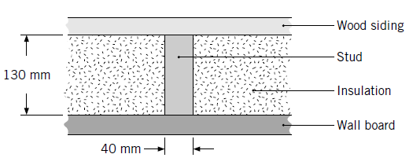
x
Hint: You can analyze a 0.65 [m] width x 2.5 [m] tall section of the wall to come up with a thermal resistance of that representative section, then treat the wall as if it were 10 segments of that section (in parallel).

