ME 345 – HTx Fall 2023 Week 5 Homework

Problem 1:
Calcium silicate is being used to insulate a steam pipe. The insulation has dimensions, properties, and temperature conditions shown below. The inner surface of the insulation is T_{s, 1} and the calcium silicate has a thermal conductivity of k = 0.089 [W/m-K]. is shown below.
The pipe is in an environment where T∞ and T_{sur} are both at 25 °C. The surface emissivity of the calcium silicate is 0.8. Heat is leaving the surface of the insulation through both convection *and* radiation.
Model the following (using software of your choice). Excel, EES, Matlab, Python, etc. are all acceptable.
- Compute the heat loss per length of pipe (q’) as a function of of the insulation thickness
(r₂ – r₁), where r₂ varies from 0.06 to 0.20 [m].
- Compute the outer surface temperature (T_{s,2}) as a function of of the insulation thickness
(r₂ – r₁), where r₂ varies from 0.06 to 0.20 [m].

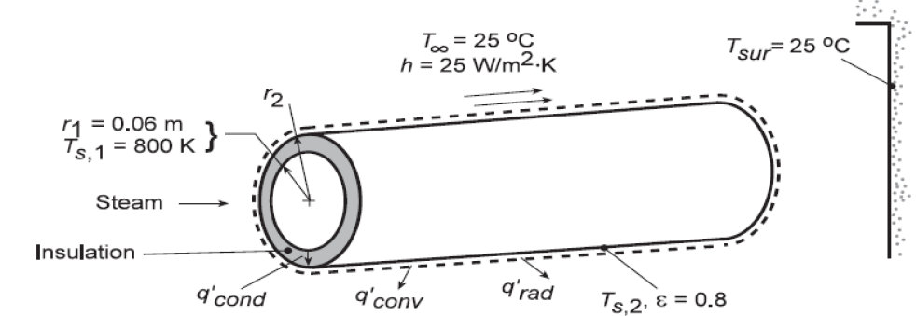

Problem 2:
Superheated steam at 575 °C moves through steel tubes (k_{steel} = 35 [W/m-K]) with an inner diameter of 300 [mm], and a wall thickness of 30 [mm]. To reduce heat lost out of the tubes they have been wrapped in insulation (k_{insulation} = 0.10 [W/m-K]). The outside of the insulation has been wrapped by aluminum foil to protect the insulation (negligable thermal resistance). The emissivity of the aluminum foil is 0.2, and the ambient air and wall temperatures are both 27 °C. The convection coefficient between the aluminum and air is 6 [W/m²-K]. Steam flowing through the center is turbulent enough that you may assume the inner sufrace of the tube is at 575 °C.
Find the following:
- Draw the thermal resistance circuit for this system.
- From a safety perspective the aluminum foil needs to stay below 50 °C. Calculate the minimum thickness of the insulation to make sure that happens.
- Make a plot of aluminum temperature (vertical axis) as a function of outer radius (x-axis). Explore a range of outer radius from 0.2 to 0.5 [m] (corresponding to an insulation thickness of 20 to 320 [mm]).

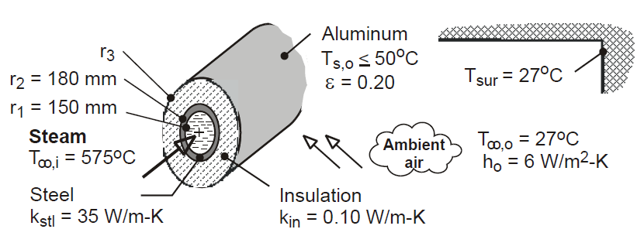

Hint:
If you do an energy balance at the outer surface you know that q’ = q’_{convection} + q’_{radiation}. Solve this for the case when T_{aluminum} = 50 °C. It will be an ugly system of equations, but outside radius (r₃ in image) should be the only unknown.

Problem 3 - MATLAB:
- I would like you to recreate the figure at the end of LECTURE 11 by performing a MATLAB simulation (using PDE Modeler) to solve for the steady-state temperature distribution in a 2D rectangular solid with the lower-left corner at 0,0, is 1.5 tall and 1.0 wide. The boundary conditions are: Both sides and the bottom surfaces are kept at constant surface temperature of θ = 0, and the top surface is kept at constant surface temperature of θ = 1. The thermal conductivity in the solid is 2.5 W/m-K.
  - Make a contour plot of temperature and add heat-flux vectors. Make sure your output matches the analytical solution we derived in LECTURE 11.
  - Save your simulation, and print out a plot of your picture to turn in.

Problem 4 - MATLAB:
- Below is a cross section of a triangular long bar. The diagonal is well insulated, while sides of equivalent length are maintained at uniform temperatures $T_{a}$ and $T_{b}$.
The co-ordinates of the triangle are (0, 0), (1, 0), and (0, 1)
- Use the MATLAB PDE Modeler to create the steady-state contour plot of temperature and heat-flux vectors.
- Save your simulation and print out a plot of your picture to turn in.
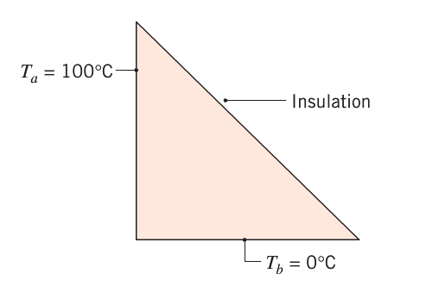

Problem 5 - MATLAB:
- Pick one of the first two problems, but make some significant changes to the problem and solve it again. Alternatively, come up with (and simulate) a different 2D heat transfer problem to solve using the MATLAB PDE solver. Some changes you might consider include:
  - Change the thermal conductivity to something much lower (less than 1) and see how that changes your contour plot.
  - Vary a volumetric heat generation term - start small (near zero) and increase in a few increments – and see how this changes the temperature distribution.
  - Change the boundary conditions to something different (insulated, known heat flux, or convection).
  - Change the grometry by adding hole(s) or other more complicated shapes.
  - Add fins to one surface that has a convection boundary.

