ME 345 – HTx Fall 2023 Week 6 Homework

Problem 1 (Internal Heat Generation):
A gas-cooled nuclear reactor is made of concentric cylinders. The inner core is insulated (you may assume adaibatic). The second layer is the Thorium nuclear rod that has an uniform internal heat generation of q_dot = 10⁸ [W/m³]. The third layer is Graphite (used to stabilize/control/contain nuclear reaction), and the fourth later is a helium coolant channel. Dimensions, and properties are shown in the figure below.
Assuming the system is at steady-state, calculate the inner and outer temperature of the Thorium fuel cylinder (T₁ and T₂) [K]. Assume that there is negligible contact resistance between layers, and that radiation heat transfer is negligible.
Hints:
- If you choose the system boundary as being the fuel rod (shown by the dashed lines in the figure), you can calculate the heat transfer per unit length – all of which will be leaving through the Graphite.
- You know you can’t use thermal resistance model where there is volumetric heat generation. However, from T₂ to T∞ there is no internal heat generation 😉.
- Once you know T₂ you can use the known solution for temperature distribution in the 1D tube with internal heat generation to solve for T₁. You can find the solution to a SS cylindrical shell with internal heat generation in Appendix C. In this case you also know the heat flux at the inner surface is zero.

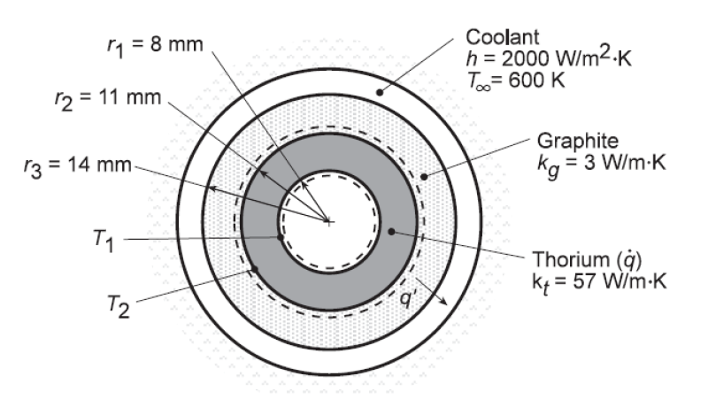

Problem 2 (Transient):
You were outside enjoying the sunshine on a beach. Unfortunately, while you did this you forgot that your drink was warming up. The liquid in your can (assume the container is a thin-wall aluminum can with nearly zero thermal resistance) is now at 90 °F. The container may be modeled as a cylinder that is 5” tall and 2.5” in diameter.
You place the warm can in a bucket of ice water at 32 °F, which results in a convection coefficient of 40 [Btu/hr-ft²-°F]. Heat transfer within your drink behaves as if it has a thermal conductivity of 17.2 [Btu/hr-ft-°F], density of 62.22 [lb/ft³], and heat capacity of 0.999 [Btu/lbm-F].
Calculate the following:
- Characteristic length [ft] for your can?
- Biot Number for this scenario?
- Thermal time constant, τ [minutes]?
- Time [minutes] for your drink to reach an average temperature of 40 °F?

Problem 3 (Transient):
It’s nearly Thanksgiving, so we should talk about cooking a turkey. Let’s do some calculations of cooking the turkey the traditional way (putting it in an oven for a long time) and calculating the temperature change as a function of time. To begin, consider the cylindrical turkey……we will model the turkey as if it is a hollow cylinder (thick-wall tube) with an outer diameter of 16 [in], and inner diameter of 6 [in], and a length of 18 [in]. Average thermal properties of the turkey are: rho_turkey = 12 [lbm/ft^3], k_turkey = 0.25 [Btu/hr-ft-R], and c_turkey = 0.5 [Btu/lbm-R].
The turkey starts out at 40 °F, and is put in an oven maintained at 300 °F. The convection coefficient between the hot air and turkey is 0.15 [Btu/hr-ft²-R]. Assume that convection happens over the whole surface of the turkey (inner and outer – as if it was floating in the hot air)
Compare the following values with your classmates:
- Surface area of the turkey [ft²]
- Volume of the turkey [ft³]
- Mass of the turkey [lbm]
- Characteristic length [ft]
- Biot Number
- Thermal time constant [hr]
Calculate/plot the following:
- Internal temperature [°F] of the turkey after cooking for 2 hours.
- Time [hr] it will take the turkey to reach an internal temperature of 170 °F.
- Average internal temperature [°F] of the turkey as a function of time over 0-6 hours.
- Amount of energy transferred to the turkey [Btu] as a function of time over 0-6 hours.

