ME 433 Week 2 Homework Spring 2024

Part I. Thermodynamic Models
The following mathematical models are foundational for this class. For each model:
- Give the correct governing equation
- Explain the concept/principle represented by the model/equation
- Make note of what each variable represents (a few words is fine), and if there is anything special about the variables (must be absolute units, or only works within a range, etc.)
- Ideal Gas Law on a molar basis
- Ideal Gas Law on a mass basis
- Caloric Equation of State (for an Ideal Gas)
- First Law of Thermodynamics for a closed system
- First Law of Thermodynamics for an open system
- First Law Efficiency (do this for an engine, for a heat pump, and for a refrigerator)

Part II. Process Modeling
- Look up the four thermodynamic processes that compose an Otto cycle. Give the correct thermodynamic name for each process in the Otto cycle. Which properties stay constant during each process?
- Sketch pressure-volume (P-V) and temperature-entropy (T-S) diagrams for the Otto cycle. CLEARLY LABEL THE ENDPOINTS OF EACH PROCESS. Begin with the start of the compression stroke.
- Make a table that shows the sign (-ve, 0, +ve) of heat transfer, work transfer, and change in internal energy associated with each process the makes up the Otto cycle.
- Shade the area on the P-V diagram which represents the NET work output.
- Shade the area on the T-S diagram which represents heat transfer INTO the cycle. (vi) Shade the area on the T-S diagram which represent the NET work output.
- Explain how to use data from the T-S diagram to estimate the Otto cycle efficiency.
- Predict changes in Otto cycle efficiency due to decreased compression ratio. Justify your reasoning using your P-V and T-S diagrams.

Part III. Combustion Chemistry
Iso-octane (C8H18) is combusted with air which is composed of 21% oxygen and 79% nitrogen (e.g. for every mole of O2 there are 3.76 moles of N2). Assume that combustion occurs under stoichiometric conditions (e.g. the only products of this reaction are CO2, H2O, and N2).
- Write an atom balanced chemical reaction equation.
- What is the air/fuel ratio on a MOLAR basis?
- What is the air/fuel ratio on a MASS basis?
- How do answers to (i), (ii), and (iii) change if iso-octane is burned in pure oxygen?

For molar masses, use the following [g/mol]
C 12, H 1, O 16, N 14

Part IV. Polytropic Relations
400 mL of air at standard conditions (25 °C, 1 atm) is compressed adiabatically and reversibly while its volume is reduced by a factor of ten. Assume that this occurs in a piston/cylinder apparatus and that the ration of Cp/Cv for air is 1.4 throughout the entire process.
- If the cylinder has a bore (diameter) of 100 mm, what is the gap between the piston and cylinder head at the end of the compression process?
- What is the final temperature [°C or K]?
- What is the final pressure [atm or MPa]?
- What heat transfer occurs during this process [J or kJ]?
- What work transfer occurs during this process [J or kJ]?

Part V. Cycle Analysis
Answer the following, using the array of state point data and the diagrams below.
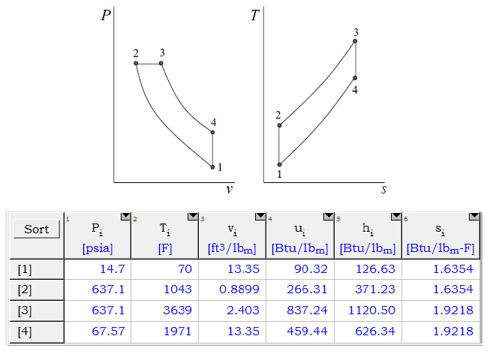
- Identify the thermodynamic name associated with each process.
- What is the work done per unit mass during the compression stroke (process 1-2)?
- What is the heat transfer into the cycle during process 2-3?
- What is the work done per unit mass during expansion (processes 2-3-4)?
- What is the entropy production during the compression stroke?
- What is the thermal efficiency of this cycle?

