Table of Contents

ABSTRACT 3

INTRODUCTION 3

VEHICLE MODEL & SIMULATION 4

Simulation 4

Event: Autocross & Endurance Laps 6

Event: Electric Only Acceleration 7

Event: Combined Acceleration 8

Competition Points 8

Model Inputs 8

Track Plotting 11

Model Outputs 13

CASE STUDY 13

Drag Strip Test 14

Autocross Test 15

CONCLUSIONS 16

REFERENCES 19

# Hybrid Vehicle Design and Performance Simulation Tool

# ABSTRACT

User-friendly tools are needed for undergraduates to learn about component sizing, powertrain integration, and control strategies for student competitions involving hybrid vehicles. This paper describes a tool developed at the University of Idaho for this purpose. The model simulates each of the dynamic events in the FHSAE competition, predicting average speed, acceleration, and fuel consumption for different track segments. Model inputs included manufacturer's data along with bench tests of electrical and IC engine components and roll-down data. Model predictions have been validated in full vehicle tests under simulated race conditions. The tool has proven effective in making decisions about sizing gasoline and electric power components, establishing an optimal coupling connection between the electric motor and the gasoline engine, selecting and configuring the battery pack, tuning the gasoline engine, and making recommendations for energy management under different driving conditions. The tool was developed using TK Solver, and was used by the Formula Hybrid SAE team at the University of Idaho to design the vehicle that is to compete in the 2014 Formula Hybrid SAE competition [1].

# INTRODUCTION

There is no commercially available product that met the needs of the University of Idaho in terms of hybrid vehicle modeling and simulation. The objective of this paper and subsequent research was to create such a program, which would be user friendly; model and simulate multiple energy sources, components, and competition events; aid in improving overall vehicle performance; and reduce design time. This program was to have the ability to accurately model a hybrid vehicle and driving event to best predict performance and efficiency for any track configuration. The basis and motivation developed from the research of the past five years [2][3][4][5][6]. Ultimately it was to be easy to use and aid as both an educational and design tool that students can use to examine how design changes affect the outcome of vehicle performance and scoring in the SAE competition.

This paper and subsequent research was conducted with the intent of continuing the past work that has gone on at the University of Idaho, to couple with the current work being performed, and in an effort to foster a culture for future student learning in the fields of research that align with the ever expanding powertrain industry.

This paper outlines the development, use, and validation of a purpose built HEV math model. The model was developed in TK Solver, a software program that University of Idaho engineering students are already familiar with by their second semester their junior year. The model provides a comparative analysis tool for powertrain and vehicle design, component selection and development, as well as environment specific parameters i.e. driving event track shape and atmospheric conditions.

Analyzing simulation results provides students the ability to explore how design changes affect the vehicle and its performance. Changing parameters and running simulations can answer questions such as:

* Does the vehicle need more longitudinal or lateral grip?
* How much drag can wings add before they negatively affect performance?
* Which final drive ratio minimizes the number of gear shifts and total lap time?
* Which hybrid powertrain architecture is going to produce the best autocross score?
* How much energy is required from both systems to complete endurance?

With proper vehicle modeling and simulation all of these questions can be answered without a single physical lap being run, giving students the ability to simulate many design ideas .

Multiple vehicle and powertrain modeling and simulation tools were reviewed for this paper. These simulation tools include, HYZEM, Simplev, ADVISOR, PSAT, RAPTOR, OptimumLap, FSAESim, and Bosch LapSim. Other tools were reviewed but were quickly disregarded due to complexity, cost, availability, hybrid powertrain compatible, etc. From the research that was done on the strengths and weaknesses of the commercially available programs that were reviewed, a comparison table was formed. This table highlights the features which the University of Idaho desires of a hybrid vehicle modeling program [7][8][9][10][11][12][13][14][15].

Table : Commercially Available Vehicle Modeling Program Comparison Table

|  |  |  |  |  |  |  |
| --- | --- | --- | --- | --- | --- | --- |
| Commercial Product | Cost | Open Source | User Defined Track | Hybrid Powertrains | Complexity | Undergraduate Student Friendly |
| HYZEM | N/A | Yes | No | Yes | High | No |
| Simplev | N/A | No | No | Yes | Medium | No |
| ADVISOR | High | Yes | No | Yes | High | No |
| PSAT | N/A | No | No | Yes | High | No |
| RAPTOR | Free | Yes | No | Yes | High | No |
| OptimumLap | N/A | No | No | No | Low | Yes |
| FSAESim | Free | No | No | No | Very Low | Yes |
| Bosch LapSim | Very High | No | No | Yes | Very High | No |

No single program was found that met all of the requirements of a modeling and simulation program for the University of Idaho, especially the ability to directly simulate all the SAE competition events and calculate the resulting score. Therefore, a vehicle performance model and simulation program was created to meet all of the objectives.

# VEHICLE MODEL & SIMULATION

The performance model is formed into function modules that perform certain calculations to simulate various systems and aspects of the vehicle [16]. Each function module takes the user inputs, vehicle parameters and track layout, and can then simulate the performance of the vehicle and powertrain during all of the dynamic events. The performance model is set up to run multiple event loops simultaneously to produce vehicle and powertrain performance. The layout of each of the model functions is pictured in Figure 1.

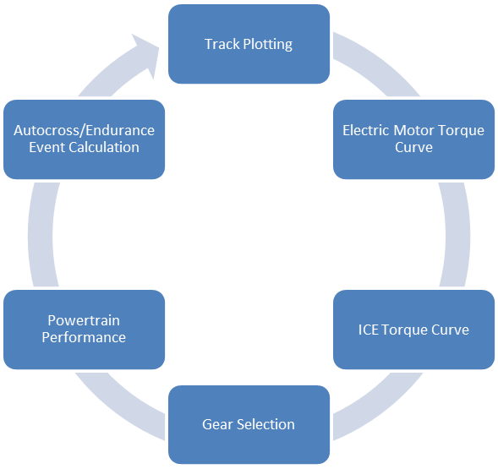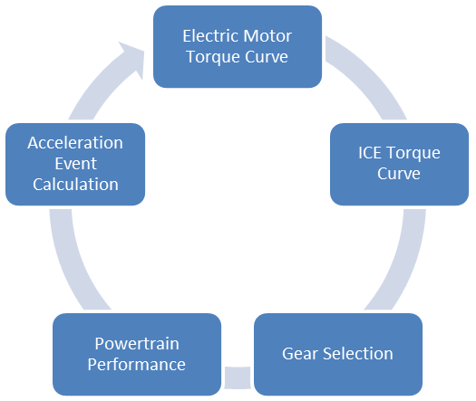

Autocross/Endurance Loop

Acceleration Loop

Figure : Model Layout

The first portion of each function sets up a loop operation by setting the drive cycle, vehicle, and environment parameters. Once these parameters are specified, the loop portion of the program begins. The loop is broken into user-defined time step intervals where the program takes the initial or previous time, position, and velocity of the vehicle. Depending on vehicle position and the upcoming track geometry, it then determines if the vehicle is to be accelerating, decelerating, or cruising. Powertrain output, resistive, and mass/inertial forces are calculated and as a result the vehicle’s actual acceleration for that given time step is found.

The loop repeats the process for each time increment until the total distance traveled equals the length of the event. Once the loop ends the program totals the time and outputs various performance markers such as total energy consumption, lap time, number of gear shifts, predicted event and competition points, and vehicle performance throughout the course. The physical design of this function is done using TK Solver’s variables worksheet for vehicle and track parameters, rules worksheet for the model architecture, and functions worksheet for component functions and subroutines.

### Event: Autocross & Endurance Laps

This function uses the track plotting function to set the drive cycle for both events. This function currently assumes that both events will have the same track layout. This is an assumption that is based off of the 2011 and 2012 Formula Hybrid events having similar track layouts for the two events.

Using the track plotting function as the drive cycle the event performance function can be set up similar to the previous event functions. Starting by setting the functions initial values and creating lists for function outputs, such as time, position, velocity, acceleration, energy consumption, etc. that will be used to determine vehicle performance and areas for improvement. The function then starts by setting the time step size. This step size determines how accurately the function will simulate the vehicles performance as well as how long it will take to process.

Once the time step size is set, the function loop can begin. The gear selection is the first subroutine that occurs within the loop. An initial velocity must be set, and this value cannot simply be set at zero as both events have rolling starts (vehicle is in motion before crossing the timing line). So the initial velocity must be estimated until the event layout is revealed at competition. Previous competitions have shown that the average vehicle velocity when crossing the timing line is close to 14 mph. Alteration of this value can greatly impact the results of the performance simulation as the value determines which gear the vehicle will start out in.

When the initial vehicle velocity and resultant gear selection are known the loop then moves on to the lap powertrain performance function which takes the vehicles velocity and outputs vehicle acceleration, motor and engine rpm and torque. The powertrain system rpm and torque are used in the energy consumption function to determine the electrical and fuel consumption for that given time step. The vehicle acceleration is then used to determine velocity and position. After output values are logged into their respective lists, the shifting subroutine determines if a gear shift occurs. If a shift occurred the subroutine adds the user defined shift time delay to account for the powertrain not being engaged.

Once this step is complete a check occurs to see if the model has simulated the entire driving cycle by comparing the vehicles current location to the end location that was determined in the track plotting function. If it is found that the vehicle is not to the end of the track then the loop continues. If it is found that the vehicle has traveled the full distance then the loop stops, lists are plotted, outputs summed, and event results are posted to the variable worksheet, as will be discussed in the next chapter. Outputs such as lap time, average speed, energy/fuel consumption, and autocross values are then extrapolated to reflect the predicted performance for the endurance event.

The energy consumption function is used to determine the fuel and energy consumption of the ICE and electric motor respectively. An initial subroutine identifies if the vehicle is in an accelerating, coasting, or braking situation, so systems rpms are accurately simulated.

Using the given rpm, torque, and efficiency of each system and the energy values for each source set by the Formula Hybrid competition or the average power output and energy consumption can be found for each time step. This fuel and energy consumption is then output to the lap performance function to determine outputs such as average and total energy consumption. These output values have now become critical for design decisions as the competition dictates the maximum allotted energy that the vehicle is allowed to use for the endurance event.

### Event: Electric Only Acceleration

The electric only acceleration event evaluates the car’s acceleration in a straight line on flat pavement. The vehicle must complete the event in under ten seconds with the ICE turned off, leaving only the electric system to propel the vehicle forward. The vehicle will accelerate from a standing start and cover a distance of 75 m (82 yards).

The event function for the electric only acceleration event requires no initial guess input variables to start the simulation loop. Once activated by the rules sheet in TK Solver the electric only acceleration function blanks all of the lists that will be filled during the simulation loop including time, position, velocity, and acceleration. The time step size is then selected from the variable sheet set by the user, currently defaulted to 0.001 seconds. Once this is done the loop starts and will run until either the vehicle completes the event or ten seconds is reached. At ten seconds an error will occur notifying the user that the vehicle did not complete the event in the allotted competition time.

Once the loop starts the function sends the current vehicle velocity to the electric only powertrain function. This velocity is used to find the vehicles acceleration for the given time step in a process that will be discussed in the next section. This acceleration is first checked within the function to see if it is within the bounds set by the user to comply with tire, powertrain, and vehicle limits. Once complete it is then used to find the vehicles velocity and position for the given time step. All of the outputs for the given time step are then logged in their respective lists for plotting and then the loop continues on to the next time step until one of the stopping criteria are met.

The current model does not incorporate drivetrain gear shifting as it is based off of a post transmission mode that has a single gear ratio between the electric motor and the rear wheels.

### 

### Event: Combined Acceleration

This event function is similar to the electric only acceleration event function with two noticeable additions; drivetrain gear selection and a combustion powertrain. The function operates by clearing the output lists and setting the event loop parameters with a gear selection that occurs at each time step. This gear selection inputs the vehicle velocity of the given time step and the gear that the vehicle was in for the previous step (starting gear dictated by the user). If the criteria set by the gear & shifting function are satisfied the vehicle will be simulated for the given time step in the current gear. If however the criteria are not met then a gear shift occurs, this process then changes the gear up or down depending on the criteria that were not met. Gear shifts in the physical world take time and as such the simulation accounts for this by adding a shift delay time that can be adjusted by the user, the default is set at 0.15 seconds.

Once the gear selection subroutine occurs, the function sends the vehicle velocity and current gear to the combined powertrain function, which will be discussed next. The combined powertrain function uses the input velocity to calculate an acceleration for the given time step. Once the vehicles acceleration is calculated the same process occurs that took place in the electric only performance function. The function verifies that the outputs are within the bounds of the function, logged for plotting, and checks to see if the end criteria have been met. The end criteria for the combined acceleration function are the same as the end criteria for the electric only function.

### 

### Competition Points

The competition point’s prediction function was created to allow easy comparison of different design decisions on the FHSAE vehicle and with the intent of introducing a value into the function that could be used for optimization. There is a total of 1000 points available for both the static and dynamic events. The static events have an available 300 points that are determined by teams of judges and those events are not something that can be simulated using this model. Using the average trend of the best event times over the course of the past five years of this competition to set the best times on the variable sheet and the predicted times from the performance simulation, a predicted competition total can be determined. Note that static events points are determined by the user and that all of the dynamic events assume no penalties or track hazards. The competition point’s prediction function is the last function that is run for the vehicle performance simulation. Once complete, all of the outputs are logged on the variable sheet, in their respective lists, and plotted [17].

## Model Inputs

The software used for implementing the model is TK Solver™ 5.0 from Universal Technical Systems, Inc. (UTS). TK Solver is a rule-based problem solving and math modeling environment that combines equation solving, unit conversion, interpolation tables, and user-defined procedures. The reason for selecting TK Solver to program the vehicle performance model is the fact that it is readily available at the University of Idaho and students are already familiar with its layout and mathematical solving abilities. This familiarity with the program structure removes a large portion of the learning curve that is faced when encountering a new program as is the case with several of the reviewed vehicle performance modeling programs. Students will be able to change a finite number of inputs to the model and learn how design changes affect the vehicle’s performance and scoring in competition events. These inputs consist of two categories, vehicle properties and race-course layout.

## 

The vehicle properties function is the first procedure that is called upon in the model and it is used to calculate all of the static parameters for the performance model, parameters such as mass, inertia, maximum powertrain rpms, vehicle cornering, braking, acceleration and velocity limits. The intent of identifying powertrain and vehicle limits is to set simulation boundary’s to reduce the likelihood of unrealistic vehicle performance being simulated. The vehicle parameters function is not located within any of the event loops, but solved before so that the vehicle properties can be pulled from the variable sheet without needless calculations occurring during each time step. The total list of model inputs is shown below in Table 2 [18].

Table : Model Inputs

|  |  |  |
| --- | --- | --- |
| **Input** | **Name** | **Comment** |
|  |  | **Vehicle properties & max rpm's** |
| 675 | weight | Vehicle weight, Including Driver (lbs) |
| 32.2 | g | Acceleration due to gravity ft/s^2 |
| 1.70833 | tire_diameter | Wheel diameter (20.5") (in) |
| 3.3529 | primary_r | 2005 Yamaha yz250f primary ratio (57/17) |
| 4.5 | motor_r | Motor ratio from the motor to the drive wheels |
| 4.5 | final_drive | Powertrain final drive from the transmission output to the drive wheels |
| .81481 | top_gear | Transmission top gear (WR250f 5th gear 22/27) |
| 13500 | max_crank_rpm | Maximum crank rpm limited by engine |
|  |  | **Vehicle rolling resistance properties** |
| .0433 | μ | Vehicle road load from test data (dimensionless) |
| .07962 | ρ | Density of air (lbf/ft^3) |
| .35 | c_d | Vehicle drag coefficient (dimensionless) |
| 9.5 | a_cross | Vehicle cross sectional area of car (ft^2) |
| 0 | grade_percent | Track/road grade; unless its a hill climb set to 0 (length/length in %) |
|  |  | **Maximum Accelerations due to tire selection & suspension setup** |
| 1.3 | g_corner | Maximum cornering in g units (1g=32.2 ft/s^2) after weight transfer |
| 1.3 | g_accele | Maximum acceleration in g units (1g=32.2 ft/s^2) after weight transfer |
| -1.3 | g_brake | Maximum braking in g units (1g=32.2 ft/s^2) after weight transfer (- negative for braking) |
|  |  | **Electric Drive Motor model** |
| 110 | max_volts | Maximum voltage that the motor was designed for (volts) |
| 110 | volts | Maximum available voltage from the accumulator (volts) |
| 7.45 | no_load_current | Minimum current to spin the motor (A) |
| 400 | peak_amps | Peak amps available from the accumulator; doesn’t include no load current (A) |
| .85 | η | High Voltage system efficiency (Motor is ~91% efficient; Controller is ~95%, etc.) |
| .21 | k_q | Motor torque constant (Nm/A) |
| 40 | k_v | Motor speed constant (rpm/v) |
| 4000 | motor_rpm | Input motor rpm to verify torque curve (rpm) |
|  |  | **Powertrain shifting parameters** |
| 4075 | shift_rpm | Shift rpm for combined acceleration (based on countershaft rpm; crank rpm/primary reduction) |
| .15 | shift | Shift delay time (sec) |
|  |  | **Powertrain Gearing** |
| 2.3846 | first | WR250f First Gear Ratio (31/13) |
| 1.75 | second | WR250f Second Gear Ratio (28/16) |
| 1.333 | third | WR250f Third Gear Ratio (28/21) |
| 1.04166 | fourth | WR250f Forth Gear Ratio (25/24) |
| .8148 | fifth | WR250f Fifth Gear Ratio (22/27) |
|  |  | **Event times** |
| 5.302 | t_min_skid | First place skidpad time (sec) |
| 4.576 | t_min_e_accele | First place electric only acceleration event time (sec) |
| 4.163 | t_min_accele | First place unlimited acceleration event time (sec) |
| 33.209 | t_min_auto | First place autocross event lap time (sec) |
| 37.65 | t_min_end_lap | First place endurance average lap time (sec) |
| 36 | lap_total | Total number of laps to complete 22km |
|  |  | **Fuel & Energy consumption** |
| 350 | bsfc | Engine fuel consumption from test data (g/kw-hr) |
| 2414 | fuel_e | Energy density of the fuel being used determined by the competition (wh/liter) |

ICE data is input as a two column list relating rpm to a given torque as shown in Figure 1. This data is then used to fit a curve, as shown, that TK Solver will then use to select an engine torque for a given crank rpm. This curve fit type can be changed to best match the data. For the current curve a cubic fit was selected.

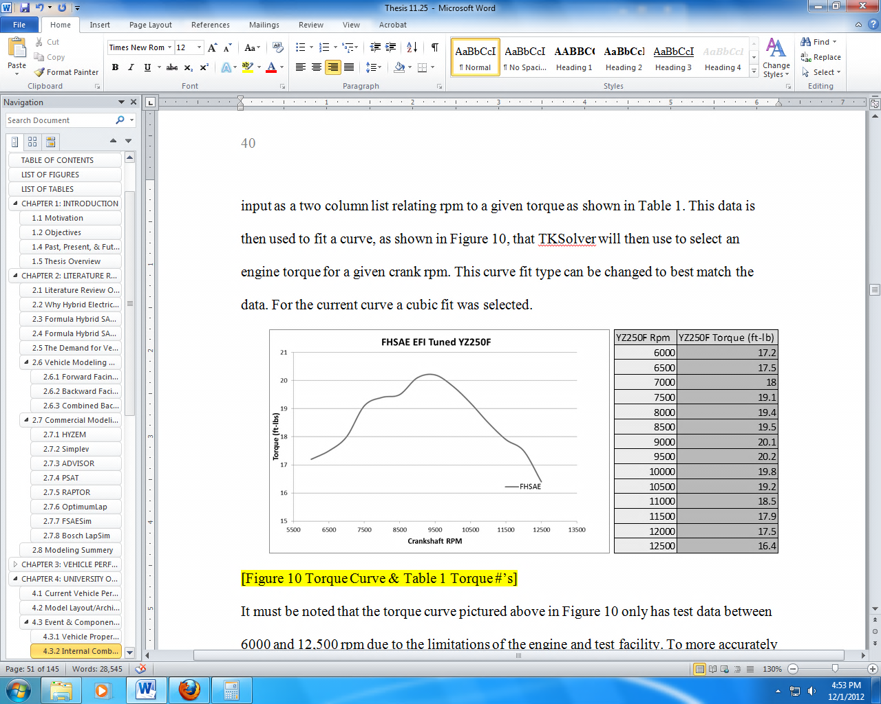

Figure : 2012 Formula Hybrid Competition ICE Torque Curve & Test Data

The electric motor function is a module that creates the electric motors torque verses rpm curve using motor rpm as the function input. Unlike the ICE, the electric motor function relies on electric motor modeling equations to simulate the motors performance. Input parameters such as peak torque, supplied voltage, and the motor rpm limit are used in this function to produce a torque curve similar to the one shown in Figure 2. This curve is then used the same way as the ICE curve in the performance model.



Figure : Typical Torque & Power vs. RPM Electric Motor Characteristics [19]

The layout of this function was created to be easily edited if more electric motors are added, the motor design changes, or physical test data is acquired for the torque curve of the electric motor. This provides the user the ability to analyze these simple curves and outputs for errors before attempting to troubleshoot the entire event function. This function also provides the ability to quickly analyze different hybrid powertrain layouts for performance without having to edit the more complex event models. This analysis is purely based off torque output over the vehicles entire speed range and does not account for any parameters outside of powertrain calculations.

## Track Plotting

After all vehicle properties are input, the track layout needs to be defined. The autocross and endurance events have both straight and cornering sections. To simulate the driving cycle without physical lap data, such as GPS information, a track creation function was needed. The track creation or plotting function requires user input of the track layout. The track layout must be defined in terms of straights, left, or right hand corners, a section length, and a cornering radius.

Once all of these parameters have been established for the event track, the section plotting function plots the user defined track layout on an X-Y plane allowing the user to visually check the track model. In addition to the visual check, the subroutine calculates the total length of the user defined track to provide a numerical check. The physical track cone layout of the 2011 Formula Hybrid Autocross event is pictured below, in Figure 3.



Figure : The 2011 Autocross Event Cone Layout

The user must first identify straight and cornering sections on the track layout that will best depict the racing line that the driver would traverse. The function is not sophisticated enough to discern the correct line for a given track layout, so the user is required to identify the ideal layout. Once section types have been established, section lengths and radiuses need to be identified to create a track, such as the one pictured in Figure 4.

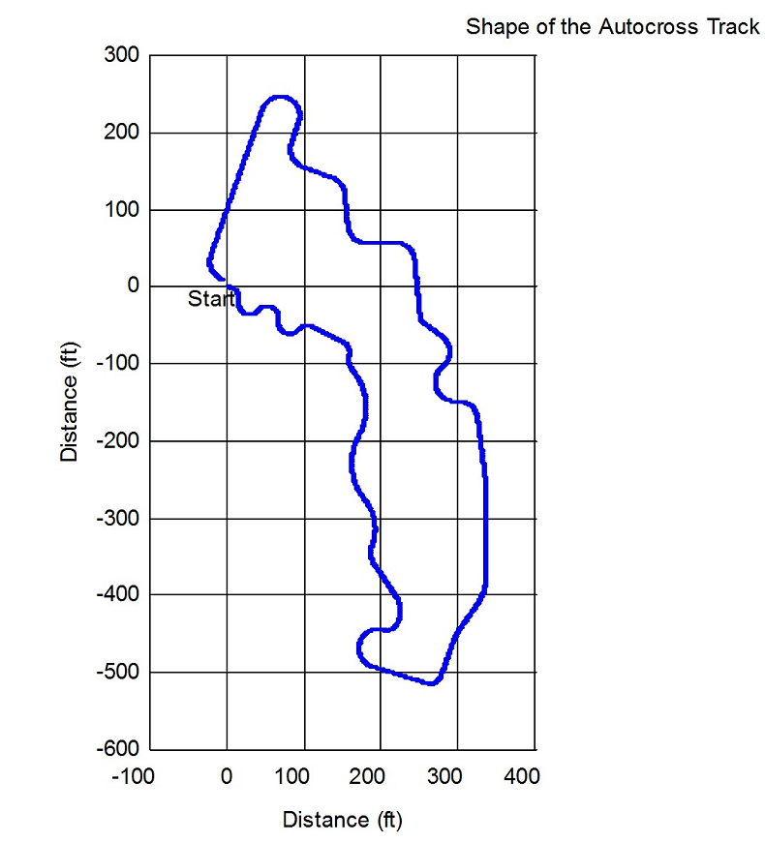

A

C

B

Figure : User Created Plot of the 2011 Autocross Event

Figure 4 is a user defined plot of the racing line for the 2011 autocross event. This data that is used for plotting is also used to create the event drive cycle. The performance simulation identifies acceleration, cornering, and braking zones to create a drive cycle unique to the track and vehicle parameters. The track plotting function can start with either a corner or a straight section with no limits on length or radius size. The labels on the track correspond to labels in Figure 6 to show the correlation between the track and the resulting drive cycle.

## Model Outputs

The outputs of the model include the predicted performance of each event, in time, fuel consumption, and competition score. Additionally the model plots the drive cycle of the autocross event. This plot is shown in Figure 6. Label A corresponds to the curves at the beginning of the course where a constant velocity is held. Label B corresponds to a straight section of the track where the vehicle reaches high speed. Label C corresponds to another longer straight section of track where the top speed is reached on the course.

C

Acceleration & Velocity during Autocross Lap

Time (sec)

Acceleration (ft/sec^2), Velocity (ft/sec)

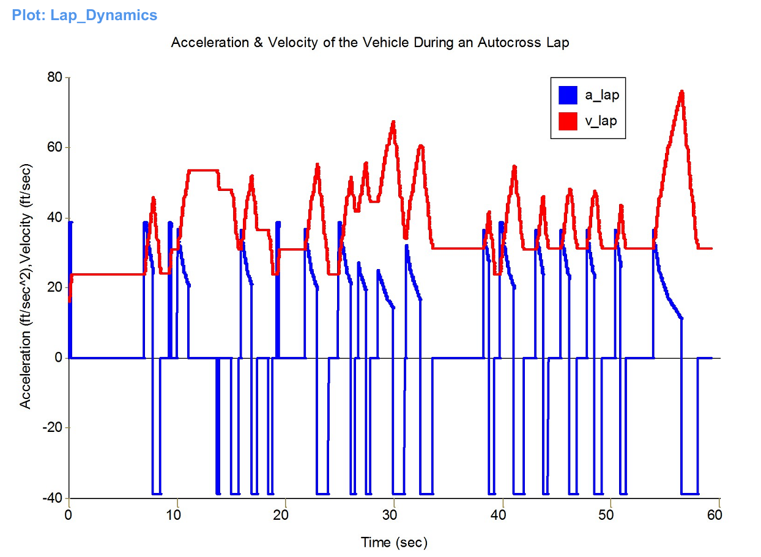

B

A

Figure : 2011 Autocross Drive Cycle Output

# CASE STUDY

The performance model was used to make design decisions for the Formula Hybrid SAE vehicle that is to compete in 2014 [20]. Various designs were simulated in order to find an optimum configuration within given parameters. The energy allocation between gasoline and batteries, as well as the coupling location between the electric motor and drive-train were chosen using the model. The vehicle was constructed and tested to validate the model used in its design. Table 3 shows the specifications for the vehicle.

Table : Vehicle Specs

|  |  |
| --- | --- |
| Engine | Yamaha YZ25F; Custom Fuel Injection |
| Electric Motor | Lynch LEM135DRAGS; 42 hp; 62 ft-lb peak torquue |
| Accumulator | Haiyin Pouch Cells; 111 V nominal; 6 Ah; 67C Peak Discharge |
| Hybrid Architecture | Post-transmission, parallel hybrid |
| Tires | 20.5” Hoosiers |
| Weight | 530 lbs. w/out driver |

In addition to full scale vehicle operation, testing included verifying model inputs such as the ICE torque curve and rolling resistance. The YZ250F torque curve was measured on an eddy-current dynamometer in an automated WOT acceleration test. Steady state fuel consumption measurements were also taken on the dynamometer. Figure 7 shows the torque and power of a quasi-dynamic WOT sweep and Figure 8 shows the steady-state bake specific fuel consumption measurements.

Figure 7: Automated WOT Sweep Torque and HP vs rpm

.

Brake Specific Fuel Consumption

rpm

Torque (ft-lb)

Bsfc (g/kW-hr)

## 

## bsfc2.JPG

Figure 8: Brake Specific Fuel Consumption

### 

### Drag Strip Test

The first event of the competition is the 250 feet acceleration event. At the competition this event is conducted in both electric-only mode and hybrid mode. In addition to these modes that occur at the competition, the performance model will also calculate ICE-only acceleration times. To test these predictions the vehicle was put through a simulated acceleration event. The competition uses transponders to measure times, but the team did not possess the equipment to utilize the transponders, thus the vehicle was timed with a stop watch. The vehicle begins from a standstill and accelerates through the 250 feet. Timing began with movement of the vehicle and stopped as the vehicle crossed the 250 feet mark. Times are reported in Table 4.

*Table 4: Acceleration Times*

|  |  |  |
| --- | --- | --- |
| **Mode** | **Test Time (seconds)** | **Model Prediction (seconds)** |
| ICE Only | 6.6 | 7.6 |
| Electric Only | 6.4 | 7.8 |
| Hybrid | 5.0 | 5.3 |

### 

### Autocross Test

A primary aspect of the performance model is to simulate laps around a track. A track of any geometry can easily be input to the model and theoretical lap times as well as fuel consumption estimates are output. To validate the performance model, as well as test the vehicle, a small track was layed out in an empty parking lot on the UI campus. The track was also input into the performance model allowing the resulting lap times and fuel consumptions to be compared. Figure 9 shows the lap from the TK model.

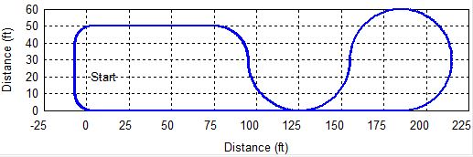

*Figure 9: Test Track Layout*

The vehicle was tested in two modes, ICE-only and hybrid. The testing included two runs for each mode, one at full race speed and one at a more conservative pace. Each run was nine laps traveling counterclockwise around the track for a total distance of one mile. To measure the fuel consumption of the vehicle under these operating conditions the fueling system was emptied, then refilled with a known volume of fuel. After each run the fueling system was then emptied again and measured. The distance traveled for each run was one mile thus the mpg was easily calculated for each run. Fuel consumption predicted by the model used a single average point method of 350 g/kw-hr estimation. The 350 g/kw-hr estimation is a result of averaging the fuel consumption measurements for all operating points. The results of the simulated laps for ICE-only and hybrid modes are summarized in Table 5 and Table 6.

*Table 5: ICE-Only Autocross Test Data*

|  |  |  |  |  |  |
| --- | --- | --- | --- | --- | --- |
|  | **Average Lap Time (s)** | **Fastest Lap (s)** | **Efficiency (mpg)** | **Average Engine Speed (rpm)** | **Max Engine Speed (rpm)** |
| **Run 1 (Fast)** | 20.4 | 19.4 | 17.6 | 7332 | 12728 |
| **Run 2 (Slow)** | 24.1 | 22.5 | 21.6 | 5826 | 7537 |
| **Model Prediction** | 18.8 | 18.8 | 22.0 | 11485 | 13650 |

*Table 6: Hybrid Autocross Test Data*

|  |  |  |  |  |  |
| --- | --- | --- | --- | --- | --- |
|  | **Average Lap Time (s)** | **Fastest Lap (s)** | **Efficiency (mpg)** | **Average Engine Speed (rpm)** | **Max Engine Speed (rpm)** |
| **Run 1 (Fast)** | 19.9 | 18.6 | 23.6 | 4367 | 9755 |
| **Run 2 (Slow)** | 25.3 | 24.1 | 18.3 | 3587 | 5009 |
| **Model Prediction** | 18.5 | 18.5 | 24.6 | 11450 | 13660 |

For the hybrid mode laps, it can be assumed that the performance of the batteries operated on the quasi-steady-state linear portion of their discharge curve. Any drop in voltage is a good indicator of capacity usage for the batteries. The fast hybrid run saw a drop in voltage of the battery pack from 116.5V to 113.6V, a 2.9V drop. The drop in voltage of the second run was from 113.6V to 110.1V, a 3.5V drop. It can be seen that the second run used approximately 0.6V more than the first run, indicating more battery power was used on the second run than the first [20].

# DISCUSSION

Comparison of the acceleration times predicted by the mathematical model to the times achieved in testing shows a slight difference. The model under-predicted the acceleration time of each mode, ICE-only, electric-only, and hybrid. The shifter was not operational during hybrid testing, therefore the discrepancy would only become larger considering the event should use four shifts to produce the best run possible. It is not obvious where the discrepancy lies. To account for the discrepancy, future work may further investigate and confirm the vehicle measurements used in the model such as the EM torque curve, however, additional analytical considerations may need to be included such as weight transfer due to acceleration and tire grip changing with temperature. The initial assumption is that the EM is producing much more power than its specifications indicate, but the ICE-only acceleration run was also faster than the model predicted, therefore the model must have some efficiencies and/or calculations that are too conservative.

Autocross times were very close to the model’s prediction; however, the model achieved its time with the use of shifting gears. The shifter was not operating correctly during testing; therefore, all testing was done in 3rd gear. Even by staying in a single gear, the vehicle was able to produce times close to what the model predicted. This indicates that had the shifter been working, faster times may have been achieved, and that the autocross testing would resemble the acceleration testing in that the vehicle out-performed the model’s predictions. This may be due to the how the model simulates cornering. In the model all braking occurs before a corner, a constant speed is then held through the corner, and acceleration occurs after the corner is completed. Though this is a decent assumption, realistically braking occurs during the corner, possibly using scrub resistance to help brake, and then acceleration occurs out of the corner, not once the corner is competed.

It can be seen that the fast ICE-only run used more fuel than the slow ICE-only run. This is the intuitive result expected. The hybrid runs, however, show a different trend. The fast hybrid run, which was the fastest of any run, was also the most efficient of any run. The slower hybrid mode run was less efficient. This is not intuitive, but other measurements support it. During the slow hybrid run the voltage drop of the accumulator was much greater than during the fast hybrid run. This indicates that the EM was taking on more load than in the fast run, yet the speed of the vehicle was slower. During the slow run the ICE was at a slower engine speed. Also, the battery voltage indicates the load on the ICE was less than the previous run. From the BSFC testing on the dynamometer, it can be seen that at low load and low engine speed the ICE is at a more inefficient operating point than at higher load and speed. This shows that to optimize fuel efficiency the vehicle needs to be operated such that the load is between 10 ft-lbs and 18 ft-lbs and the engine speed is between 5000 rpm and 9000 rpm. This is controlled by the driver shifting and throttling the vehicle appropriately.

# CONCLUSIONS

The objectives set forth at the beginning of this work were to create a user-friendly program that modeled and simulated the multiple energy sources, components, event drive cycles, and predicted competition scores. The model purpose was to improve overall performance and efficiency, reduce manufacturing costs, and shorten design time. It was to also have the ability to accurately simulate the vehicle and the event drive cycles that it would be racing on, to best predict its performance and its outcome at competition. Ultimately, this model was to be quick to pick up, easy to use, and most importantly, useful as both an educational and design tool.

The model that was created and discussed in this report met the objectives set forth. The model that was created has been deemed a viable program for vehicle performance modeling and simulation. The discussed model and simulation provides multiple vehicle performance metrics as well as simulation of every competition event along with an easy-to-use event track model. In addition the model has been created with the intent that it would continue to be improved upon in the future providing a sound base from which a powerful design tool can be created. The creation and implementation of this model has also shown the usefulness and opportunities of possessing a vehicle performance modeling and simulation program. Opportunities such as future areas of research and development both in the expansion of the performance model and in the physical vehicle design.

The future opportunities that could and should be pursued span powertrain control scheme implementation, regenerative braking, optimization, suspension design, chassis dynamics, third party user interface to improve usability to model validation, vehicle optimization, hybridization of the model, etc. As has been discussed previously the intent of the performance model and simulation presented in this report was to be a program that would expand and grow as more users became familiar with it. A list is provided below as a jumping off point for future research and model expansion:

* Improving the graphic user interface beyond the capabilities of TK Solver.
* Creating an ICE model that simulates the entire powertrain performance.
* Updating the electric motor model with empirical data to better reflect actual performance.
* Improve the ability to change powertrain layouts for comparison.
* Implement a dynamic cornering model with weight transfer, tire modeling, etc.
* Creation of a dynamic vehicle resistance.
* Improve the gear-train selection, shifting points, modeling and simulation.
* Implement a dynamic fuel consumption calculation method.

# REFERENCES

1. Dartmouth College. Formula Hybrid. Online. http://www.formula-hybrid.org/
2. Storms, Randall. “Fuel Injection and Intake/Exhaust Sizing of a YZ250F Engine for a Formula Hybrid Vehicle.” MS paper. University of Idaho, Moscow, 2009. Print.
3. Butsick, Brandon. “Design of a Hybrid Drivetrain for a FSAE Hybrid.” MS paper. University of Idaho, Moscow, 2011. Print.
4. Bashford, Brett. “Electric Propulsion Subsystem for a Parallel Drive Formula Hybrid Vehicle.” M.S. paper University of Idaho, June 2012. Print.
5. Ulrich, Joshua. “Real Time Optimized Performance Control of a FSAE Hybrid Vehicle.” MS paper. University of Idaho, Moscow, 2012. Print.
6. Wos, Samuel. “Hybrid Vehicle Mathematical Modeling & Drive Cycle Simulation.” MS paper. University of Idaho, Moscow, 2012. Print.
7. SIMPLEV, “Simulation Of Electric And Hybrid Vehicles”, Idaho National Engineering and Environmental Laboratory, Idaho Falls, ID 83415, USA, Available: <http://ev.inel.gov/simplev/desc.html>
8. K. Wipke, M. Cuddy, and S. Burch. “ADVISOR 2.1: A User-Friendly Advanced Powertrain Simulation Using a Combined Backward/Forward Approach.” IEEE Transactions on Vehicular Technology, Vol. 48, Nov. 1999, PP. 1751-1761. Print.
9. K. Wipke, “Using An Advanced Vehicle Simulator (ADVISOR) To Guide Hybrid Vehicle Propulsion System Development.” National Renewable Energy Laboratory (NREL), Golden, CO, USA, 1998. Online: <http://www.ctts.nrel.gov/analysis/documents/NESEA/>
10. Rousseau A. , “PSAT software for electric and hybrid vehicles.” Argonne National Laboratories, email: [ARousseau@perilous.es.anl.gov](mailto:ARousseau@perilous.es.anl.gov)
11. Southwest research Institute, “Modeling, Simulation, and Hardware-in-the-Loop Transmission Test System Software Development,” SAE Paper 2203-01-0673, 2003. Print.
12. OptimumG Offical Website, 8801 East Hampden Ave - Suite 210, Denver CO 80231 USA. online. <http://www.optimumg.com/>
13. Formula SAE Unofficial Student Forums, OptimumLap posts, online. <http://fsae.com/eve/forums/a/tpc/f/125607348/m/11120586151/p/1>
14. Shalygin, O. “FSAESim Offical Website”, <http://www.fsaesim.com/>
15. Bosch, “Lapsim Manual”, online. <http://www.bosch-motorsport.com/content/downloads/Software/ManualLapSimV2007.pdf>
16. Heath, R.P.G., C.Y. Mo. “A Modular Approach to Powertrain Modeling for the Prediction of Vehicle Performance.” Economy and Emissions, Ricardo Consulting Engineers Ltd, SAE 960427(1996). Print.
17. Thayer School of Engineering at Dartmouth, “2012 Formula Hybrid Rules.” Hanover, NH, 2012. Online. <http://www.formula-hybrid.org/pdf/Formula-Hybrid-2012-Rules.pdf>
18. “2012 Formula Hybrid Final Results.” Online. <http://www.formula-hybrid.org/history/2012-competition.php>
19. Drela, M. “First-Order DC Electric Motor Model. MIT, Aero & Astro.” 2007. Online. <http://web.mit.edu/drela/Public/web/qprop/motor1_theory.pdf>
20. Rinker, Dylan. “Use of a TK Solver Performance Model in the Design and Testing of a Formula Hybrid Racecar.” MS paper. University of Idaho, Moscow, 2013. Print.