Setup and File Transfer for Bridgeport
Using Hyper Terminal

Needed Software/Equipment
- Null Modem Serial Cable: 9 Pin(F)-25Pin(M)
- Hyper Terminal Software

Hyper Terminal Setup
- Start a Hyper Terminal session (Start>All Programs>Accessories>Communication>Hyper Terminal)

- Enter a name for the terminal session, choose an Icon and click OK.

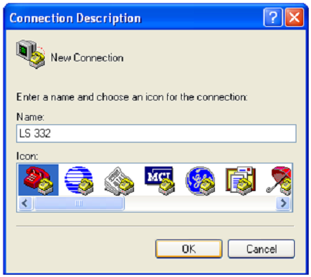

- Select the COM Port that will be used for the connection and click OK.

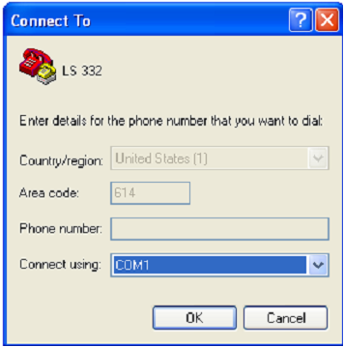

- Enter the following information on the COM1 Properties Screen and then click ok.
Bits per second: 9600
Data bits: 8
Parity: None
Stop bits: 1
Flow Control: None

- Click on the Properties icon.

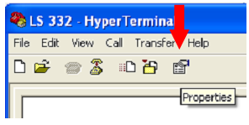

- Under the Settings tab, select VT100 from the Emulation drop down.

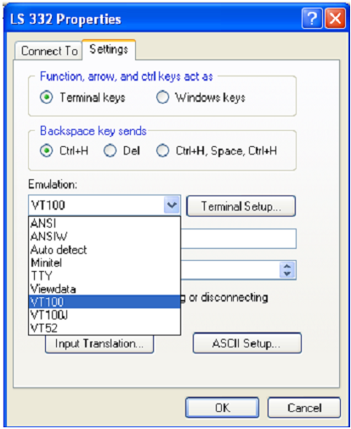

- Click on the ASCII Setup button and check all boxes except for Force Incoming Data to 7Bit ASCII.

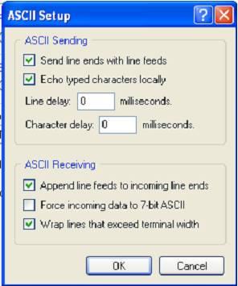

- Click OK twice to return to the terminal window. Click File then Save As and Save the Hyper Terminal to the Desktop.

Sending MasterCam Files via Hyper Terminal
- Save your Bridgeport file with eight characters or fewer using the .txt extension via MasterCam.
- After Bridgeport axis have been enabled and homed proceed to the main menu and follow these steps to begin loading your program by using the number and Function keys:
Load Remote (4) < RECVX ON/OFF (2) < LOAD (F3)
- Type the name of your MasterCam file with the .txt extension (e.g. COASTER.TXT) then hit enter.
- Open the Hyper Terminal from the desktop.
- Click Transfer and select Send Text File. Locate your MasterCam file and click open.
- Your file is then transferred to the Bridgeport and will be done once the Bridgeport confirms the last line of text received.

