INSTRUCTIONS:
The horizontal bandsaw is to be used to cut metal and plastic. Large, flat pieces should be cut on the vertical bandsaw, so it does not ruin the blade.
- Lift and lock hood with head feed speed control.
(DO NOT TIGHTEN TOO MUCH)

- Secure part in the vise using the vise hand wheel. (MAKE SURE THAT THE VISE IS SECURED AT 90°, IF ADJUSTMENT IS NEEDED, SEE TROUBLESHOOTING GUIDE)

- Adjust blade guide arm close to the part.
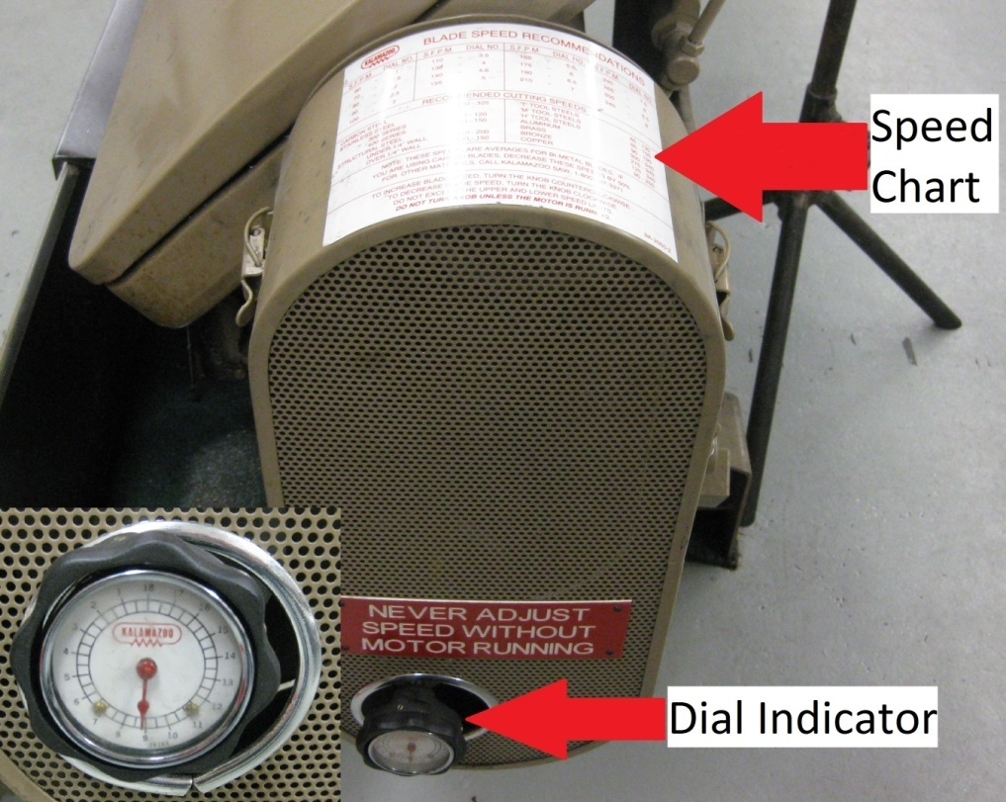
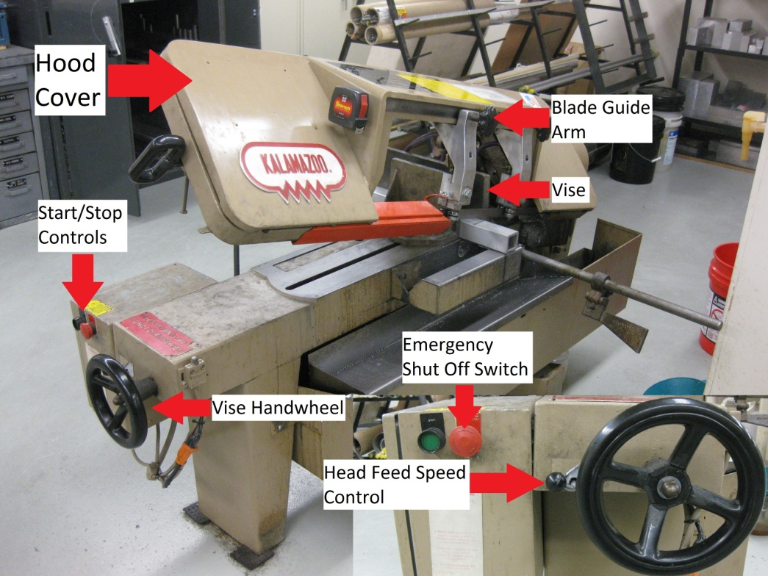
- Turn on machine.

- Set speed based on Speed Chart using the Dial Indicator.
  - 3.5-4 for steel
  - 8.5-9 for aluminum and plastic

- Verify that the coolant is turned on. (If it is not, see troubleshooting guide)

- SLOWLY lower blade using the head feed speed control. (FAILURE TO DO SO WILL DESTROY THE BLADE)

- The blade should stop when the cut is complete. If it doesn’t, hit the emergency shut off switch.

- Clean machine of debris (lift hood cover and vacuum around wheels)
FOR TROUBLESHOOTING AND MAINTENANCE TIPS, SEE TROUBLESHOOTING GUIDE

