TROUBLESHOOTING:

- There’s no coolant in the trough
  - Mix 0.5 quarts of cutting oil with 2.5 gallons of water and pour into trough

- The coolant is not pumping to the blade
  - Turn the pump on, the switch is located beneath the vise hand wheel

- There is not enough coolant getting to the blade
  - Adjust the coolant adjusting valves

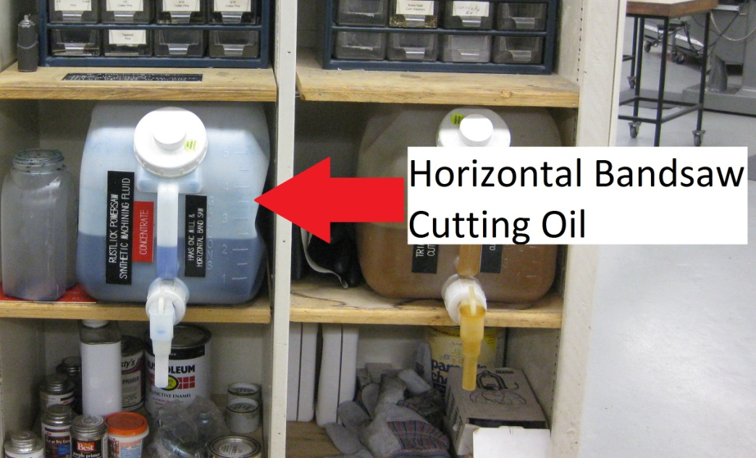
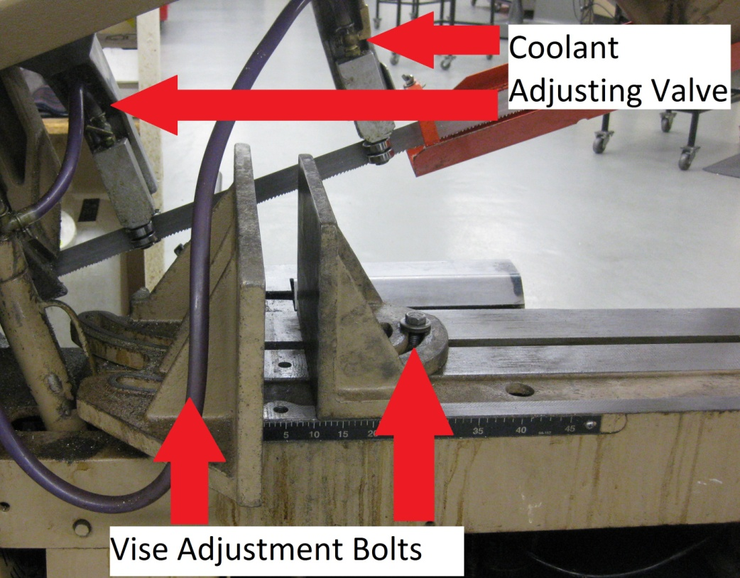
- There is a puddle of coolant beneath the motor
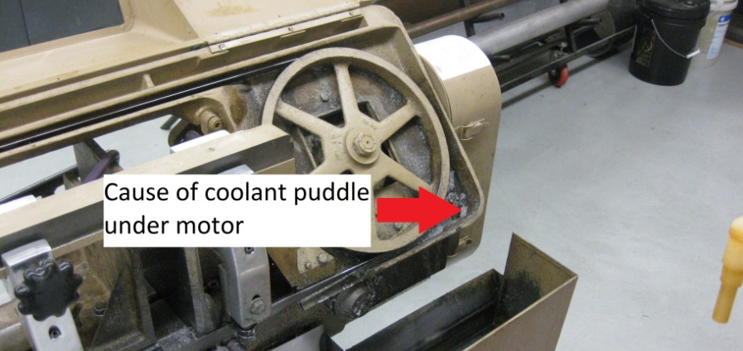
  - Clean the shavings built up under the hood cover of the saw

- To get a cut to be a angle different than 90°
  - Loosen the vise adjustment bolts and turn the vise to the angle desired
  - Remember to put the vise back to 90° to the blade when done

