.. HAAS Lathe Tutorial
(Print this tutorial out and follow step-by-step)
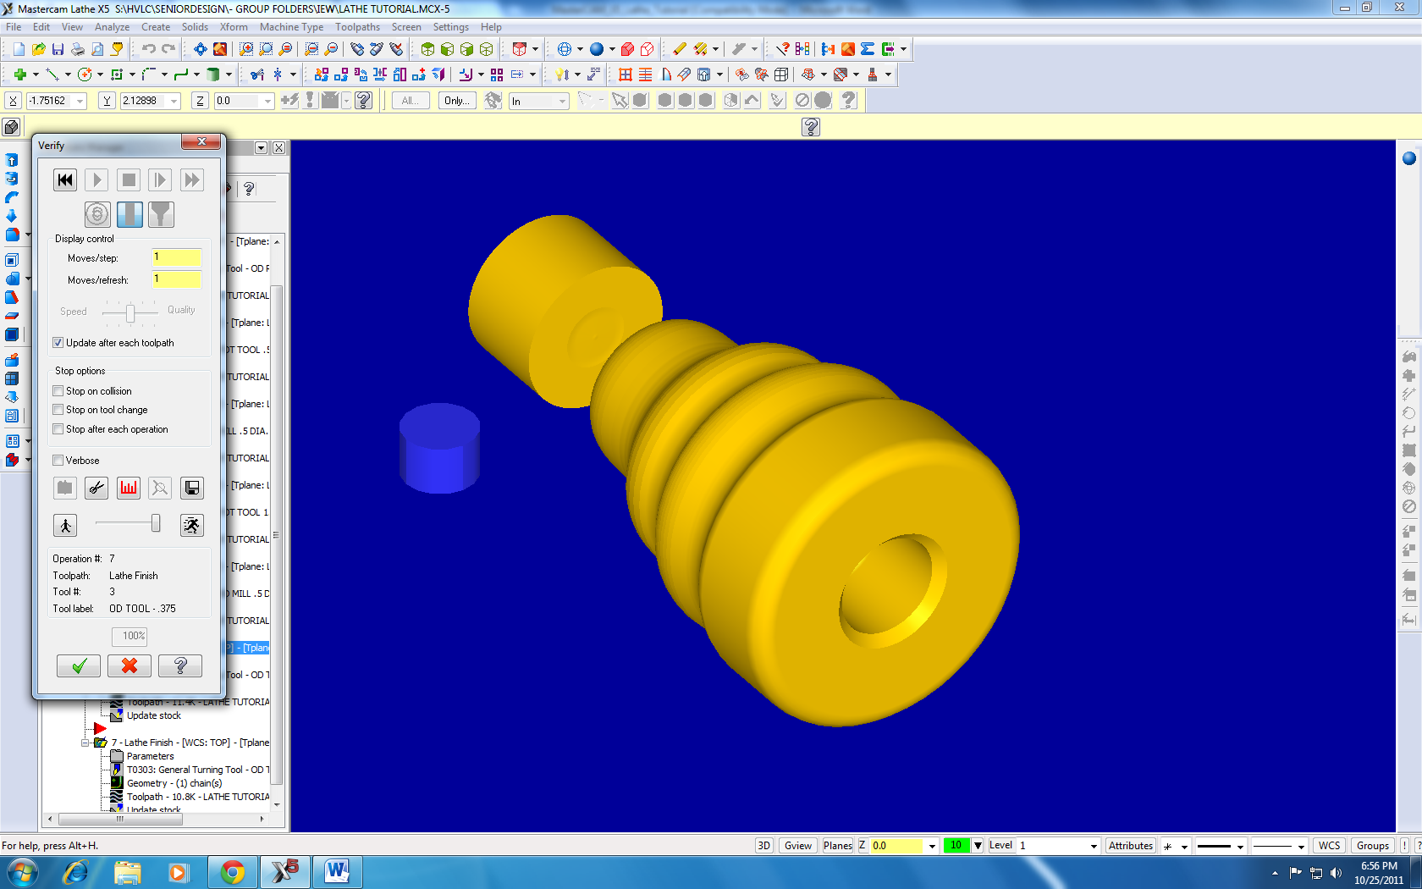
- After reading the Mastercam X5 HAAS mill tutorial and finishing it to receive the basics. Load the Solidworks file Lathe Tutorial.
- Open the file in SolidWorks and select the wireframe option and save it as an IGES file. 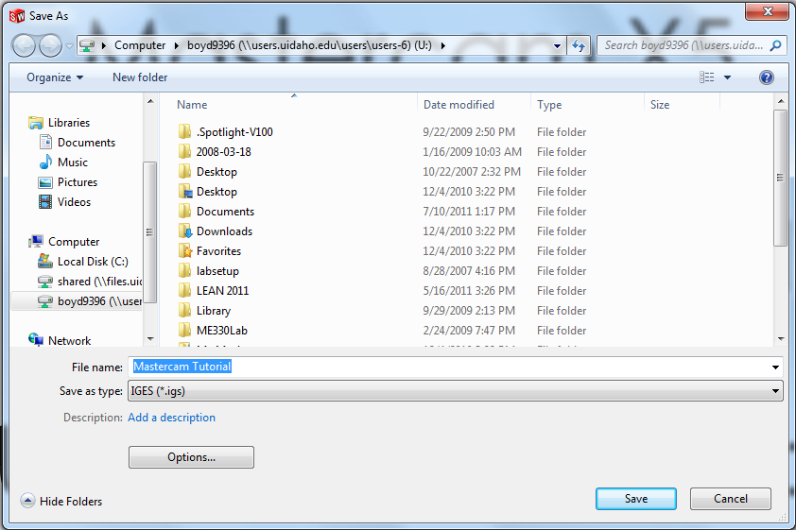

Be sure to check the “IGES wireframe” option.
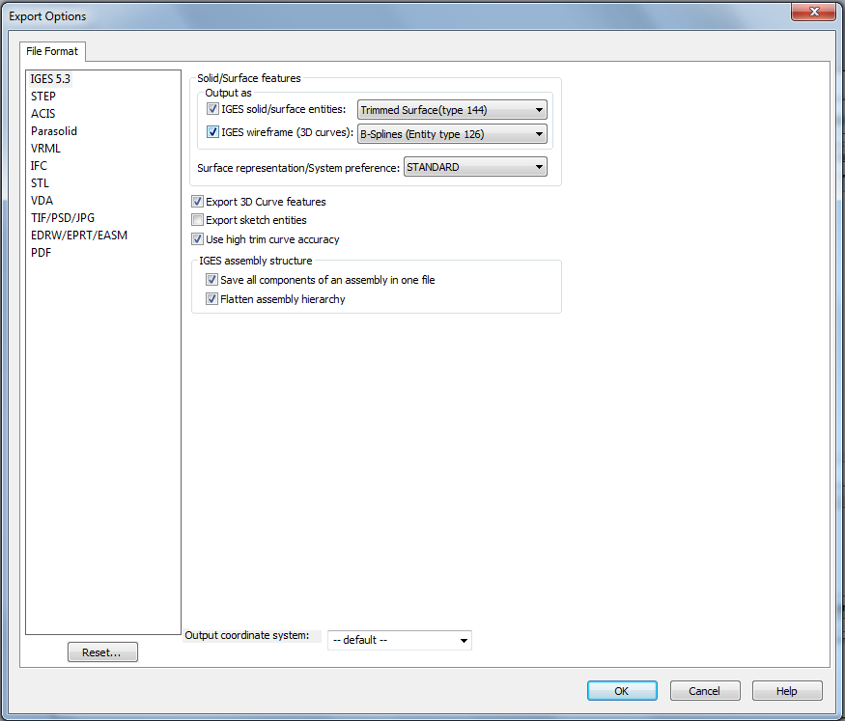
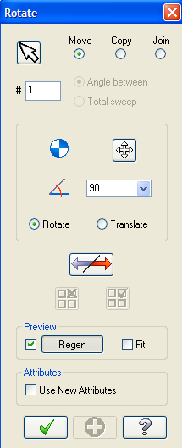
- Open the part in MasterCam X5.
- Once the part loads click Fit 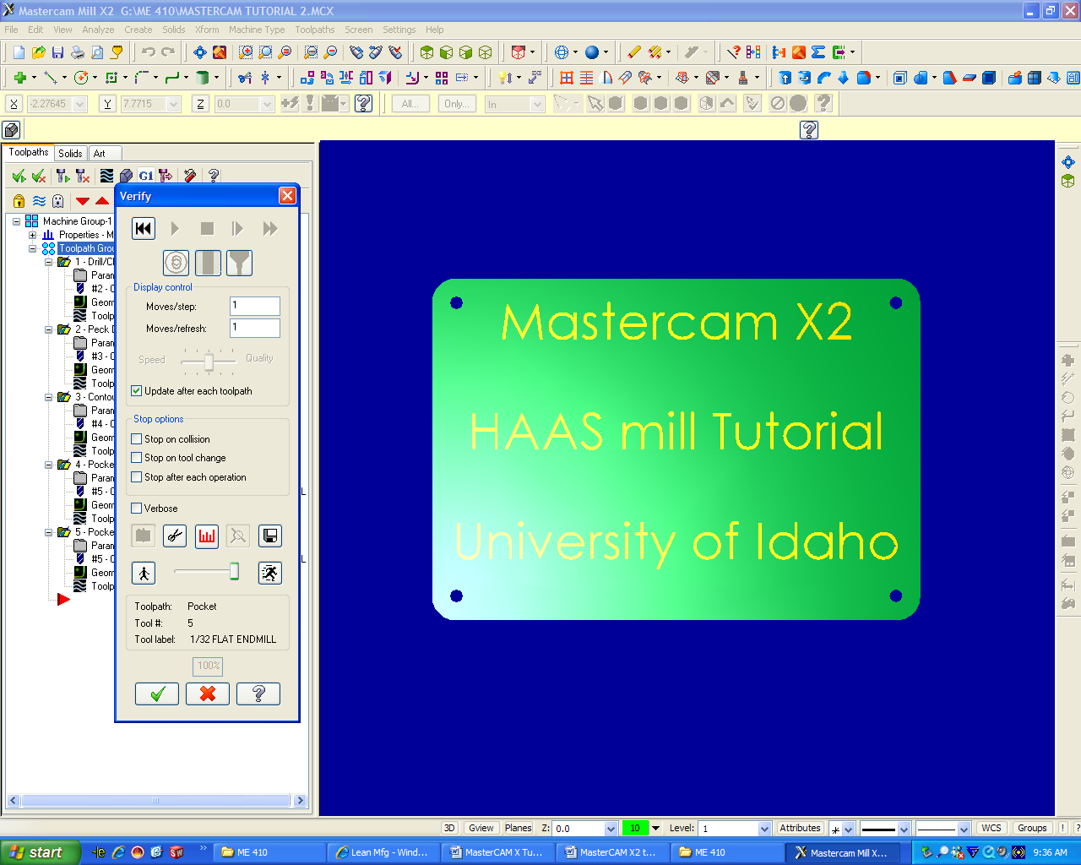 to see the entire work piece.
- Align the part to a usable orientation, in order to do this we want the part to be facing right from a top view with the axis of rotation along the X-Axis. (refer to Mill Tutorial for object orientations)
- For a more visual representation of the origin and the HAAS axis press F9. To make sure that the part is oriented properly click on the Top View . In this view the part should be oriented as you would see it on the lathe, with the face of the part .05 inches from the origin to allow for facing of the stock.
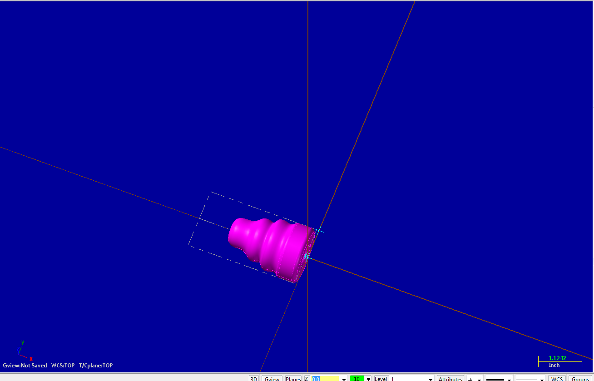
- Before starting the tool paths, define the machine that you will be using. To do this click Machine Type (found on the top toolbar), Mill, and select the HAAS CNC Lathe.
Note: If the HAAS CNC Lathe is not an option select Manage List, HAAS Lathe, and then Add to add it to the list of machines. This allows the final code to be posted to the HAAS CNC Lathe.
- Under the tool paths tab on the left in the design tree, you will notice that some new items have appeared. Expand the properties menu and click on stock setup .
- Click on the properties under the stock setup area and left spindle setup.
Machining Note: At this point you will need to enter coordinates for the lathe tools that allow you to remove material. The machine will know only where the actual zero origin is so it is important to write down the relationship your origin has to the face of the part as well as the diameter of your stock.
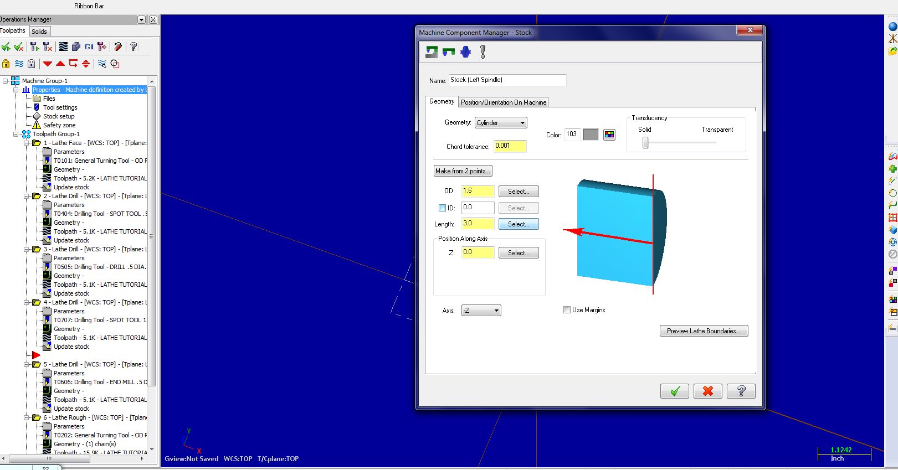
Now that the stock has been defined it is important to make sure that it encompasses the entire part and is directed along the correct axis. If you have any issues with this please make sure that you have your part oriented correctly.
- Before continuing the part should be saved to your personal folder or other media (NOT the same location as the tutorial).
- Next we will face the part: Under toolpaths, select lathe toolpaths and then face. Select a right hand rough facing tool. Now you will select your speeds and feeds.
Note: Refer to the speeds and feeds chart on the mindworks website (http://www.webs1.uidaho.edu/mindworks/machine_shop.htm ), and remember to differentiate between carbide and high speed steel cutting tools.
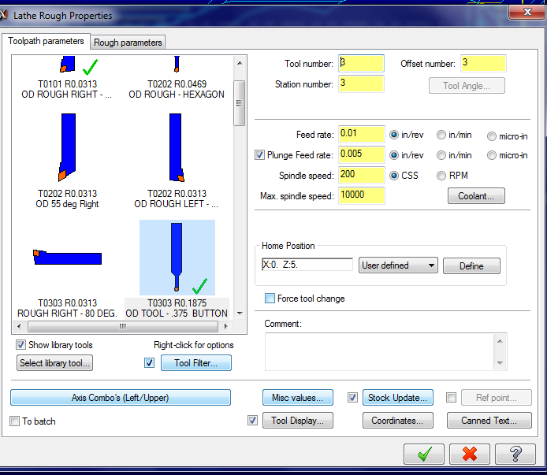

- When cutting on the OD cuts should take off no more than .05 on the diameter during a roughing pass, and no more than .008 on a finish pass. With all contours, facing, OD or ID turns it is important to turn on CSS (Constant Surface Speed), and can be seen right next to the spindle speed information input. The CSS will speed up the lathe according to the real diameter of your part as it is being turned down. The speeds for this are approximately 65 for Stainless Steel, 100 for Steel, 140 for Aluminum, and 180 for Brass. Feeding too fast can cause problems for both parts and tools, so it is important to feed at approximately .003 for SS, .005 for Steel, .007 for Aluminum, and .008 for Brass. These values can be adjusted if the material is coming off well. The other important thing is that when you are parting off a finished product you should feed at half to a third of the speed.
- Tab over to the face parameters and enter the entry amount, overcut amount (keep the other side in mind, and your stock size), and finishing parameters all in the same screen.
Machining Note: For the lathe often you will want to switch between roughing and finishing tools, so you may opt to leave stock on the face or walls. Reminder when cutting on the face with a roughing tool you should take steps of no more than .03 with a roughing tool, and no more than .005 on a finish pass.

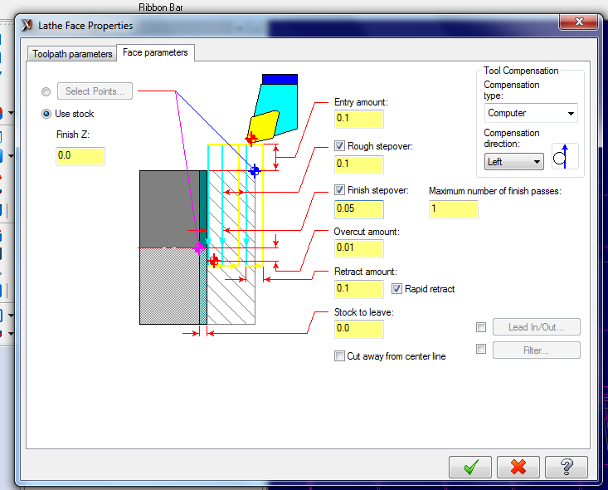
- Click ok, and regenerate the toolpath if it does not automatically update. The toolpath should run right along the face of the part and have no collisions and make the stocks outline disappear where the tool would have passed.
  - Click to select all operations.
  - Click to regenerate all tool paths.
  - Click to verify operations.

- Now Click the dropdown menu and select a drill toolpath. This will be very similar to the drilling operation on the mill, but will require the use of different parameters. We will start with a center drill, follow that up with a 3/8” drill, and finish with a ½” center cutting endmill.
Machining Note: This can all be done with the same type of operation but depths need to be specified and the operation needs to be changed for peck drilling and simple drilling.
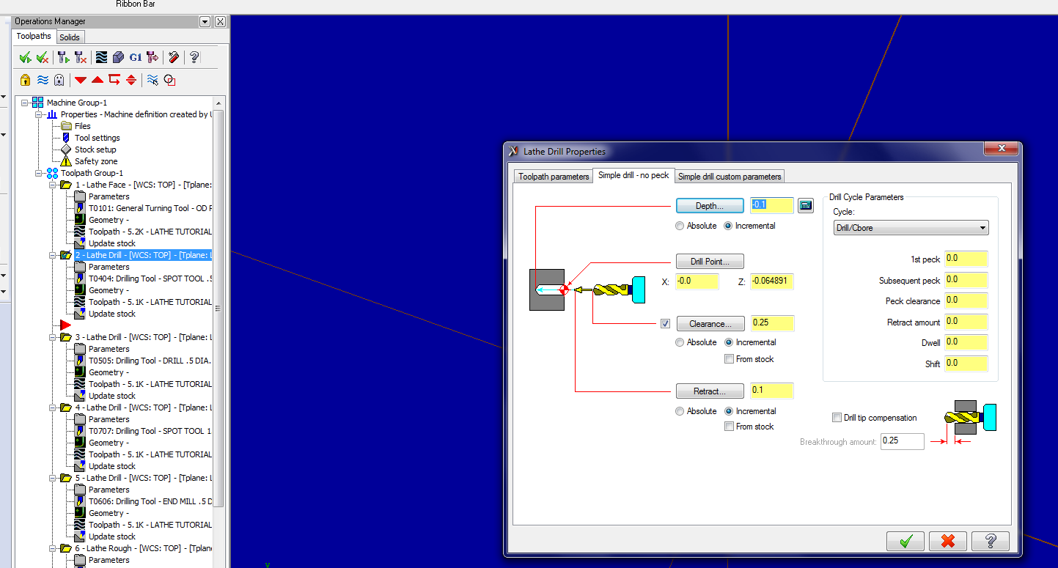
- Now right click the design tree on the left side of the screen, select Lathe Toolpaths then select Rough from the drop menu. Then choose a tool that would be used for an outer diameter or OD turn. Then you will have to select a chain, which is the tool’s cutting path while the lathe is turning.
Note: Make sure to read the prompts at the upper left of the part window, they will give you hints as to how to properly select your chain. The chain must have the starting link selected, and then the final link, then each branch point.
- Now you may notice that the toolpath throws several warnings when it is trying to create. This is important to recognize because we have to create tooling geometry so that the roughing passes do what we need them to. We do this by creating a series of lines from the base of the spline and outward in a procession as shown here. These lines are an important part of any complex geometry so that the roughing pass can leave an appropriate amount of material.
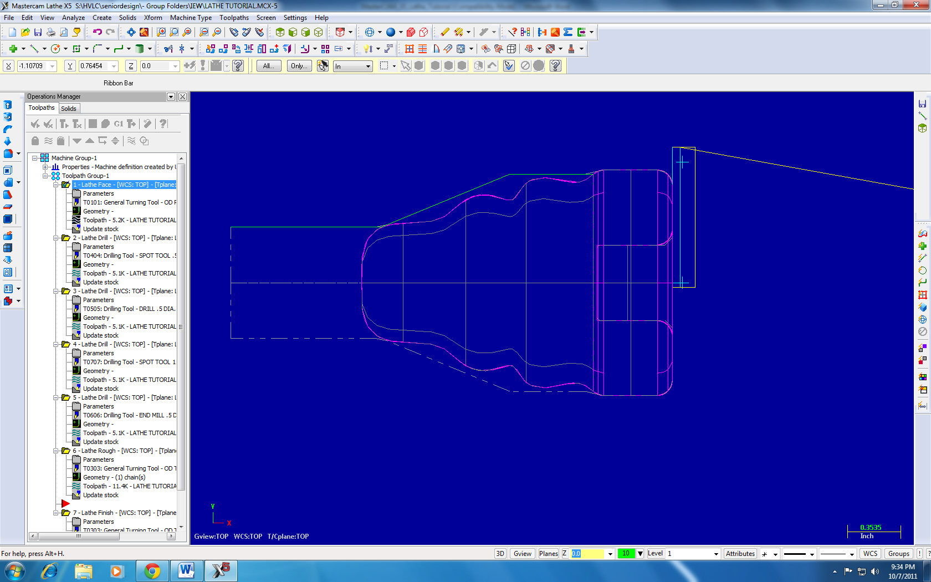
- Now tab over to Rough parameters, and change the settings as necessary. This pass will require the changing of the rough direction drop down menu to OD turn. This will be important for making the toolpath generate correctly.
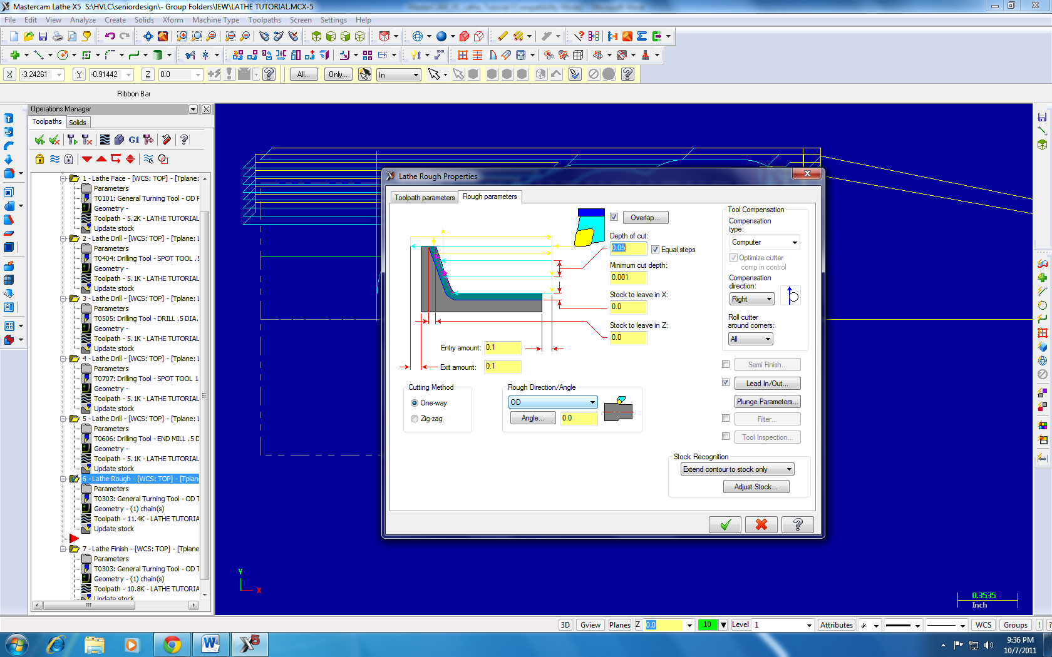
- Finally, we will want to give this part a finish pass that will finish all of the contours and part off the finished product.
- This contour select will be the radiuses and the spline which will make the part a finished product. At this point the program should be completely back plotted or modeled using the tools that are part of Mastercam.
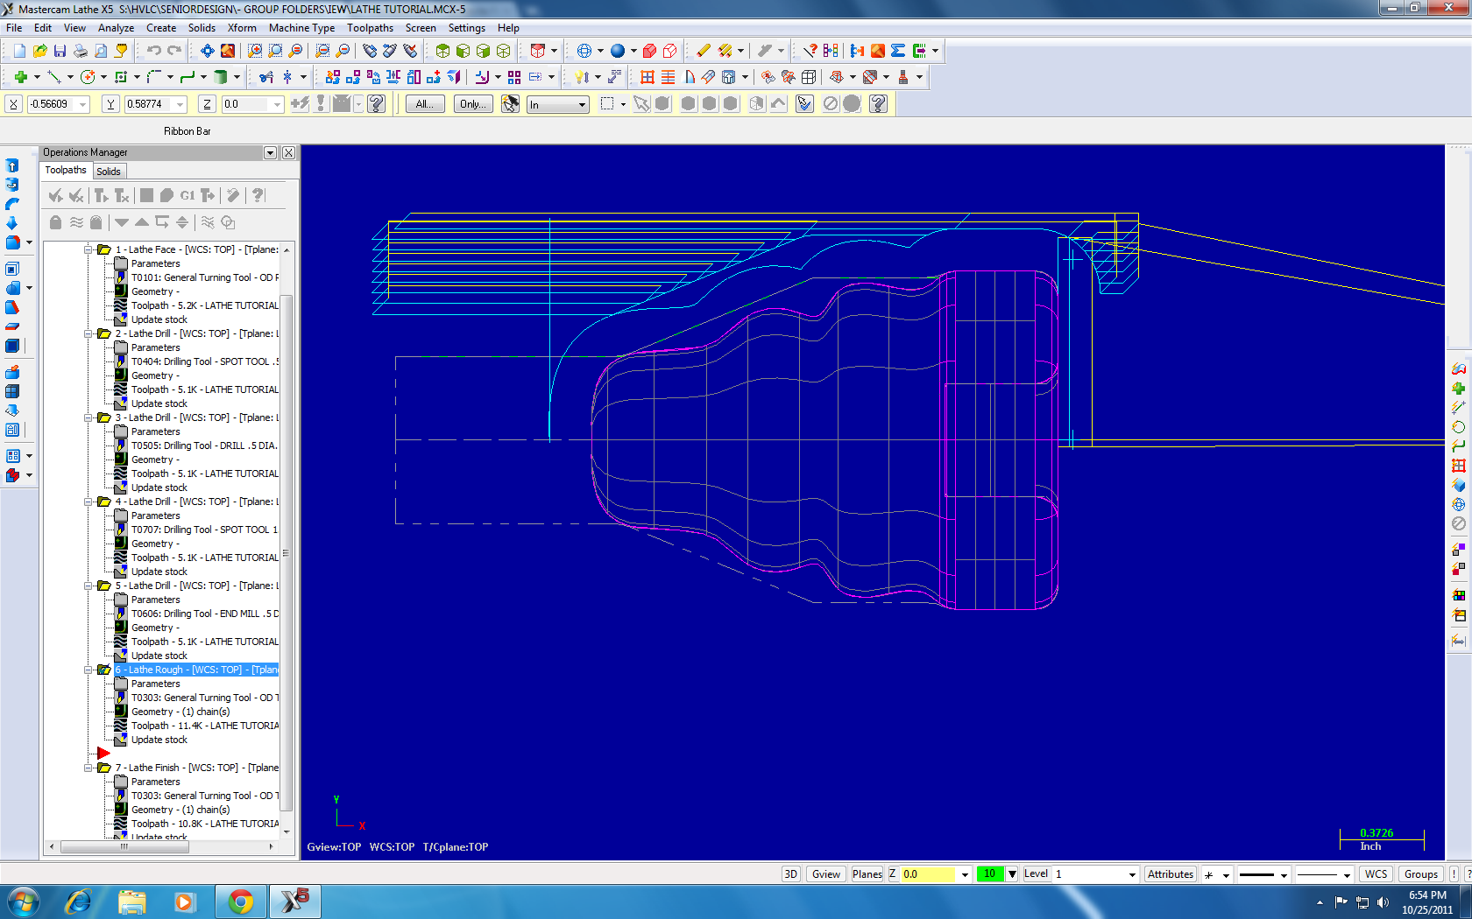
- Your CNC code should now be finished. To verify the operations:
  - Click to select all operations.
  - Click to regenerate all tool paths.
  - Click to verify operations.
- For posting the code that you have just written, go to http://www.webs1.uidaho.edu/mindworks/machine_shop.htm and select the tutorial on posting the “G1” code to the HAAS mill.

