Appling Images, Text, and Color to Materials

By Amanda Battles June 1, 2012

Engraving
Engraving is the practice of inscribing a design on to a hard surface by cutting grooves into it. The result is your image permanently engraved on the object. Engraving can be done in metal and plastic. Colors can be achieved by painting the surface and then the engraved area will be the color of the material be it aluminum, brass, etc. as shown in Figure 1.
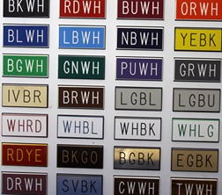
Figure 1: Engraving Example
Also you can fill the can fill in the engraved text with paint to highlight it as shown on the ThinkTank sign in Figure 2. “ThinkTank” is engraved in to the metal and “University of Idaho College of Engineering” is engraved and then filled in with black paint.
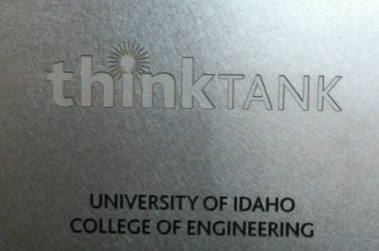
Figure 2: ThinkTank Sign
Engraving can be done by Precision Engraving or you can use the CNC mill in the shop. The University of Idaho Art and Architecture wood shop’s laser cutter can engrave plastic (and wood).
Summary of Engraving:
- Very durable
- Can outsource or do in house
- Some coloring options

Etching – Chemical Etching or Abrasive Blasting
Etching is a process where strong acids or abrasive material is used to cut into unprotected parts of a surface to create a design. The process begins by covering up the parts of the material that you don’t want etched with wax or some other substance. Then you expose the material to the etching process and your design is created. It is most commonly done to glass but is often done in metal as well. An example is shown in Figure 3.
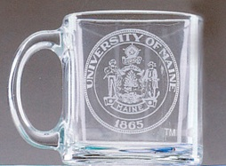
Figure 3: Abrasive Etching Example
Locally, Precision Engraving does their etching with sand blasting and you can also use the ME Shop’s bead blaster to do small etching projects. A vinyl sticker will sufficiently protect the area you don’t want etched using the ME Shop’s bead blaster. There is no way to add color to your part with etching.
Summary of Etching:
- Very durable
- Can outsource or do in house
- No coloring options

Laser Printing
For laser printing your piece of a material is covered in a special ink. Then the piece is put into the laser machine. The laser will follow a desired pattern and where the laser hits the paste it will burn the metal leaving the image behind. Figure 4 shows an example of laser printing on stainless steel.
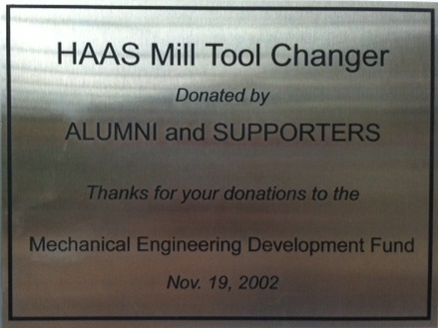
Figure 4: Laser Printing on Stainless Steel
Currently you can only print in black as other color inks have not been developed. You have some color options as you can print black different colored metals. Figure 5 shows an example of black printing on brass to achieve a gold color.
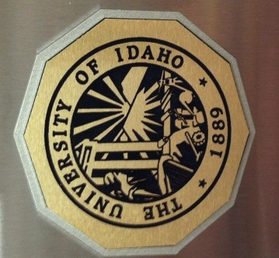
Figure 5: Laser Printing on Brass
Precision Engraving has a laser printer and can do up to 24 inch flat pieces. As this method does not cut into the material, it is easier to clean but still very durable.
Summary of Laser Printing:
- Expensive
- Very durable
- Does not remove material
- Limited color options

Anodizing
Anodizing is basically a series of chemical baths that prep the metal’s surface for accepting a dye. A strong acid purposely corrodes the outside layer making it porous. After rinsing the part to be anodized is put into another bath while being electrically charged, the dye is oppositely charged and by attraction the dye is absorbed into said porous layer of the metal. This leaves a very vivid layer of color that dries as smooth as the original metal. An example is shown in Figure 6; the part was anodized black with the University of Idaho in yellow.
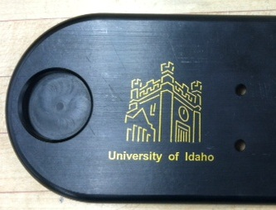
Figure 6: Anodizing Example
Anodizing only works with certain types of metal, aluminum is most common. You can color the entire part or do images and text. The University of Idaho does their anodizing with Deming Industries in Coeur d’Alene (demingindustries.com). Figure 7 shows the colors that Deming has available. For more information, go to the MindWorks website and on the Machine Shop page you will find a document on anodizing.
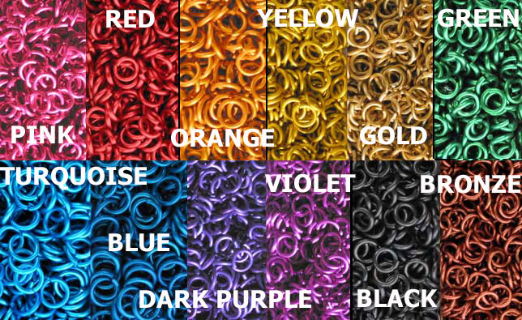
Figure 7: Anadizing Colors
One benefit of anodizing is that because you have to setup a large chemical bath the cost is very similar if you do one part or multiple parts.
Summary of Anodizing:
- Very durable
- Best method if needing multiple parts
- Only works on Aluminum
- Only way to color an entire part

Stickers and Decals
This is by far the cheapest, easiest, and quickest route to go to put images and text on a surface. They are not as durable on metal as the other methods but you can stick them on about any surface.
There is no technical difference between a ‘sticker’ and a ‘decal’ but they generally used to signify different things. A sticker is printed on low grade paper (but can be done on heavy duty material) while a decal is printed on outdoor duty vinyl and is die-cut leaving no background.
Stickers are traditionally printed in a rectangular or circular shape. If you are looking to get the appearance of text without a background you could print on to a transparent sticker. Examples include bumper stickers, some warning labels, and stickers in children’s sticker books. Stickers vary in price ranging from $0.50 to $10.00. You can by the material and print yourself or any of the office/printing places locally can print them for you. The University of Idaho Copy Center prints stickers on campus. They charge around $0.50 for a half sheet white background and $1.25 for a half sheet transparent background.
A decal is more complicated but will last longer than a typical sticker. It consists of a front and back removable layer with vinyl and adhesive in the middle. To apply you peel off the backing revealing the adhesive side of the vinyl. You stick it on to the desired surface and remove the front layer as shown in Figure 8. The result is an image that is ‘cut out’ or floating. Decals are commonly used to put advertising on cars.
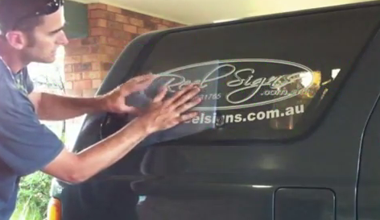
Figure 8 Applying a Decal
Decals would be the most economical way to do very large images and text. Allegra Print and Imaging has a vinyl cutter in Pullman (they do have an office in Moscow as well). They charge $12 a square foot with a $25 minimum charge with fees varying slightly depending on the job. They can print several colors on the vinyl or you can do single color decals.
Summary of Stickers and Decals:
- Cheapest and quickest
- Least durable
- Best option for very large images and text
- Lots of coloring options

Appling Images, Text, and Color to Materials

Outsourcing Options
 | Engraving | Etching* | Laser Printing | Anodizing* | Stickers | Decals*
Cost | $$ | $$ | $$ | $$ | $ | $
Lead Time | 1 week | 1 week | 1 week | 1 week | 1-4 days | 3-4 days
Durability | High | High | High | High | Low | Low
Color? | Can use paint | Same color as material | Black print on material color | Many | Many | Many
Metal? | Yes | Yes | Yes | Aluminum | Yes | Yes
Plastic? | Yes | No | No | No | Yes | Yes
Glass? | No | Yes | No | No | Yes | Yes
Vendor | Precision Engraving | Precision Engraving | Precision Engraving | Deming Industries | Many | Allegra Printing
Location | Moscow | Moscow | Moscow | Coeur d’Alene | Moscow | Pullman
*Etching is done at Precision Engraving with sandblasting
*Anodizing can only be done to aluminum and is the only method where you can color an entire part
*A decal is referring to an image die-cut out of vinyl with no background

In House Options
 | CNC Engraving | Bead Blasting | Laser Engraving | Stickers
Cost | Shop Time | Shop Time | Wood Shop Fee | Paper cost
Setup Time | High | Medium | High | Low
Durability | High | High | High | Low
Color? | Same color as material unless you use paint | Same color as material | Same color as material | Many
Metal? | Yes | Yes | No | Yes
Plastic? | Yes | No | Yes | Yes
Glass? | No | Yes | No | Yes
Location | ME Shop | ME Shop | Art & Architecture Wood Shop | U of I  Copy Center

Image from http://www.albestamp.com/namebadgessigns.html
Image from http://www.wausauawards.com/glass-etching.htm
Image from http://www.youtube.com/watch?feature=endscreen&NR=1&v=3_cO57auO8I

