Water Jetting
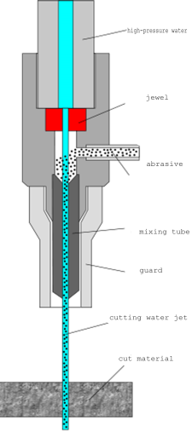
Water jet cutters use high pressure water forced through a nozzle to cut though materials. These materials can be either dense such as steel or granite or light weight such as wood or foam. To cut denser materials, an abrasive such as sand, garnet, or aluminum oxide is often added to the jet in the nozzle. Water jetting has many unique advantages to offer when compared to other traditional machining methods. Some of these advantages include being able to cut multiple layers without bonding the edges, no toxic fumes, the elimination of the heat effected zone (HAZ) of the material being cut, and its ability to be used to perform very intricate cuts and carve away the material.

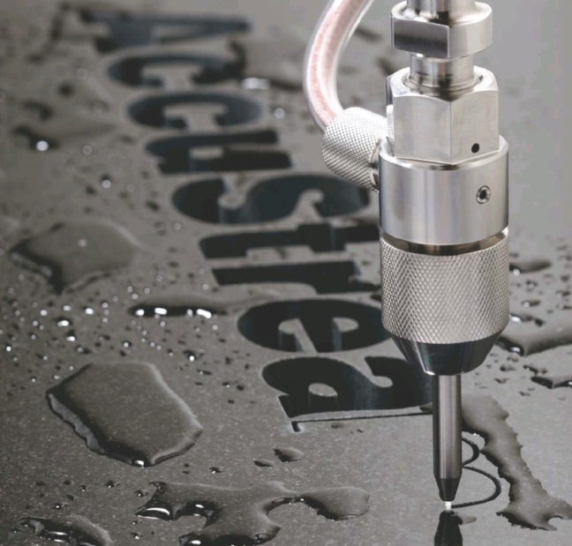
Uses:
- Cutting
- Shaping
- Carving
- Reaming

Tolerance:
+/- 0.005 (Average)
+/- 0.001 (High accuracy machines)

Advantages:

- Does not heat up material or change physical properties
- Easy to cut complex shapes at a relatively high speed
- Metal does not collect slag during this operation
- Can cut layered materials without bonding them
- Can cut heat sensitive materials such as wood and fabric
- Relatively low cost, quotes are available at most companies

Disadvantages:

- Cutting thick pieces causes a decrease in dimensional accuracy and the quality of the cut
- Accuracy of cut is directly proportional to the depth of the cut

Companies offering Services

Precision H2O

6328 east Utah Avenue
Spokane, WA 99212

PH: (800)-425-2098
Web: http://www.precisionh2o.com

Additional capabilities:
- Finish machining
- material bending
- welding
- sandblasting
- de-burring
- coatings

Nott-Atwater Company

1309 North Bradley Road
Spokane, WA 99212

PH: (509)-922-4522
FX: (509)-922-9820
Web: http://www.nottatwater.com

Additional capabilities:
- Prototyping
- die cutting
- CNC knife cutting
- Extrusions
- custom seals
- custom fabrication
- Kiss cutting

Spokane Water Knife

1514 E. Riverside
Spokane, WA 99202

PH: 509-536-6643
FX: (509)-535-0910
Web: http://www.spokanewaterknife.com

Additional capabilities:
- CNC milling and lathe work
- forming
- powder-coating

Forest steel

7448 Aqua Circle
Dalton Gardens, ID 83815

PH: (208)-762-4766
FX: (208)-762-5210
Web: http://www.foreststeel.com

Additional capabilities:
- Laser cutting
- Flame cutting
- Plasma cutting
- Breaking
- Shearing
- Sawing
- Steel rolling

Additional Information:
- Large stock of material on hand
- Ships to Pullman regularly

