Practice Problems (8 points)
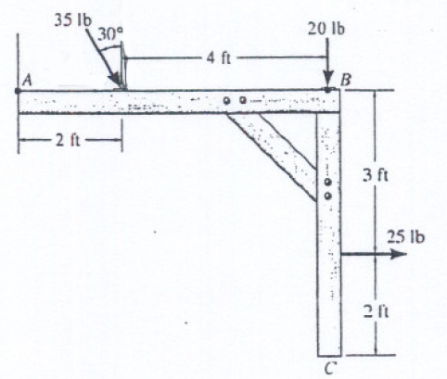
- Using the figure above, find the equivalent force [lb_{f}] and couple moment [lb_{f}-ft] acting at point A. Note, the 35 lb_{f} force is acting at an angle.

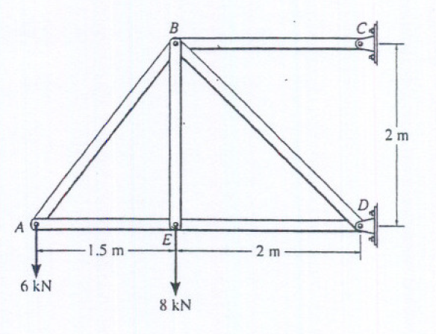
- Using the figure above, draw a FBD of the entire truss assembly, and from this determine the following:
  - Reactions at C and D [kN]
  - Force in member BD [kN]

Preparation for Next Class Period (10 points)
Dig back in your memory bank to when you took ENGR 210 (Statics) to answer the following questions.

- Visit the MecMovies site (https://web.mst.edu/~mecmovie/). Review the four sections under the “Home” link (Title, About, Navigation, and Objectives). According to Dr. Philpot, what is the difficulty in learning Mechanics of Materials?
- Which two concepts or topics in Statics were hardest for you to learn?
- Which two course topics in Statics are you least confident in?
- What are three resources you have to help get up to speed on Statics materials you’ve forgotten?
- On a separate piece of paper (not stapled to this homework so you can turn it in separately), bring in the hardest problem you can remember from your Statics class. If you have a solution for it, you can attach that as well. Make sure your name is on the sheet, and turn this in to a separate pile when turning your homework in at the beginning of class.

