Practice Problems (8 points)
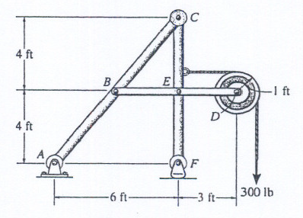
- Using the figure above, draw appropriate FBD’s to find the following:
  - Reactions at A and F [lb_{f}]
  - Horizontal force [lb_{f}] at point C which member ABC exerts on member CEF

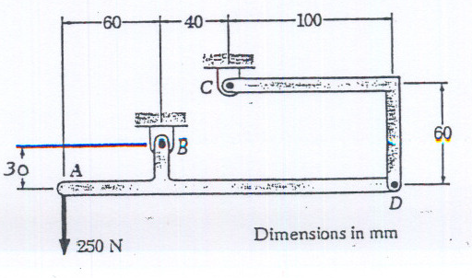
- Using the figure above, do the following:
  - Draw a FBD of member ABD and show all the forces acting on the member
  - Find the magnitude of the force at B [N]
  - Find the magnitude of the force at C [N]

Preparation for Next Class Period (4 points)
Dig back in your memory bank to when you took ENGR 210 (Statics) to answer the following questions.

- Visit the MecMovies site (https://web.mst.edu/~mecmovie/). Review the movies for section 1.1 and section 1.2. What are two things you already knew before watching these modules? What are four new things you learned through reviewing the modules?
- On the MecMovies site, under “Assignments” and “Checkpoints Try One”, complete the two concept checkpoints for M1.2. Attach your documentation for these problems.

