Practice Problems – Short Documentation (16 points)
For these 4 problems, the Given, Find, and Solution are the only required documentation.

- Work the MM Checkpoint M2.3. There are three sets of problems. The first set has two questions, and the next two sets have one problem each. You should be working four problems.
  - Attach your work showing how you got to your answers (you do not need to document this as an engineering solution)
  - After the fourth problem, when you click “continue” it should take you to a page you can enter your name and print off your results. Print this page and attach it behind your work in part a.
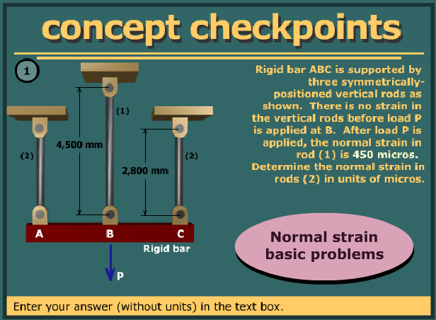

- In the figure below, two bars are used to support load P. When unloaded, the joint B is at position (0,0). After load P is applied, joint B moves to position (-0.55 in, -0.15 in). Distances are:
  - 15 ft
  - 27 ft
  - 11 ft
  - 21 ft
Determine the normal strain in bar (1) and bar (2).
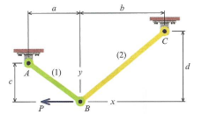

- The figure below represents a sanding drum for use on a hand drill or Dremel tool. It has a rubber core, and when the nut is tightened it causes the length to shorten and the diameter to expand (holding on a sleeve of sandpaper). For the sake of this problem, assume the density of the rubber stays constant. If the initial diameter is 2.00 in, and when tightened the diameter grows to 2.15 in, find the following:
  - Along the axis of the cylinder, what is the normal strain?
  - On the outside edge of the rubber cylinder, what is the circumferential strain?
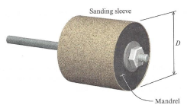

- Describe the normal strain in the tungsten cable that was suspended from the high-altitude balloon from HW3? What is the normal strain in the cable right next to the ground? What is the normal strain of the cable near the balloon? Use the answers to those questions to describe the strain as a function of height from the ground.

Preparation for Next Class Period (6 points)
Note: Write down enough to show that you’ve done the following things to prepare for our next class session. This part of your homework can all be on a single page. It can be typed up, hand-written, or a combination of both. Put this at the end of your homework packet.

- TB Reading 2.3 and 2.4
  - What is the sign convention for shear strain? What are the units for shear strain?
  - What Greek letter is used to represent thermal strain? What are typical units for the coefficient of thermal expansion?
  - How does temperature change effect normal strain in a part?
  - What are two applications where you can use thermal strain to your advantage?

- Review the various shear strain presentation in MM Module 2.5. Make sure you have a solid understanding of the following concepts:
  - What does shear strain represent?
  - What does positive shear strain look like? What about negative shear strain?
  - How do you calculate the change in angle at the corner P?
  - Can you calculate the change in angle at corner Q and S? Are these the same shear strain as at P?

- Imagine you have a thick, large steel plate with a small hole in the middle (similar to image below)
  - If you heat the whole piece up, what do you expect will happen to the outside diameter of the piece? How about the outside diameter of the hole in the middle?
  - If you heat only the region directly around the hole in the middle what do you expect will happen to the outside diameter of the piece? What about the outside diameter of the hole in the middle?
