## Practice Problems – Short Documentation (12 points) For these 4 problems, the Given, Find, and Solution are the only required documentation.

1. The figure below represents a portion of the stress-strain curve for a stainless steel alloy. A round bar of this material with initial length of 350 mm, and initial diameter of 20 mm was loaded in tension until it had an elongation of 2.0 mm, and then the load was removed. Calculate the following after the load has been removed:
   1. Permanent set in the bar
   2. Length of the bar
   3. Proportional limit of the bar if it were put in the tensile test after loading/unloading



1. An aluminum alloy specimen (7075-T651) with a diameter of 0.500 in and a 2.0 in gage length was tested to fracture. The data is in an Excel file linked on our Mindworks site just below this homework assignment. Use this data to make a full-page plot of the stress-strain curve for this material. Print your plot and use it to determine the following:
   1. elastic modulus of the material
   2. proportional limit
   3. yield strength using the 0.2% offset method
   4. ultimate strength
   5. fracture stress
   6. ductility using percent elongation
   7. ductility using percent reduction in area
   8. true fracture stress if the final fracture diameter was 0.387 in
2. The figures below represent a full stress-strain curve and detailed linear curve for a particular stainless steel alloy. A rod of this material has an initial length of 800 mm and is at a temperature of 20 °C. After heating the rod to 200 °C and applying a tensile load the new length of the rod is 804 mm. The coefficient of thermal expansion for this material is 18 x 10-6 1/°C. Calculate the following:
   1. Calculate the thermal strain in the rod
   2. Calculate the normal strain due to the tensile load
   3. Determine the normal stress in the rod
   4. State if the elongation in the rod is elastic or plastic

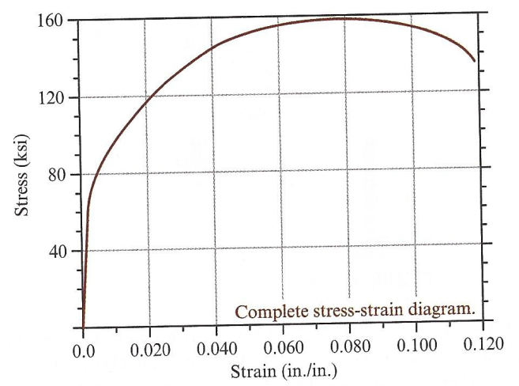

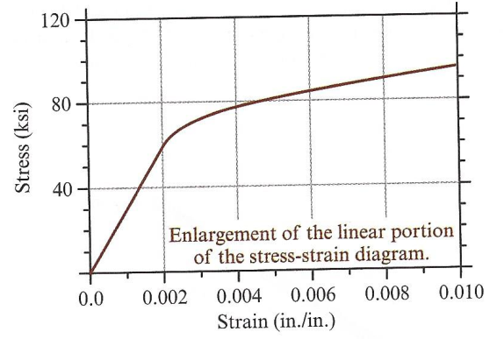

## Preparation for Next Class Period (6 points)

Note: Write down enough to show that you’ve done the following things to prepare for our next class session. This part of your homework can all be on a single page. It can be typed up, hand-written, or a combination of both. Put this at the end of your homework packet.

1. TB Reading sections 3.3 and 3.4.
   1. What region of the stress-strain curve does Hooke’s Law apply?
   2. What is the equation that relates Poisson’s ratio to the lateral and axial strain?
   3. What are typical values for Poisson’s ratio?
   4. What is the maximum value for Poisson’s ratio?
   5. How is the shear modulus (G) related to the elastic modulus (E) and Poisson’s ratio (v)?
   6. Write down any concepts you find confusing or want to discuss during next class