Practice Problems – Short Documentation (12 points)
For these 4 problems, the Given, Find, and Solution are the only required documentation.

- A bar of aluminum alloy (E = 70 GPa, ν = 0.33, α = 23.0 x 10⁻⁶ 1/°C) initially has initial dimensions of d = 260 mm, L = 4.5 m, and a cross-sectional area of A = 6500 mm². Load P is applied, and the temperature of the bar is increased by ΔT by 56 °C you find the longitudinal strain in the bar is 2,950 με. Calculate the following:
  - Magnitude of the load P
  - Change in length Δd (due to combination of thermal strain and load P)
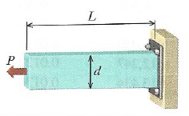

- The rigid plate in the figure below is supported by bar (1), and a double shear connection at B. Bar (1) has a length L = 60 in, a cross-sectional area A = 0.47 in², and elastic modulus E = 10 Mpsi, and coefficient of thermal expansion α = 13 x 10⁻⁶ 1/°F. The pin at B has a diameter of 0.438 in. The plate has dimensions of a = 12 in, b = 20 in, and a thickness of 0.75 in. The total strain in bar (1) after load P is applied and the assembly has decreased by 30 °F is ε_{total} = 570 με. Calculate the following:
  - Magnitude of load P
  - Average shear stress in pin B
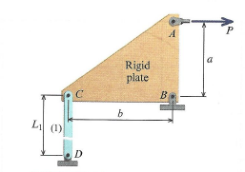

- The figures below a square (with a = 40 mm) drawn on a rectangular bar prior to loading. Once a uniform normal stress of σ = -54 MPa is applied the square shape turns in to a rhombus with dimensions of b = 56.88 mm and c = 55.61 mm. Calculate Young’s Modulus for this material, assuming that the materials behaves elastically with the applied stress.

Preparation for Next Class Period (6 points)
Note: Write down enough to show that you’ve done the following things to prepare for our next class session. This part of your homework can all be on a single page. It can be typed up, hand-written, or a combination of both. Put this at the end of your homework packet.

- TB Reading sections 4.1 through 4.5.
  - What are several types of design loads to consider?
  - What is a safety factor? How is it used to calculate safe loads and safe stresses?
  - From section 4.5, write out the short definitions for:
    - Resistance (R*)
    - Service Load Effect (Q*)
    - Resistance Factor (φ)
    - Load Factor (γ_{i})
    - Nominal Component Resistance (R_{n})
    - Nominal Service Load Effects (Q_{ni})
  - Write down any concepts you find confusing or want to discuss during next class

- Review MM Modules 4.1 through 4.3. You can do the “Try One” problems, but don’t need to turn in any work for these.

