Practice Problems – Short Documentation (12 points)
For these 3 problems, the Given, Find, and Solution are the only required documentation.

- The truss shown below is made of three aluminum members with cross-sectional area A = 850 mm², and elastic modulus E = 70 GPa. Dimensions are: a = 7.0 m, b = 4.5 m, and c = 5.0 m. Calculate the horizontal displacement of A when loads P = 12 kN and Q = 30 kN.

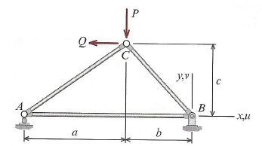

- A pin-connected structure is shown in the figure below. Member ABCD is a rigid bar, and members (1) and (2) are aluminum, both with cross-sectional area A = 160 mm², and modulus of elasticity E = 70 GPa. Member (1) is originally 900 mm long, and member (2) is originally 1250 mm long. After load P = 35 kN is applied, calculate the following:
  - Axial forces in members (1) and (2)
  - Normal stress in members (1) and (2)
  - Vertical displacement of point D

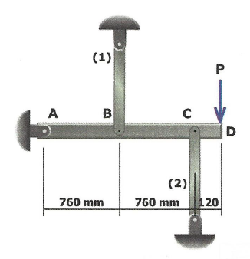

- An aluminum alloy, pipe (1) is connected to bronze, pipe (2) with a flange at B. Supports at A and C are rigid and do no move. Properties for the pipes are:
Pipe | Outer Diameter [in] | Wall Thickness [in] | Length [ft] | Modulus [ksi] | σ_{y} [ksi]
(1) | 2.375 | 0.203 | 6 | 10,000 | 40
(2) | 4.50 | 0.226 | 10 | 16,000 | 45

If a minimum factor of safety of 1.67 is required for each pipe, calculate the following:
  - Maximum load P that can be applied
  - Deflection of the flange B from the load in part (a)

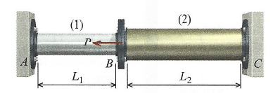

Preparation for Next Class Period (4 points)
Your next class period is just a review of chapters 1-5. There isn’t any new material to cover. But I still want you to come to class prepared with a few questions in mind.
- Look back through the last 11 homework assignments.
  - What problem (or types of problems) do you still have difficulty with?
  - For the problems you struggle with, what part of the problem are you hanging up on? (i.e. visualizing the problem, setup, equations, variable definitions, solution, etc.)

- What is one way in which you plan to prepare for the exam?

