Practice Problems – Short Documentation (12 points)
For these 3 problems, the Given, Find, and Solution are the only required documentation.

- The steel bar shown below has a rectangular cross section that is 40 mm by 15 mm. If an axial force of P = 55 kN is applied to the bar, determine the magnitudes of the normal and shear stresses acting on the inclined surface a-a.

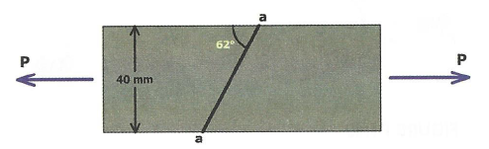

- Two pieces of wood are joined using a scarf joint (angled, glued connection) as shown below. If d = 0.5 in, and b = 1.5 in. If β = 40 °, and the maximum shear stress the glue can hold is 90 psi, what is the largest axial force P that can be applied to this joint?
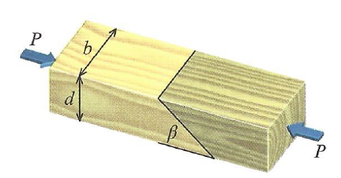

- Two wooden members are glued together as shown below. Each member has a width b = 1.5 in, and depth d = 3.5 in. If β = 75 °, and the force P is 1300 lbf, calculate the average shear stress in the glue joint.

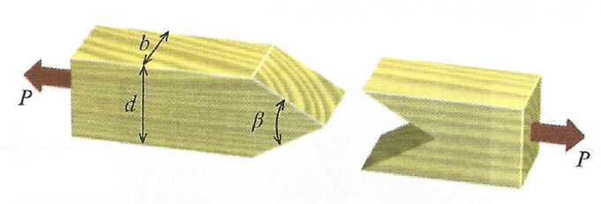

Preparation for Next Class Period (6 points)
The next topic we are covering in class is going to be Chapter 12. In preparation for this, review Amazing Stress Camera found in MM Module M12.1. Do both of the virtual experiments (You will print a summary sheet at the end of the module).
- What does the term Principle Stress mean?
- Where is the location of maximum shear stress relative to the principle stress orientation?
- On the last slide, type in your name and print your results from the module. Turn this in, along with the answers to the questions above as part of this homework.

