Practice Problems – Short Documentation (8 points)
For these 2 problems, the Given, Find, and Solution are the only required documentation.

- For this homework you need to use MM Module M12.2. After going through the slides there is a Checkpoint that has ~8 problems for you to answer questions about picking the right angle. Once you are done with the Checkpoint, type in your name and print your results.

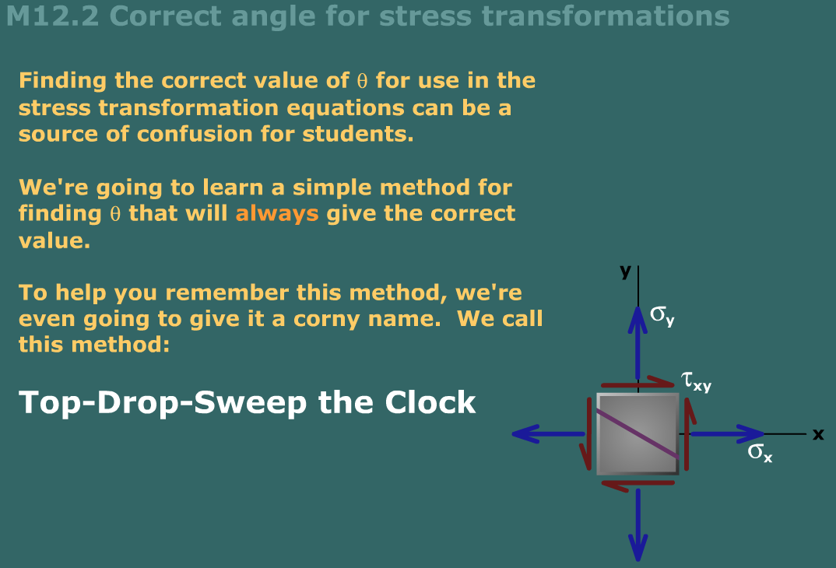

- If you have a Plane Stress element with σ_{x} = 35 MPa, σ_{y} = -125 MPa, and τ_{xy} = -62 MPa, answer the following questions:
  - What are σ_{n} and τ_{nt} in a n-t coordinate system that is rotated 37.5° counter-clockwise from x-y?
  - What is the angle θ (from the x-y coordinate system) where shear stress is zero?

