## Practice Problems – Short Documentation (32 points) For these 8 problems, the Given, Find, and Solution are the only required documentation.

For the next eight problems, determine the following:

1. θp
2. σp1, σp2, and σp3
3. θs
4. τmax (in-plane)
5. τmax (absolute)
6. 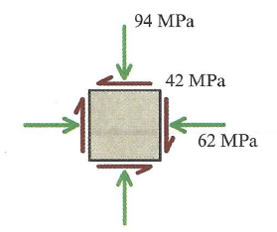
7. 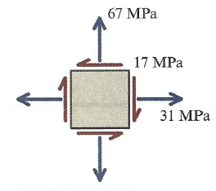
8. 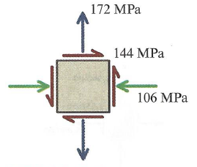
9. 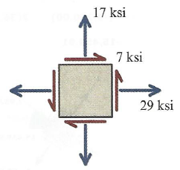
10. 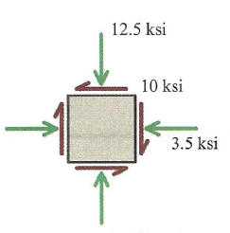
11. 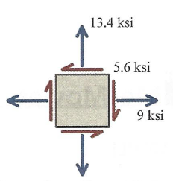
12. 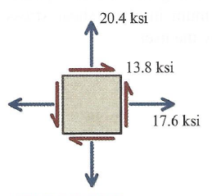
13. 