Practice Problems – MecMovies (20 points)
Make sure you do this assignment at a machine that can print your final page.

MM Module 7.2 is a long one. There are five rounds, and each round has several questions in it. Complete the five rounds in M7.2. At the end, type your name and print out the sheet as part of your assignment.
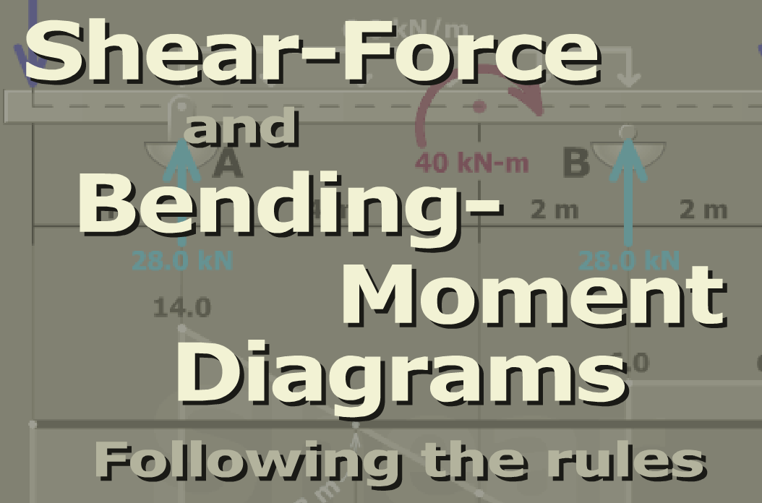

On Your Own (0 points)
MM Module 7.3 has a bunch of step-by-step examples making shear and moment diagrams. You should browse these until you feel confident in your abilities to make a correct VM diagram.

