Practice Problems – MecMovies (12 points)
Make sure you do this assignment at a machine that can print your final page.

- Go through the example problem in MM Module 8.9. (0 points) This is an example similar to what we did in class. You don’t need to print anything from this module.

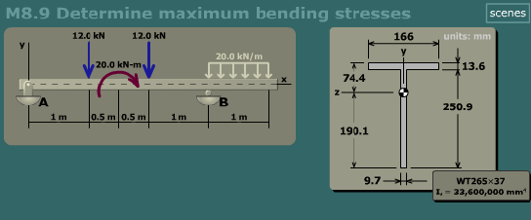

- (12 points) At the end of MM Module 8.9 there is a concept checkpoint with three problems to work. Complete these problems, type in your name, and print the results page.

