Practice Problems – MecMovies (12 points)
Make sure you do this assignment at a machine that can print your final page.

- Play the Boundary Conditions Game from MM M10.1. When finished, type in your name and print your results.

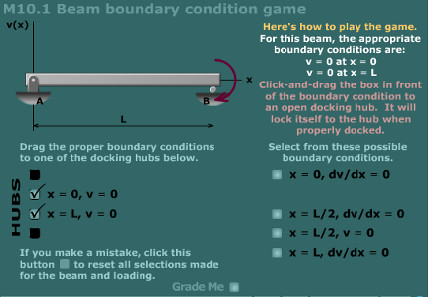

Preparation for Next Class – MecMovies (0 points)
- Review MM M10.2 about finding beam deflections using the integration method. This will be discussed more in the next class period and you’ll have some example problems to work in this area.

