**Fastener Demonstration Block**

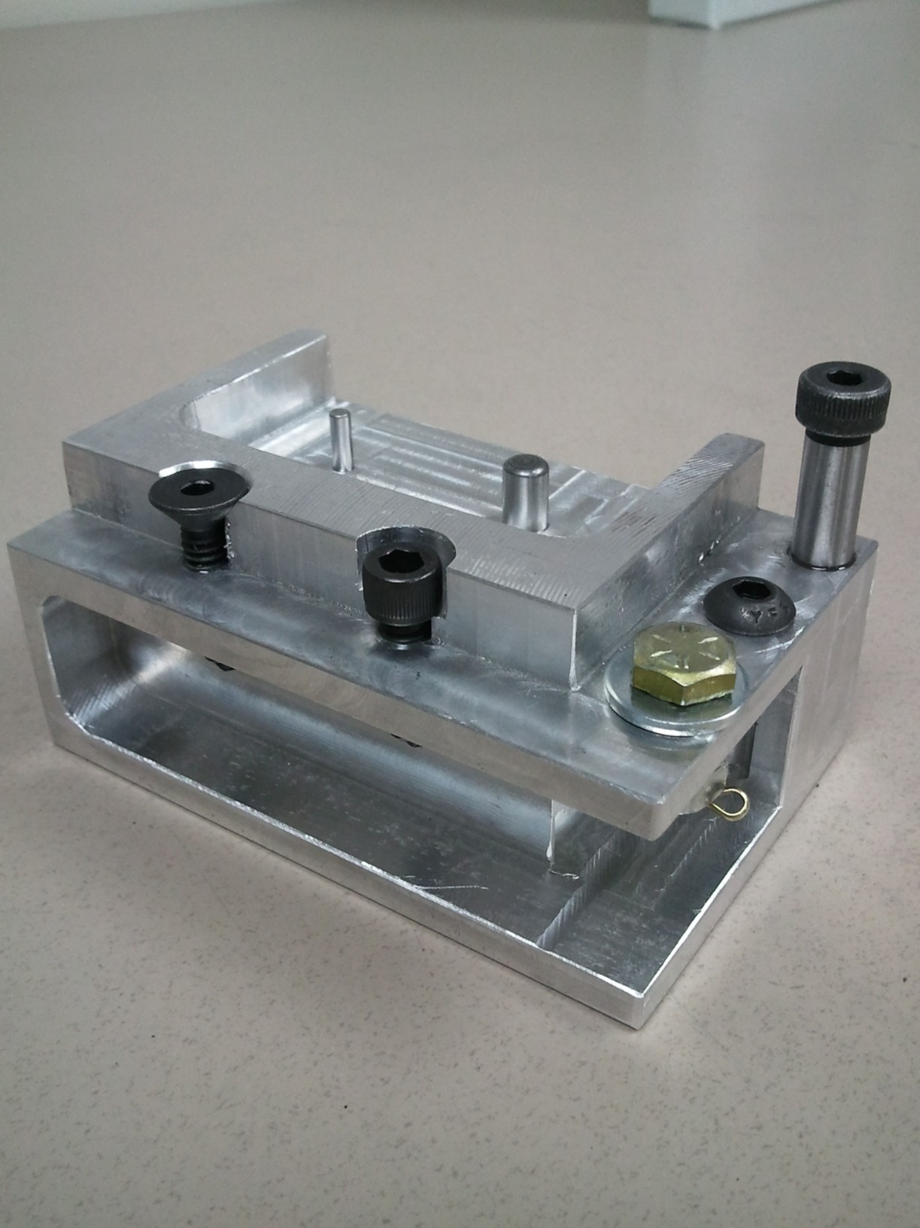

Example of Using Pins for Alignment

Example of Counterbore

Example of Locking Fasteners

Example of Thread and Hole Depth

Example of Countersink