OneDrive Shared Folder Access
  - This tutorial will walk you through linking a shared folder to the desktop OneDrive Application. This will allow you to save files into your class folder and work directly from your folder without having to download and upload new copies continuously.
The picture below shows the results of having a shared folder linked to your files. Notice the blue attachment clip icon in the bottom left of the folder. This is a file created by Dr. Perry but is in My Files. The series of steps below will show how to get a file like this in your files.
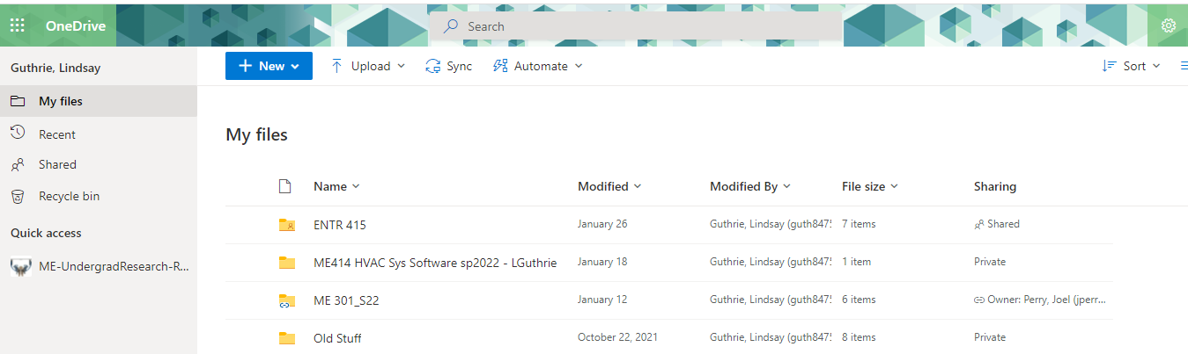
Step 1: Open OneDrive in the browser and go to the shared dropdown.
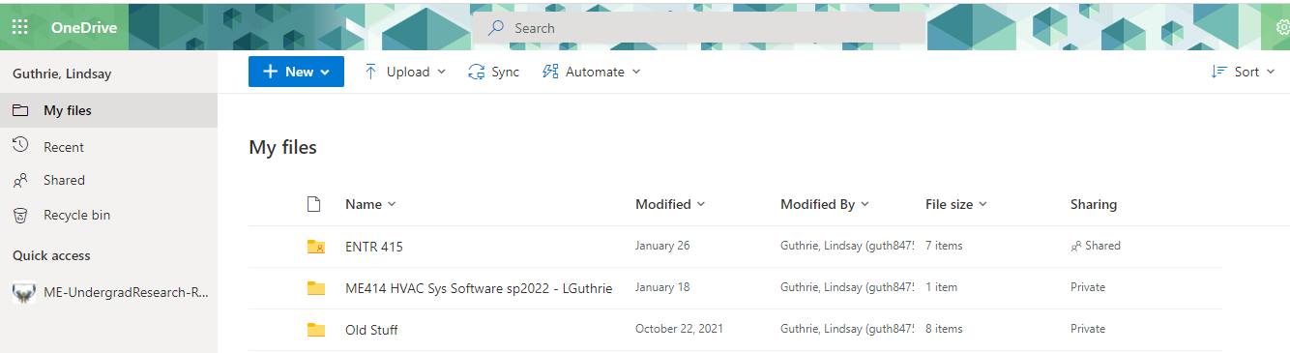
Step 2: Find the folder you want to access from the desktop version of OneDrive.
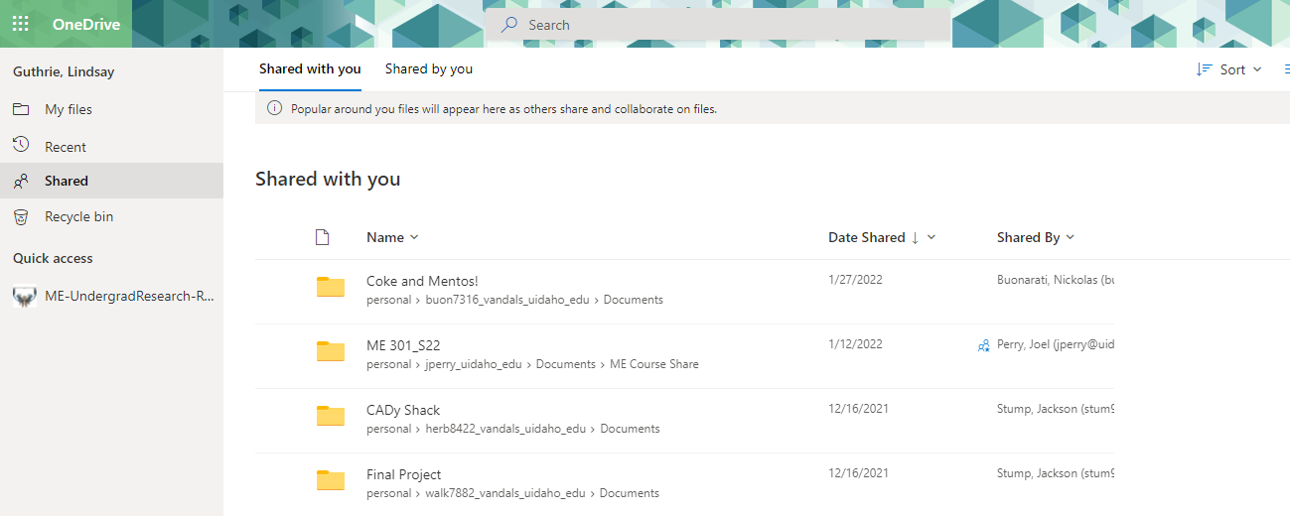
Step 3: Right click on the folder and click “Add shortcut to My Files”.
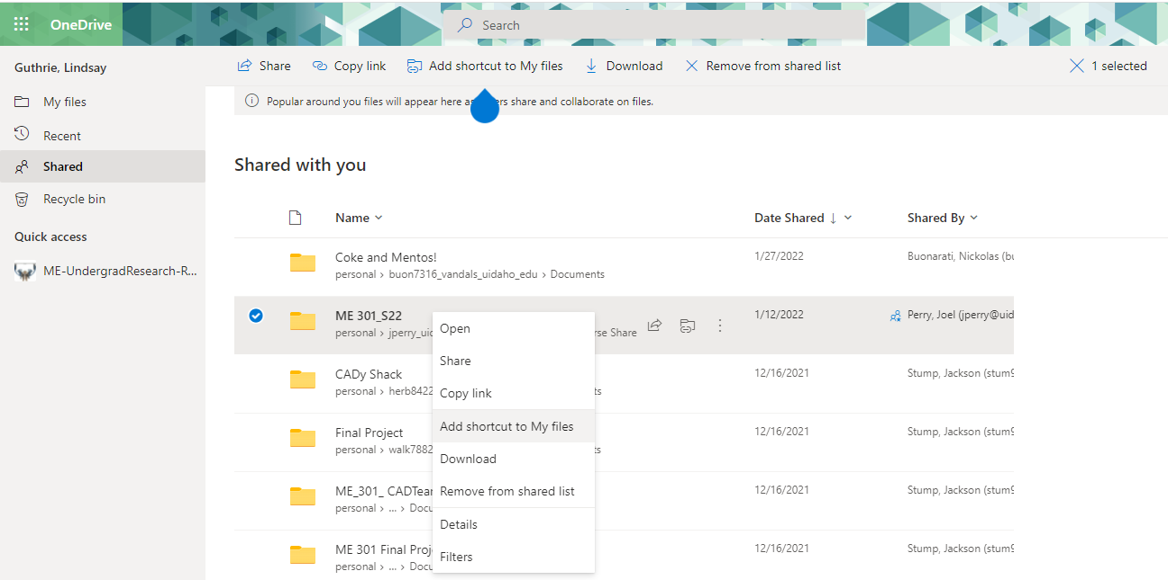
Step 4: Go back to your “My Files” tab and you should see the folder there with the little blue icon next to it. Hit the “Sync” button.
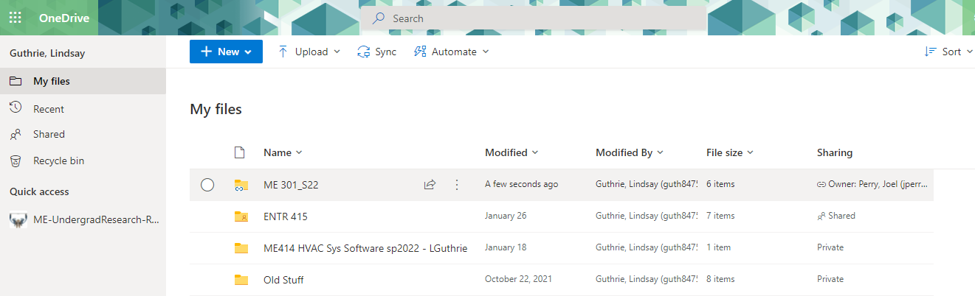
Step 5: Once it is synced you can now open the desktop app (hit the window button, type “onedrive”, and log in with your school credentials) on the computer and access that shared folder and work directly from it.
