## Practice Problem

In class we looked at the **Ideal** Rankine Cycle with superheat. For this assignment you are going to do a similar analysis for a **Real** Rankine Cycle. The only difference between the Ideal and Real cycles are that we will introduce an isentropic turbine efficiency of 85% ,and an isentropic pump efficiency of 90%.

1. Implement your solution in EES with strong internal documentation (comments).
2. Store property data for real cycle state points in an array table.
   1. For ideal points do *not* store these in your array table. Instead use subscripted variables for isentropic state points (i.e. h_2s, h_4s).
3. Make two property plots (P-v and T-s), and overlay the real state points (with labels)
4. Compare the performance of the real cycle versus the ideal cycle with respect to:  
     
   a) The pump, turbine, and net power (kW)

b) The thermal efficiency of the cycle

c) The boiler duty or the heat transfer rate from the boiler (Btu/hr)

d) The heat rate of the cycle

e) The back work ratio of the cycle

f) The mass flow rate of the cooling water (lbm/hr)

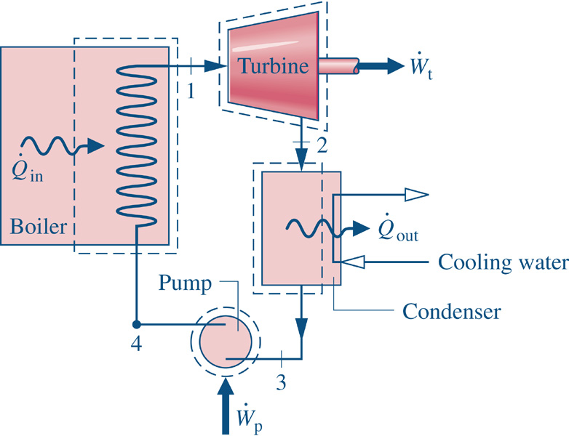

Saturated Liquid

## Answers

In class we looked at the **Ideal** Rankine Cycle with superheat. For this assignment you are going to do a similar analysis, but will include a turbine and pump with a known isentropic efficiency.

When you’re done with your code, if you input isentropic efficiencies of 1 (100%) you should get the same results as the ideal case that was shown in class. Your ‘real’ case with isentropic efficiencies less than 100% will have a lower efficiency.