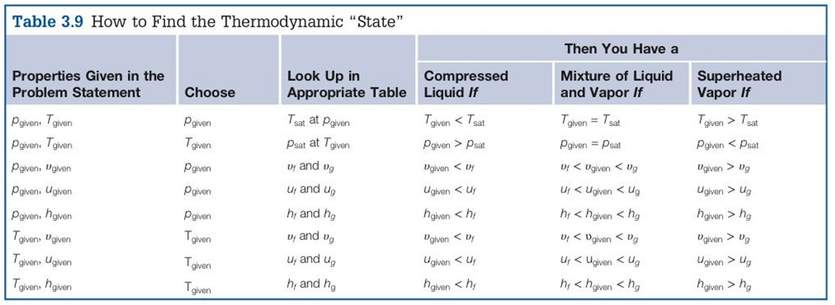
Given: Water at T = 300°F, p = 500 psia
Find: v, ρ, u Draw diagram that shows the location of the state

Which table to find p_{sat}?
Which table to find T_{sat}?
Current phase is????
_______________________________________

Which table would you use to find data?

Given: R-22 at T = 200°F, p = 120 psia
Find: v, u Draw diagram that shows the location of the state

Which table to find p_{sat}?
Which table to find T_{sat}?
Current phase is????
_______________________________________

Which table would you use to find data?

Given: Ammonia at T = -30°F
Find: vapor pressure, p_{sat} and h_{fg} Draw diagram that shows the location of the state

The current phase is????
___________________________________

Which table can we find data about vapor pressure, p_{sat} and h_{fg}?

Given: R-134a
Find: The normal boiling point (temperature) Draw diagram that shows the location of the state

What is normal pressure?
Which table to find T_{sat}?

The current phase is????
__________________________
How do we calculate a value between tabulated values?

Given: Water at p = 200 psia, x = 0.36
Find: v, h Draw diagram that shows the location of the state

Current phase is????
_______________________________________

Which table would you use to find data?

Given: Ammonia at T = 200°F, h = 700 BTU/lbm
Find: p

Which table can we find p_{sat}?
Which table can we find the critical point?
Current phase is????
_______________________________________

Which table would you use to find data?

Given: R-22 at T = 10°F, p = 60 psia
Find: v, u, h Draw diagram that shows the location of the state

Which tables to find p_{sat}?
Current phase is????
_______________________________________

Which table would you use to find data?
How are we going to calculate values that doesn’t exist in the table? What assumption can we make about liquids?

