ME 322 – Mechanical Engineering Thermodynamics (Exam 1)
Spring 2018
DO NOT TURN THIS COVER PAGE OR LOOK THROUGH THE EXAM QUESTIONS UNTIL YOU ARE INSTRUCTED TO DO SO.
Please read the following statement:
Article II, Section 1 of the University of Idaho Student Code of Conduct states,
Cheating on classroom or outside assignments, examinations, or tests is a violation of this code. Plagiarism, falsification of academic records, and the acquisition or use of test materials without faculty authorization are considered forms of academic dishonesty and, as such, are violations of this code. Because academic honesty and integrity are core values at a university, the faculty finds that even one incident of academic dishonesty seriously and critically endangers the essential operation of the university and may merit expulsion.
I have read and understand the above statement.

___________________________________________________ _____________
Signature Date

___________________________________________________
Printed Name (40 points)

EXAM INSTRUCTIONS – PLEASE READ THIS CAREFULLY
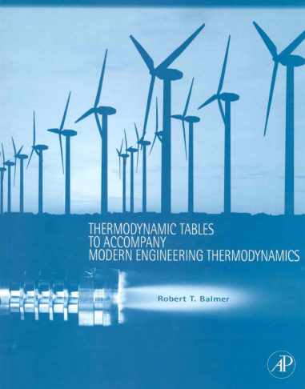
You will have 50 minutes to complete this exam. This time limit will be strictly enforced. This is a CLOSED TEXTBOOK exam. The only resources allowed are a hand-held calculator and the course textbook supplement cited below,
Balmer, R.T., “Thermodynamic Tables to Accompany Modern Engineering Thermodynamics, Elsevier Inc., Burlington, MA, 2011.
You may use the blank pages in the booklet to write anything you desire IN YOUR OWN HANDWRITING. Absolutely no cutting and pasting in the book is allowed, with the exception of a table that helps identify the phase of a state.
No computers, cell phones, iPhones, iPods, iPads, music players, or any other electronic equipment may be used during the exam with the exception of a hand-held calculator.
Show all of your work in the space provided on the exam. If more space is needed you should use the back of the exam.
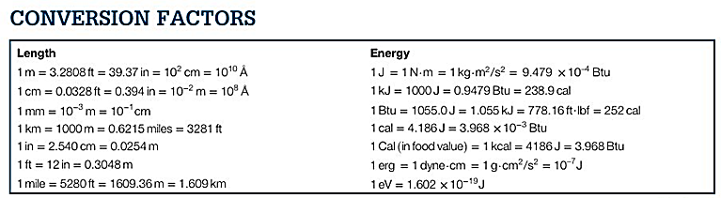
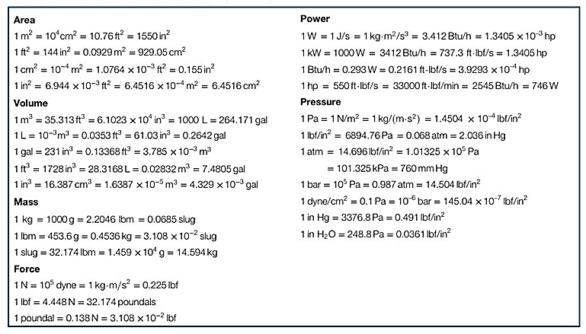
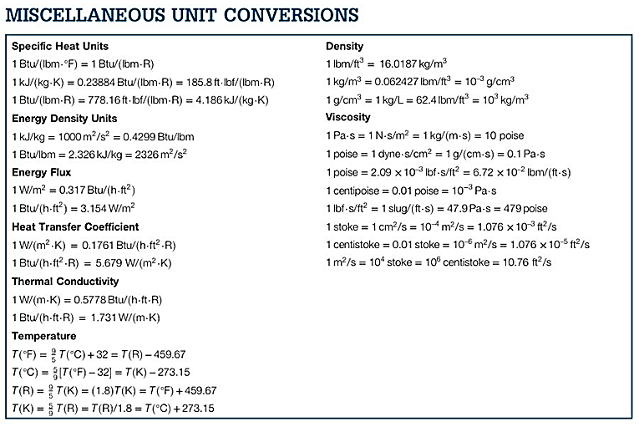
COMMON MOLAR MASSES: C=12; H=1; O=16; N=14
Part 1: Engineering Calculations – 45 Points
Problem 1: (15 points) You have R-134a at a temperature of 70 °F and a pressure of 250 psia. Use your supplemental tables to calculate/determine the following:
- What phase is the R-134a in (solid, liquid, saturated, or superheated)? (2 points)

- What is the density [lbm/ft³] of the R-134a? (5 points)

- What assumption(s) did you have to make to get to this answer? (3 points)

- What is the value of specific enthalpy [Btu/lbm] of the R-134a? (5 points)
Tip: You can’t ignore the pressure effects when calculating enthalpy.

Problem 2: (15 points) Saturated water vapor (H₂O) is at a temperature of 320 °F. It is in a cylindrical sealed container with an initial volume of 1.50 ft³, and pressure in the container is kept constant by a sealed, movable piston with a mass on top of it. You remove heat from the water until it reaches saturated liquid. Use your supplemental tables to calculate/determine the following:
- Calculate the mass [lbm] of water in the cylinder. (2 points)

- Draw this process on the P-v diagram below and label the initial and the final states. (3 points)
- Calculate the work [ft*lbf] done on the water during this process. (5 points)

- Use First Law of Thermodynamics to calculate the amount of heat [Btu] that was removed for this process to occur. (5 points)
Tip: The unit conversion sheet shows 1 Btu = 778.16 ft*lbf
Problem 3: (15 points) An Atkinson cycle engine can be modeled by an ideal gas undergoing the following closed cycle.
1-2: Isobaric compression at P₁ from V₁ to V₂
2-3: Adiabatic, polytropic compression from P₂ to P₃
3-4: Isochoric combustion from P₃ to P₄
4-1:Adaibatic, polytropic expansion back to state 1
- Complete the following table, giving the correct sign (+, -, or zero) (1 point each)
Tip: It may be helpful to draw the cycle on a Pv diagram.
 | Work | Heat | Change in  Internal Energy
Process 1-2

Process 2-3 |  | Q=0  (process is adiabatic)
Process 3-4 | W = 0  (process is isochoric, so no dV)
Process 4-1

Net for Entire Cycle

Part 2: Multiple Choice Conceptual Questions –15 Points
5 points each. Some problems have multiple answers. To earn all 5 points you must mark all the correct answers.
Problem 4: What is true about this EES code
T_1 = 350 [C]
x_1 = 0.9
v=Volume(steam_IAPWS, T=T_1, x=x_1)
a) this will compute volume of water in the container
b) this will compute the specific volume of steam as a compressed liquid
c) the current state is a saturated mixture
d) This will compute the specific volume of the two-phase water mixture

Problem 5: Which of the following statements are true about the 1st law equation?
E_{T} + E_{p} = E_{g}
a) E_{p} can be zero, positive, or negative
b) E_{g} is the net energy gain of the system over a finite interval
c) E_{g} is the change in internal energy if kinetic and potential energy are negligible
d) E_{T} is thermal energy inside the system

Problem 6: In a two phase mixture, the correct definition of quality is:
a) The volume of vapor divided by the total volume
b) The volume of liquid divided by the total volume
c) The mass fraction that is saturated vapor
d) The volume fraction of saturated vapor

