ME 322 – Mechanical Engineering Thermodynamics (Exam 1)
Fall 2019
DO NOT TURN THIS COVER PAGE OR LOOK THROUGH THE EXAM QUESTIONS UNTIL YOU ARE INSTRUCTED TO DO SO.
Please read the following statement:
Article II, Section 1 of the University of Idaho Student Code of Conduct states,
Cheating on classroom or outside assignments, examinations, or tests is a violation of this code. Plagiarism, falsification of academic records, and the acquisition or use of test materials without faculty authorization are considered forms of academic dishonesty and, as such, are violations of this code. Because academic honesty and integrity are core values at a university, the faculty finds that even one incident of academic dishonesty seriously and critically endangers the essential operation of the university and may merit expulsion.
Passing on exam information to someone who has not taken the exam constitutes cheating on an examination. Such action is a violation of the University of Idaho Student Code of Conduct.
I have read and understand the above statement.
__________________________________________________ _____________
Signature Date
__________________________________________________
Printed Name

EXAM INSTRUCTIONS – PLEASE READ THIS CAREFULLY
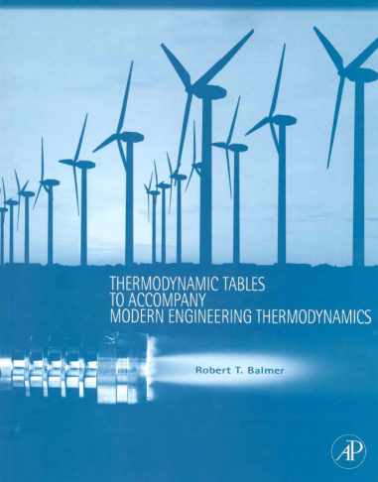
You will have 50 minutes to complete this exam. This is a CLOSED TEXTBOOK exam. The only resources allowed are:
- A hand-held calculator
- One 8.5” x 11” piece of paper of hand-written notes/equations/etc. (both sides are okay)
- The course textbook supplement cited below (and pictures to the right)
Balmer, R.T., “Thermodynamic Tables to Accompany Modern Engineering Thermodynamics, Elsevier Inc., Burlington, MA, 2011.
You may use the blank pages in the booklet to write anything you desire IN YOUR OWN HANDWRITING. Absolutely no cutting and pasting in the book is allowed. Exception is you may copy the table showing you how to find your state.
A hand-held calculator may be used during the exam. All other electronic devices may not be used (no computers, cell phones, iPhones, iPods, iPads, music players, etc.)
Circling the correct answer is not enough to earn points for the problem You must also show how you got to that answer. This may include calculations, or justifications.
There are a total of 100 points on this exam, and the point distribution is shown for each section.
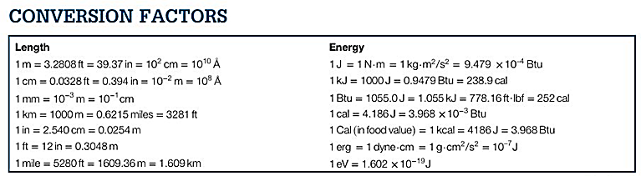
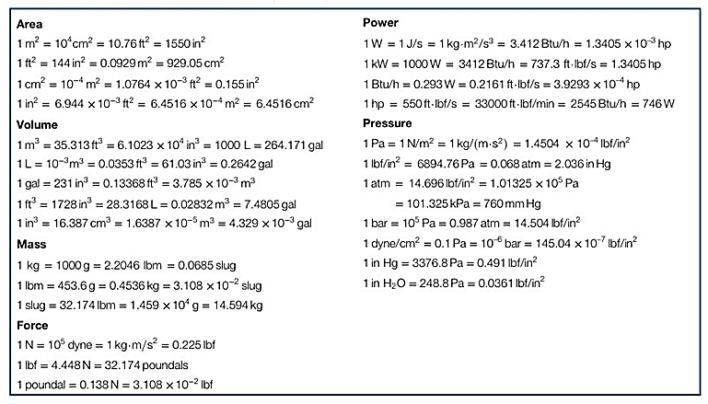
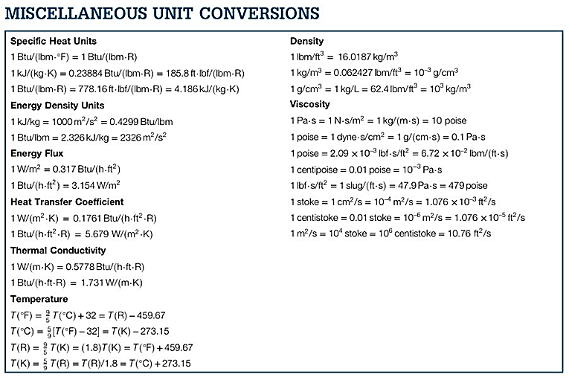
COMMON MOLAR MASSES: C=12; H=1; O=16; N=14
1 ton = 12,000 Btu/hr

Part 1: Are you alive, and taking this exam – 30 Points
- Thermo students who create quality memes for the “**** **** for Scott’s Tots” group should:
a) First Rule of _____ ______ for _____ _____ is, there is no _____ ______ for _____ _____
b) Get an automatic degree, because they’ve already succeeded in life
c) Receive bonus points for each of their classes, because quality memes take time
d) Make more, because less that one meme per week is, um, weak

Part 2: Multiple Choice, Single Answer – 50 Points
You must show your work on each of these problems to get full credit. This might include things like: equations used, sketches, unit conversions, Table and table inputs used, an explanation of why you chose the answer, etc.
- How many lbmol are in 1 lbm of ethanol (C₂H₅OH)?
a) .011 lbmol
b) .022 lbmol
c) .111 lbmol
d) 46.0 lbmol

- What are the fundamental dimensions of specific enthalpy (h) in the mass-length-time (MLt) system?
a) L/t²
b) ML/t
c) L²/t²
d) ML²/t

- In the UI dorms, a bowling ball with a mass of 14.0 lbm is raised to a height of 60 ft. How much potential energy does the ball have?
Remember: PE = mgh/g_{c}, and g_{c} = 32.2 (lbm*ft)/(lbf*s²)
a) 26.1 ft*lbm
b) 27,050 ft*lbf
c) 840 ft*lbf
d) 26.1 ft*lbf

- Since you don’t have EES available during this exam, use your supplemental tables to figure out the internal energy of 3.25 lbm of water that is at 300 psia, and 300 °F.
a) 269.5 Btu
b) 393.0 Btu
c) 875.9 Btu
d) 1277.3 Btu

- You have helium gas inside a balloon that has cooled from 21.5 °C to -52.2 °C. Assuming specific heat remains constant over this range, what is most nearly the change in specific internal energy (Δu) [kJ/kg]?
a) -95.88 kJ/kg
b) -230.2 kJ/kg
c) -383.2 kJ/kg
d) -622.9 kJ/kg

- If you have a system that is sealed and adiabatic, what does the First Law of Thermodynamics become?
a) Q – W + Σ m_{in}e_{in} - Σ m_{out}e_{out} = ΔU + ΔKE + ΔPE
b) W + Σ m_{in}e_{in} - Σ m_{out}e_{out} = ΔU + ΔKE + ΔPE
c) Q – W = ΔU + ΔKE + ΔPE
d) – W = ΔU + ΔKE + ΔPE

- What is the correct definition of quality within the two phase region?
a) mass fraction that is saturated liquid
b) mass fraction that is saturated vapor
c) volume fraction that is saturated liquid
d) volume fraction that is saturated vapor
- Ideal combustion in a gasoline engine is modeled by an isochoric process. The initial pressure before combustion is 210 psia, and the pressure after combustion is 2250 psia. If the mass inside the cylinder is 1.5 lbm, and the piston has an area of 12.5 in². The specific work of the combustion event is most nearly?
a) 17,000 lbf/lbm
b) 17,000 (lbf*ft)/lbm
c) 245 lbf/lbm
d) 0 (lbf*ft)/lbm
- What is the thermodynamic phase of ammonia at 70 °F and a specific enthalpy of 700 Btu/lbm?
a) compressed liquid
b) two phase region
c) superheated vapor
d) ideal gas

- What will you get from the following line in EES: v_1 = volume(water, T=T_1, P=P_1),
a) EES will output the volume occupied by liquid water
b) EES will output the volume occupied by saturated vapor
c) EES will output the specific volume of saturated water
d) EES will output the specific volume of water at the input temperature and pressure

Part 3: Thermodynamic Calculations – 20 Points

- You have 2.5 lbm of superheated steam expanding in a cylinder with a moving piston. The expansion is characterized as an ideal gas undergoing a polytropic process with a polytropic exponent of n = 2.0. The initial state in the cylinder is 600 psia and 1500 °F, and the steam expands until it reaches 100 psia. In this particular steam engine, this process happens every two seconds. Find/calculate the following:
  - (5 points) What is the specific volume [ft³/lbm] of the steam at the initial state?

  - (5 points) What is the specific volume [ft³/lbm] of the steam at the final state?

  - (5 points) How much work [Btu] is produced by this process?

  - (5 points) How much power [hp] is produced by this engine?

