ME 322 – Mechanical Engineering Thermodynamics (Exam 2)
Fall 2018
DO NOT TURN THIS COVER PAGE OR LOOK THROUGH THE EXAM QUESTIONS UNTIL YOU ARE INSTRUCTED TO DO SO.
Please read the following statement:
Article II, Section 1 of the University of Idaho Student Code of Conduct states,
Cheating on classroom or outside assignments, examinations, or tests is a violation of this code. Plagiarism, falsification of academic records, and the acquisition or use of test materials without faculty authorization are considered forms of academic dishonesty and, as such, are violations of this code. Because academic honesty and integrity are core values at a university, the faculty finds that even one incident of academic dishonesty seriously and critically endangers the essential operation of the university and may merit expulsion.
Passing on exam information to someone who has not taken the exam constitutes cheating on an examination. Such action is a violation of the University of Idaho Student Code of Conduct.
I have read and understand the above statement.
__________________________________________________ _____________
Signature Date
__________________________________________________
Printed Name

EXAM INSTRUCTIONS – PLEASE READ THIS CAREFULLY
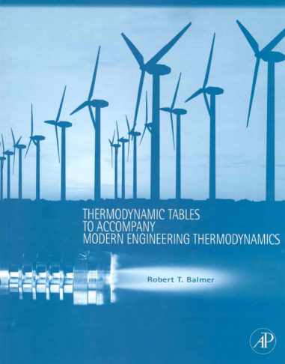
You will have 50 minutes to complete this exam. This is a CLOSED TEXTBOOK exam. The only resources allowed are:
- A hand-held calculator
- One 8.5” x 11” piece of paper of hand-written notes/equations/etc. (both sides are okay)
- The course textbook supplement cited below (and pictures to the right)
Balmer, R.T., “Thermodynamic Tables to Accompany Modern Engineering Thermodynamics, Elsevier Inc., Burlington, MA, 2011.
You may use the blank pages in the booklet to write anything you desire IN YOUR OWN HANDWRITING. Absolutely no cutting and pasting in the book is allowed. The exception is you may paste in the table that helps guide you in identifying the phase of a substance.
A hand-held calculator may be used during the exam. All other electronic devices may not be used (no computers, cell phones, iPhones, iPods, iPads, music players, etc.)
Circling the correct answer is not enough to earn points for the problem You must also show how you got to that answer. This may include calculations, or justifications.
There are a total of 100 points on this exam, and the point distribution is shown for each section.
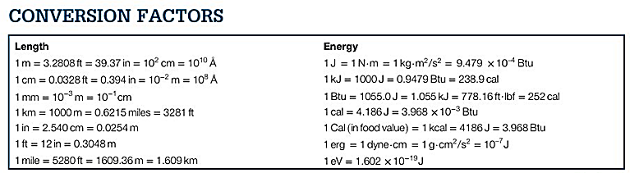
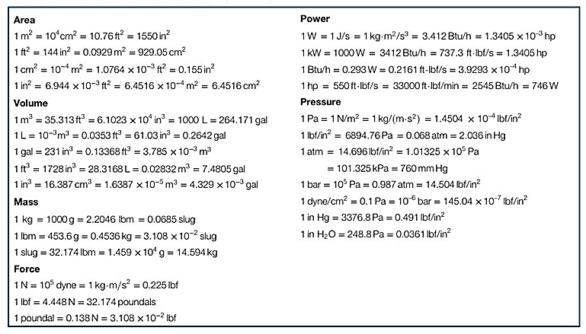
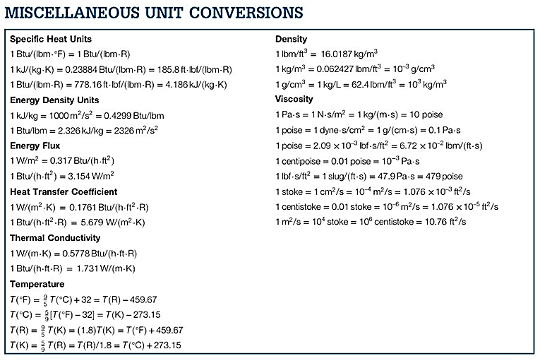
COMMON MOLAR MASSES: C = 12; H = 1; O = 16; N = 14
1 ton = 12,000 Btu/hr

Part 1: Are you alive, and taking this exam in class – 40 Points
- For Halloween I plan to:
a) Dress up like a bartender, then just show up at some bar and start working. I’m taking all the tips home.
b) Start trick-or-treating at 7pm. At 9pm start selling my candy to the houses that have run out.
c) Watch horrible horror movies all night.
d) Other: ______________________________________________________________________________

Part 2: Engineering Calculations – 30 Points
- You are going to heat 3.5 lb_{m} of Ammonia at constant pressure of 247 psia from a saturated liquid to a saturated vapor. Calculate how much heat (Btu) will be required to do this.
Remember: This process will have both heat and moving boundary work.
Tip: Be very careful with units on the $\int{Pdv}$ work calculation

- Air enters the compressor at 14.7 psia and 60 °F, and leaves at 119.0 psia. If the process is reversible and adiabatic (which means isentropic), but the specific heat of air is *not* constant, calculate the temperature (in °F) of the air leaving the compressor. Hint: There is a table in your supplement that will be very useful.

- You are going to fill an initially empty Acetylene tank (C₂H₂) tank until it reaches 250 psia. The tank is wrapped in adiabatic insulation. The tank is connected to a supply of Acetylene that stays at a constant 500 psia and 75 °F through the filling process. Additionally, the specific heats for Acetylene at 100 °F are: c_{p} = 0.35 Btu/(lbm °R), and c_{v} = 0.27 Btu/(lbm °R)
  - Set up the equations that describe the process happening, completing separating and integrating terms to get the governing equation. Simplify as appropriate.
$$\dot{Q}-\dot{W}+\sum_{i}{\dot{m_{i}}\left(h_{i}+\frac{V_{i}^{2}}{2g_{c}}+\frac{g}{g_{c}}z_{i}\right)}-\sum_{e}{\dot{m_{e}}\left(h_{e}+\frac{V_{e}^{2}}{2g_{c}}+\frac{g}{g_{c}}z_{e}\right)}=\frac{d}{dt}\left(U+KE+PE\right)$$
$$\sum_{i}{\dot{m_{i}}}-\sum_{e}{\dot{m_{e}}}=\frac{dm}{dt}$$

  - Assuming constant specific heats (given above), solve for the final temperature (°F) of the Acetylene gas in the cylinder after it is filled.

Part 3: Multiple Choice, or Short Answer – 30 Points
You must show your work on each of these problems to get full credit. This might include things like: equations used, sketches, unit conversions, an explanation of why you chose the answer, etc.
- Circle which of one in each pair has higher entropy?
Liquid water at 0.0 °C or Solid water at 0.0 °C
Brakes on your car before stopping or Brakes on your car after stopping
A gas at high temperature or Same gas at lower temperature

- A home freezer is operating with a condenser temperature of 25 °F and an evaporator temperature of 95 °F. What is the maximum theoretical COP for this freezer?
a) 0.357
b) 1.36
c) 6.93
d) 7.93

- What is the value of the polytropic exponent for isentropic expansion of water vapor?
(Assuming constant heat capacities)
a) 1.00
b) 1.33
c) 1.40
d) 1.67

- Circle the terms in the First Law of Thermodynamics equation that represent the transport of energy across the system boundary?
$$\dot{Q}-\dot{W}+\sum_{i}{\dot{m_{i}}\left(h_{i}+\frac{V_{i}^{2}}{2g_{c}}+\frac{g}{g_{c}}z_{i}\right)}-\sum_{e}{\dot{m_{e}}\left(h_{e}+\frac{V_{e}^{2}}{2g_{c}}+\frac{g}{g_{c}}z_{e}\right)}=\frac{d}{dt}\left(U+KE+PE\right)$$

- If a fluid with a specific volume of 3.0 m³/kg flows at 1.5 kg/s through a 0.20 m diameter pipe, what is its velocity?
a) 35 m/s
b) 57 m/s
c) 143 m/s
d) 173 m/s

- Four devices (Carnot heat engine, real heat engine, heat pump, and refrigerator) operate between the same high and low temperature thermal reservoirs. What is the order of the most efficient device to the least efficient device?
a) Heat pump > Carnot engine > Refrigerator > Real engine
b) Heat pump > Refrigerator > Carnot engine > Real engine
c) Carnot engine > Refrigerator > Heat pump > Real engine
d) Carnot engine > Heat pump > Refrigerator > Real engine

- What is a reasonable assumption when modeling/analyzing a turbine?
a) aergonic
b) isenthalpic
c) adiabatic
d) isochoric

- (Multiple Answer) Of the following answers, circle ones that are a property (intensive or extensive)
a) dQ (differential heat)
b) Enthalpy
c) dW (differential work)
d) dQ/T (differential heat over boundary temperature)

- On a T-s diagram, isotherms look like
a) lines that slope from the upper left to the lower right
b) lines that slope from the lower left to the upper right
c) horizontal lines
d) vertical lines

- The specific volume of R-134a at 500 psia and 50 °F is most nearly:
a) 0.0200 ft³/lbm
b) 0.0657 ft³/lbm
c) 0.7871 ft³/lbm
d) 0.0127 ft³/lbm

