**Principles of Vegetation Measurement & Assessment**

Content Summary Assignment #2 (30 points total) Name:________________

Complete answers and submit assignment by blackboard ([www.blackboard.uidaho.edu](http://www.blackboard.uidaho.edu)) by midnight on **Tuesday, September 04**)

Describe each of the following terms and give an example related to vegetation assessment (1 pts each):

1. Population -
2. Sample -
3. Accuracy -
4. Precision -

|  |  |  |  |  |
| --- | --- | --- | --- | --- |
| Quadrat # | kg/ha |  | Quadrat # | kg/ha |
| 1 | 0 |  | 11 | 1 |
| 2 | 79 |  | 12 | 35 |
| 3 | 240 |  | 13 | 19 |
| 4 | 34 |  | 14 | 123 |
| 5 | 40 |  | 15 | 168 |
| 6 | 126 |  | 16 | 257 |
| 7 | 40 |  | 17 | 65 |
| 8 | 35 |  | 18 | 138 |
| 9 | 175 |  | 19 | 22 |
| 10 | 244 |  | 20 | 55 |

*A few winters ago, I did a winter grazing study and I wanted to estimate forage biomass for winter sheep grazing. To determine how many plots I needed to clip, I first conducted a pilot study of 20 quadrats. Calculate the following statistics to describe this pilot study sample:*

1. Average = .  
   (2 pts)
2. Median = .   
   (2 pts)
3. Standard Deviation = .

(2 pts)

1. Standard Error = .  
   (2 pts)

**Question 9** (3 point) **-** A **Subjective** Sampling Scheme: **Subjectively** place **25** points on the pasture map below to create a representative sample.

The **red circle-X** symbols below represent 25 potential sampling locations. **Left** click on each **circle-X** symbol and drag to a potential sampling location on the map. *(Note -- place mouse pointer over symbol, click the left mouse button, hold down left mouse button, drag to location, and release -- if you are having problems, make sure you are holding the left mouse button, not the right button).*

MCj04325460000[1]MCj04325460000[1]MCj04325460000[1]MCj04325460000[1]MCj04325460000[1]MCj04325460000[1]MCj04325460000[1]MCj04325460000[1]MCj04325460000[1]MCj04325460000[1]MCj04325460000[1]MCj04325460000[1]MCj04325460000[1]MCj04325460000[1]MCj04325460000[1]MCj04325460000[1]MCj04325460000[1]MCj04325460000[1]MCj04325460000[1]MCj04325460000[1]MCj04325460000[1]MCj04325460000[1]MCj04325460000[1]MCj04325460000[1]MCj04325460000[1]

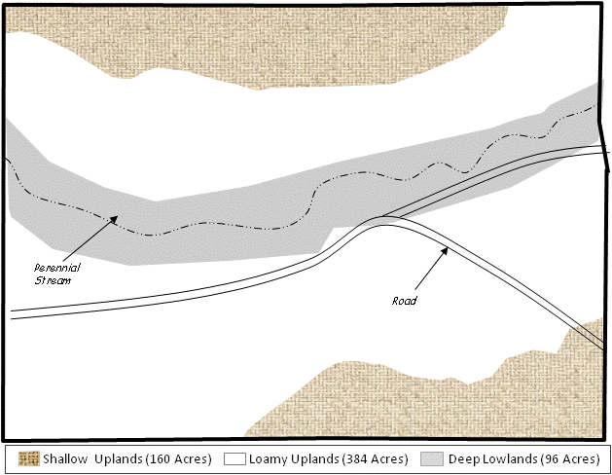

What aspects of the pasture did you consider while subjectively placing your sample locations?

Count up your sampling points and complete the following table:

|  |  |  |  |  |  |
| --- | --- | --- | --- | --- | --- |
| **Range Site** | Actual %  of Area |  | Number of Plots Placed |  | % of Placed Plots |
| Shallow Upland |  |  |  |  |  |
|  |  |  |  |  |  |
| Loamy Uplands |  |  |  |  |  |
|  |  |  |  |  |  |
| Deep Lowland |  |  |  |  |  |
|  |  |  | 25 total |  | 100% total |

**Question 10** (3 point) **-** A **Systematic** Sampling Scheme: **Systematically** place **25** points on the pasture to create a representative sample. Put a **circle-X** on each cell on the map that you select to be sampled.

The **red circle-X** symbols below represent 25 potential sampling locations. **Left** click on each **circle-X** symbol and drag to a sampling location on the map. *(Note -- place mouse pointer over symbol, click the left mouse button, hold down left mouse button, drag to location, and release -- if you are having problems, make sure you are holding the left mouse button, not the right button)*

MCj04325460000[1]MCj04325460000[1]MCj04325460000[1]MCj04325460000[1]MCj04325460000[1]MCj04325460000[1]MCj04325460000[1]MCj04325460000[1]MCj04325460000[1]MCj04325460000[1]MCj04325460000[1]MCj04325460000[1]MCj04325460000[1]MCj04325460000[1]MCj04325460000[1]MCj04325460000[1]MCj04325460000[1]MCj04325460000[1]MCj04325460000[1]MCj04325460000[1]MCj04325460000[1]MCj04325460000[1]MCj04325460000[1]MCj04325460000[1]MCj04325460000[1]

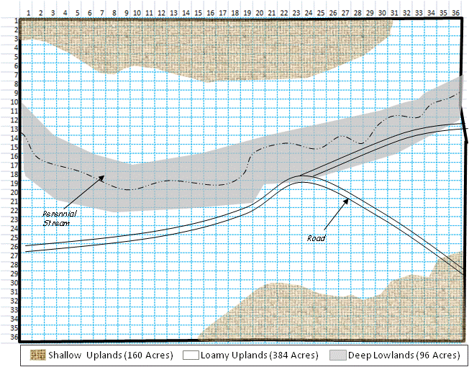

What aspects of the pasture did you consider while systematically placing your sample locations?

Count up your sampling points and complete the following table:

|  |  |  |  |  |  |
| --- | --- | --- | --- | --- | --- |
| **Range Site** | Actual %  of Area |  | Number of Plots Placed |  | % of Placed Plots |
| Shallow Upland |  |  |  |  |  |
|  |  |  |  |  |  |
| Loamy Uplands |  |  |  |  |  |
|  |  |  |  |  |  |
| Deep Lowland |  |  |  |  |  |
|  |  |  | 25 total |  | 100% total |

**Question 11** (3 point) **-** A **Random** Sampling Scheme: **Randomly** place **25** points on the pasture to create a representative sample. Choose a number between 1 and 10, and a letter A, B, C, or D in the random numbers table below. (For example, 2D or 9A). Find your designated cell for your first set of x/y coordinates. (For example, 2D is x=5 and y=31). Then, simply continue down the column and to the next column till you have 25 x/y coordinates. Use these sets of coordinates to place 25 points. Left click on each **circle-X** symbol and drag to a potential sampling location on the map.

MCj04325460000[1]MCj04325460000[1]MCj04325460000[1]MCj04325460000[1]MCj04325460000[1]MCj04325460000[1]MCj04325460000[1]MCj04325460000[1]MCj04325460000[1]MCj04325460000[1]MCj04325460000[1]MCj04325460000[1]MCj04325460000[1]MCj04325460000[1]MCj04325460000[1]MCj04325460000[1]MCj04325460000[1]MCj04325460000[1]MCj04325460000[1]MCj04325460000[1]MCj04325460000[1]MCj04325460000[1]MCj04325460000[1]MCj04325460000[1]MCj04325460000[1]



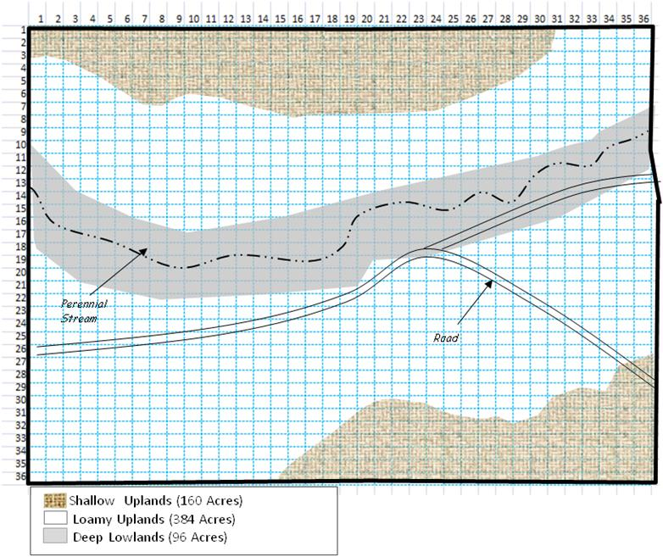

Count up your sampling points and complete the following table:

|  |  |  |  |  |  |
| --- | --- | --- | --- | --- | --- |
| **Range Site** | Actual % of area |  | Number of Plots Placed |  | % of Placed Plots |
| Shallow Upland |  |  |  |  |  |
|  |  |  |  |  |  |
| Loamy Uplands |  |  |  |  |  |
|  |  |  |  |  |  |
| Deep Lowland |  |  |  |  |  |
|  |  |  | 25 total |  | 100% total |

**Question 12** (3 point) **-** A **Stratified** Sampling Scheme: Look at the map and think about how you would sample the 640 acre pasture depicted. Place **25** points that are **stratified** by range site on the pasture. To stratify your points calculate the % of points that should occur in each range site based on the area that it covers in the pasture *(see map legend)*. Then place the appropriate % of plots in each range site.

Left click on each **circle-X** symbol and drag to a potential sampling location on the map.

MCj04325460000[1]MCj04325460000[1]MCj04325460000[1]MCj04325460000[1]MCj04325460000[1]MCj04325460000[1]MCj04325460000[1]MCj04325460000[1]MCj04325460000[1]MCj04325460000[1]MCj04325460000[1]MCj04325460000[1]MCj04325460000[1]MCj04325460000[1]MCj04325460000[1]MCj04325460000[1]MCj04325460000[1]MCj04325460000[1]MCj04325460000[1]MCj04325460000[1]MCj04325460000[1]MCj04325460000[1]MCj04325460000[1]MCj04325460000[1]MCj04325460000[1]



Count up your sampling points and complete the following table:

|  |  |  |  |  |  |
| --- | --- | --- | --- | --- | --- |
| **Range Site** | Actual %  of Area |  | Number of Plots Placed |  | % of Placed Plots |
| Shallow Upland |  |  |  |  |  |
|  |  |  |  |  |  |
| Loamy Uplands |  |  |  |  |  |
|  |  |  |  |  |  |
| Deep Lowland |  |  |  |  |  |
|  |  |  | 25 total |  | 100% total |

**Answer the following questions** with a few well reasoned and well crafted sentences

1. (3 point) Which system gave the best distribution of sampling points in this situation? (Refer to your data and describe your results)
2. (3 point) If a colleague wrote you an e-mail asking for guidance on how set up their sampling design (random, subjective, systematic, or stratified), what would you write back in response? (Give some basic guidance).