Vegetation Measurement & Assessment (REM 357 & REM 410)

Assignment #3 (30 points total) Name:_____________________
Answer the following questions in your own words. Submit assignment by blackboard (www.blackboard.uidaho.edu) by midnight on Thursday, September 13)

What are ecosystem services? (2 pts.)

Explain two ecosystem services the soils provide. (2 pts.)

Explain two reasons biological soil crusts are particularly important in dryland systems. (4 pts.)

Which method of measuring soil moisture can give you continuous measurements through time? (1 pt.)

Why are soils considered the foundation for ecosystems? (3 pts.)

Explain the difference between inherent and dynamic soil properties. (4 pts.)

What are the two criteria for an ecological site? (2 pts.)

Briefly describe the three components of a state and transition model. (4 pts.)

List two pros and two cons of using ecological site descriptions. (4 pts.)

Label the following in the diagram: (4 pts.)
States
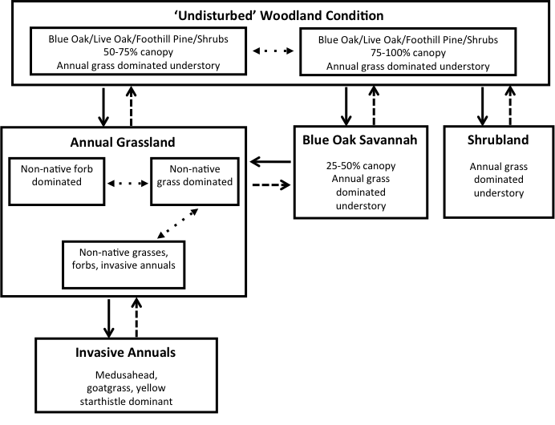
Transitions
Community pathway
Active restoration

