Vegetation Measurement & Assessment (REM 357 & REM 410)

Name: _____________________

DATA Summary Assignment - Module 5 – Density (60 points total)
Due Tuesday, October 02, 2012 by midnight through the University Blackboard System (www.blackboard.uidaho.edu/)

•• You can use excel to summarize data, or, you can make calculations by hand. Include detail on how you made calculations (i.e., show your work). Address the following questions with short essay-style answers.

- Compare a plot-based to a plotless technique for estimating plant density (40 pts):
  - (15 pts): Examine the 10 plots in the activity file “Assign_5_Density_Activity.pdf”. Record the number of golden cedar trees in each plot.
What is the density (in plants/hectare ± standard error) of golden cedar estimated by the quadrat technique?

  - (15 pts): Examine the 10 plots in the activity file “Assign_5_Density_Activity.pdf”. This time, record the distance from the center point to the closest golden cedar plan.
What is the density (in plants/hectare ± standard error) of golden cedar estimated by distance technique? **Use “Closest Individual” method outlined in the web lesson.

  - (5 pts): Compare results from each method. Do you think the methods are equivalent in estimating density? (Use your data to make and describe the comparison.) What might have caused similarity or differences in density estimates between the two methods?

  - (5pts): Which method would be most accurate if this was a real world situation with golden cedar and plump pine trees? Which method would be easier to use? (Think carefully about how this might work in a real world situation and clearly describe what you see as advantages or drawbacks in accuracy and ease of use.)

- Density is an attribute that is used widely in natural resources to study plants and animals. In this question, you will examine the use of density to study the effect of targeted grazing by domestic goats on Yellows Starthistle, a noxious weed, in Northern Idaho. (20 pts):
- Review Yellowstarthistle Case Study (details on next page).
- Examine data in excel spreadsheet for module 5 (Assign_5_YST_Density.xls).
- Summarize data for density of plants and seedheads in grazed and ungrazed plots.

  - (10 pts): What is the average (and standard error) density of plants and seedheads in grazed and ungrazed plots?

  - (10 pts): Write a summary of results and make some conclusions about the observed effect of grazing on yellow starthistle.

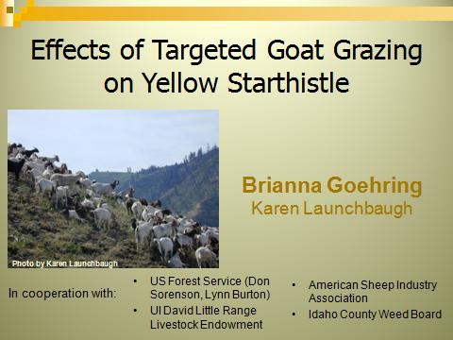 | 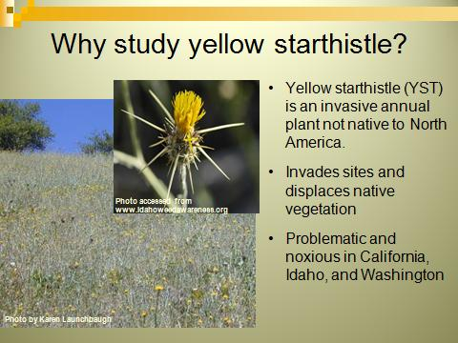
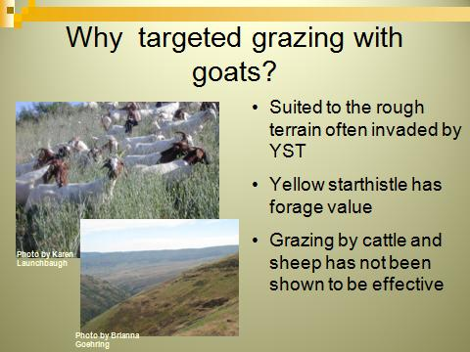 | 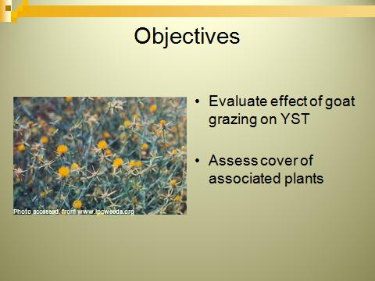
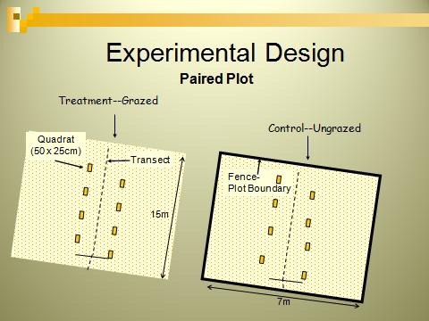  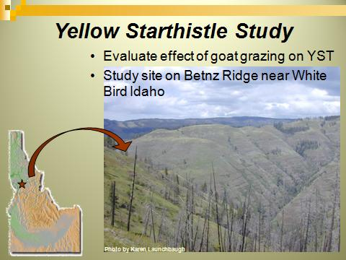 | 