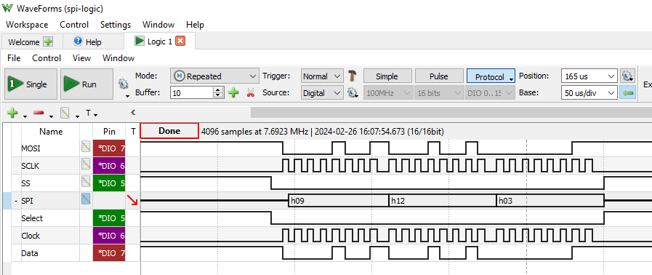
Logic Instrument
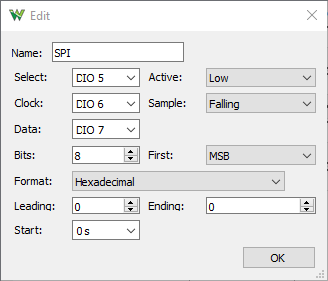 | Setup for SPI Protocol using Logic Instrument
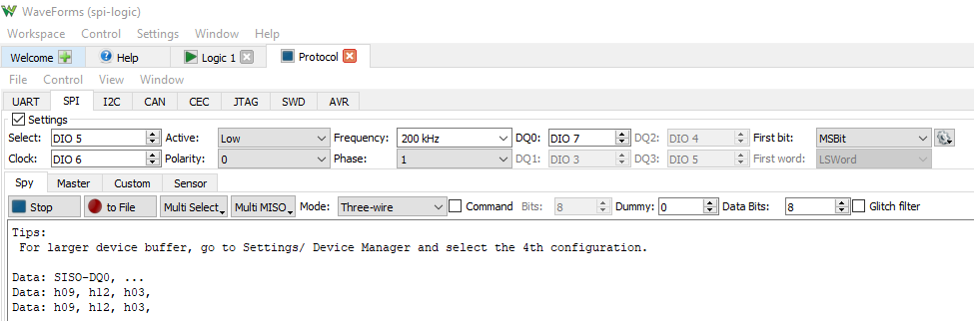
Protocol Instrument

